

**COURSE PROJECT REPORT**

**Subject: SWD392**

– Da Nang, April 2025 –

**Table of Contents**

Record of Changes 3

I. Overview 4

I.1 Project Information 4

I.2 Project Team 4

II. Requirement Specification 4

II.1 Problem description 4

II.2 Major Features 4

II.3 Context Diagram 4

II.4 Nonfunction Requirements 5

II.5 Functional requirements 5

II.5.1 Actors 5

II.5.2 Use Cases 5

II.5.2 .1 Diagram(s) 5

II.5.2.2 Use case descriptions 6

**II.5.3 Activity diagram** 8

III. Analysis models. 9

III.1 Interaction diagrams 9

III.2 State diagram 10

IV. Design specification 11

IV.1 Integrated Communication Diagrams 11

IV.2 System High-Level Design 11

IV.3 Component and Package Diagram 11

IV.4 Class diagram 12

IV.5 Database Design 12

V. Implementation 13

V.1 Map architecture to the structure of the project 13

V.2 Map Class Diagram and Interaction Diagram to Code 13

V. Applying Alternative Architecture Patterns 13

V.1 Applying the service-oriented architecture 13

V.2 Applying Service Discovery Pattern in the service-oriented architecture 13

# Record of Changes

| **Date** | **A* M, D** | **In charge** | **Change Description** |
| --- | --- | --- | --- |
| 1/8/2026 | A |  |  |
|  |  |  |  |
|  |  |  |  |
|  |  |  |  |
|  |  |  |  |
|  |  |  |  |
|  |  |  |  |
|  |  |  |  |
|  |  |  |  |
|  |  |  |  |
|  |  |  |  |
|  |  |  |  |
|  |  |  |  |

*A - Added M - Modified D - Deleted

# I. Overview

## I.1 Project Information

* Project name: Build a Web-based Rental Management System for Boarding Houses/Apartments
* Project code: RoomHub
* Group name: 2
* Software type: MVC Model with ASP.NET and SQL Server

## I.2 Project Team

| **Full Name** | **Role** | **Email** | **Mobile** |
| --- | --- | --- | --- |
| Nguyen Hong An | Member | annhde180358@fpt.edu.vn | 0375534677 |
| Phan Hoai An | Leader | anphde180303@fpt.edu.vn | 0847343246 |
| Do Thanh Tin | Member | tindtde180794@fpt.edu.vn | 0774454307 |
| Tran Dinh Quy | Member | quytdde180286@fpt.edu.vn | 0823881884 |

# II. Requirement Specification

## II.1 Problem description

The management of boarding houses and rental apartments in Vietnam is currently facing many challenges due to the heavy reliance on manual and fragmented management methods. Most landlords still use notebooks, spreadsheets, phone calls, and messaging applications to record tenant information, rental contracts, monthly payments, and maintenance issues. As a result, data is scattered across multiple sources, making it difficult to track, update, and verify information accurately.

These traditional approaches often lead to common problems such as lost or inconsistent data, delayed rent collection, unclear billing, and ineffective communication between landlords and tenants. When the number of rooms and tenants increases, the complexity of management also grows significantly, increasing the risk of human errors and reducing overall operational efficiency. Moreover, tenants usually lack transparency regarding rental fees, payment history, and maintenance request status, which may cause disputes and dissatisfaction.

Another major issue is the absence of a centralized system that supports structured data storage and systematic management. Without a unified platform, landlords cannot easily generate reports, monitor occupancy status, or analyze rental performance. In addition, existing solutions in the market are often either too simple to meet practical needs or too complex and costly for small and medium-sized boarding house owners.

Therefore, there is a clear need for a practical, scalable, and user-friendly web-based solution that can support the daily management of boarding houses and rental apartments, improve information transparency, reduce manual workload, and enhance communication between stakeholders.

## II.2 Major Features

This section presents the major features of the RoomHub system. These features represent the core functional capabilities of the system and are designed to address the key problems identified in the problem description. Each feature supports one or more user roles, including administrators, property owners, and tenants, and collectively distinguishes RoomHub from traditional manual or fragmented rental management solutions.

**Core Features**

## A. Core System Features

### **1. Secure User Authentication & RBAC System**

**FE-01: Secure User Authentication & RBAC System** Implements a secure identity management system (using ASP.NET Identity). It enforces strict **Role-Based Access Control (RBAC)** for three key roles:

* **Administrators:** Full system control and configuration.
* **Property Owners:** Management of buildings, rooms, and contracts.
* **Tenants:** Access to personal bills, contracts, and service requests.

### **2. Hierarchical Property Structure Management**

**FE-02: Hierarchical Property Structure Management** Allows administrators to digitize the physical layout of rental properties. Users can create **Buildings**, define **Floors**, and configure individual **Rooms** with specific attributes (Max capacity, Amenities), establishing a structured data hierarchy for management.

### **3. Real-time Room Status & Lifecycle Tracking**

**FE-03: Real-time Room Status & Lifecycle Tracking** Tracks the precise lifecycle of every room unit. The system visually displays status updates in real-time: **Available** (Ready for rent), **Deposited** (Holding deposit), **Occupied** (Contract active), or **Under Maintenance** (Blocked for repairs), preventing booking conflicts.

### **4. Advanced Multi-Criteria Search Engine**

**FE-04: Advanced Multi-Criteria Search Engine** Empowers users to filter the room database using a comprehensive set of parameters. Tenants can search by **Price Range, Location (District/Ward), Room Type, Surface Area, and Availability Dates**, with results updated instantly via AJAX/API calls.

### **5. Tenant Profile & Legal Compliance Hub**

**FE-05: Tenant Profile & Legal Compliance Hub** Centralizes tenant data management. Stores personal profiles, identity documents (CCCD/Passport), and rental history. Supports the export of tenant lists for **Temporary Residence Registration** compliance with local authorities.

### **6. Digital Contract Lifecycle Management**

**FE-06: Digital Contract Lifecycle Management** Digitizes the entire rental agreement process. Features include **Drafting** new contracts (auto-filling tenant data), **Renewing** expiring leases, and executing **Termination/Liquidation** protocols with automated calculations for refunds or penalties.

### **7. Utility Recording & Automated Billing Engine**

**FE-07: Utility Recording & Automated Billing Engine** Streamlines the monthly financial cycle.

1. **Input:** Staff records **Electricity and Water meter readings** (Old vs. New index).
2. **Process:** System calculates usage based on tiered pricing or flat rates.
3. **Output:** Automatically generates a consolidated invoice including Rent, Utilities, and Service fees (Internet, Trash collection).

### **8. Payment Gateway Integration & Transaction Tracking**

**FE-08: Payment Gateway Integration & Transaction Tracking** Facilitates financial settlements.

* **Integration:** Supports Online Payment via QR Code/E-wallets (simulated or real integration).
* **Verification:** Allows tenants to upload **Proof of Payment** images. Admins verify transactions to update invoice status from "Unpaid" to "Paid".

### **9. Maintenance Ticketing & Service Request System**

**FE-09: Maintenance Ticketing & Service Request System** A dedicated portal for issue resolution. Tenants create "Tickets" for facility problems (e.g., broken AC, plumbing). Admins track the ticket lifecycle (**Open -> In Progress -> Resolved**) and assign tasks to maintenance staff.

### **10. Automated Smart Notification Service**

**FE-10: Automated Smart Notification Service** Runs background services to send timely alerts via Email or In-App Notifications.

* **Triggers:** Rent Due Dates, Payment Success Confirmations, Contract Expiration Warnings (30 days prior), and Maintenance Schedule updates.

### **11. Executive Dashboard & Analytics**

**FE-11: Executive Dashboard & Analytics** Provides a visual command center for owners. Displays key performance indicators (KPIs) such as **Monthly Revenue, Occupancy Rate (%), Outstanding Debts,** and Expense breakdowns using interactive charts.

### **12. In-App Real-Time Chat & Communication System**

**FE-12: In-App Real-Time Chat & Communication System** Provides a built-in messaging feature to enable direct communication between Tenants, Property Owners, and Administrators within the platform. The system supports real-time one-to-one chat, message history persistence, image sharing (e.g., room condition photos, payment proofs), and contextual linking to specific Rooms or Contracts. This feature enhances transparency, reduces off-platform communication, and improves issue resolution efficiency.

### **13. Rating & Review Management System**

**FE-13: Rating & Review Management System** Allows tenants to submit ratings and written reviews after staying in a room or completing a rental contract. The system supports a 5-star rating scale (1–5 stars) and textual feedback for Rooms, Property Owners, and related Services. Average ratings are automatically calculated and displayed to improve trust, transparency, and decision-making for future tenants.

### **14. Room Holding Deposit Management**

**FE-14: Room Holding Deposit Management** Introduces a temporary room reservation mechanism through holding deposits. Tenants can place a deposit to reserve a room for a configurable time period before signing a formal rental contract. During this period, the room status is updated to “Deposited,” preventing booking conflicts. The system supports configurable deposit amounts, holding durations, and refund or forfeiture policies based on business rules.

### **15. Integrated Service Marketplace & Revenue Mediation**

**FE-15: Integrated Service Marketplace & Revenue Mediation** Expands the platform into a service intermediary by offering value-added services such as maintenance, cleaning, moving assistance, and utility installation. Tenants can request services directly through the system, and service fees can be consolidated into monthly invoices. The platform or property owner can earn commissions from each transaction, creating an additional revenue stream.

## B. AI-Powered Features

### **1. Intelligent Room Recommendation System**

**FE-AI-01: Intelligent Room Recommendation System** Uses a **Recommendation Engine** (Content-Based Filtering) to personalize the user experience. By analyzing the user's search history, viewed items, and stated preferences (budget, location), the AI suggests the most relevant rooms, increasing the likelihood of successful booking.

### **2. AI-Driven Dynamic Pricing Assistant**

**FE-AI-02: AI-Driven Dynamic Pricing Assistant** Assists property owners in setting competitive rental prices. The AI analyzes internal data (room size, amenities, floor level) and compares it with historical successful booking data to suggest an **Optimal Rental Price Range** that maximizes revenue while ensuring occupancy.

### **3. 24/7 Virtual Assistant (AI Chatbot)**

**FE-AI-03: 24/7 Virtual Assistant (AI Chatbot)** Integrates an NLP-based Chatbot (using OpenAI API or minimal intent recognition) to handle Level 1 support. It instantly answers FAQs regarding **Room Availability, Booking Procedures, Contract Terms, and Payment Policies**, reducing the workload for human admins.

### **4. Occupancy Demand Forecasting**

**FE-AI-04: Occupancy Demand Forecasting** Utilizes predictive analytics models (Regression Analysis) on historical booking data to forecast future demand. This helps administrators anticipate **Peak/Off-peak seasons** and adjust marketing or pricing strategies proactively (e.g., offering discounts during low-demand months).

### **5. Sentiment Analysis for Maintenance Quality**

**FE-AI-05: Sentiment Analysis for Maintenance Quality** Analyzes textual feedback and comments from tenants regarding maintenance requests. The AI classifies sentiment (Positive, Neutral, Negative) to identify recurring facility issues or dissatisfaction trends, enabling owners to improve service quality before tenants decide to leave.

### **6. AI-Based Comment Moderation**

**FE-AI-06: AI-Based Comment Moderation** Utilizes Natural Language Processing (NLP) models to automatically review and moderate user-generated comments and reviews. The system detects offensive language, abusive behavior, spam, or policy violations, classifying content into approved, flagged, or hidden states. This ensures a healthy and trustworthy community environment while reducing manual moderation effort.

### **7. AI-Based Content Moderation for Posts & Messages**

**FE-AI-07: AI-Based Content Moderation for Posts & Messages** Applies AI-driven content analysis to room descriptions, user posts, and in-app chat messages to detect sensitive or prohibited information. This includes personal identification numbers, contact details, financial data, or legally restricted content. The system can automatically mask, warn, or block such content to ensure compliance with privacy and regulatory requirements.

### **8. KYC – User Identity Verification System**

**FE-16: Know Your Customer (KYC) – User Identity Verification System** Implements a digital identity verification process to enhance platform trust and legal compliance. Users are required to upload government-issued identification documents (e.g., ID card or passport) and perform selfie-based facial verification. AI-powered OCR and face-matching technologies are used to validate authenticity. Verified users receive a “Verified” status, which is mandatory for contract execution and high-value transactions.

## II.3 Context Diagram

*[Context Diagram is the highest-level system analysis diagram, showing the system as a "black box" with:*

*External entities interacting with the system*

*Data flows into and out of the system]*

## II.4 Nonfunctional requirements

| **#** | **Feature** | **System Function** | **Description** |
| --- | --- | --- | --- |
| 1 | Performance | User Authentication & Authorization | The system shall authenticate users and assign role-based access rights within **≤ 2 seconds** for 95% of login requests under normal load. |
| 2 | Performance | Room Search & Filtering | The system shall return room search results based on multiple criteria (price, location, availability, room type) within **≤ 3 seconds** for up to 10,000 room records using AJAX/API calls. |
| 3 | Performance | Invoice Generation | Monthly invoices, including rent, utilities, and service fees, shall be generated automatically within **≤ 5 seconds** per tenant after meter data is submitted. |
| 4 | Security | User Authentication | The system shall enforce secure authentication using **ASP.NET Identity**, password hashing, and session management to prevent unauthorized access. |
| 5 | Security | Role-Based Access Control (RBAC) | The system shall restrict access to system functions strictly based on user roles (Administrator, Property Owner, Tenant), preventing privilege escalation. |
| 6 | Security | Payment & Transaction Data | All payment-related data, invoices, and uploaded proof-of-payment images shall be protected against unauthorized access and tampering. |
| 7 | Security | Personal Data & KYC Information | Tenant identity documents (CCCD/Passport), KYC data, and personal profiles shall be stored securely and accessed only by authorized roles to ensure privacy compliance. |
| 8 | Usability | User Interface | The system shall provide a responsive and intuitive web interface that is accessible on desktop and mobile browsers without requiring technical training. |
| 9 | Usability | Navigation & Workflow | Common user tasks (searching rooms, paying rent, submitting maintenance requests) shall be completable within **no more than 3–5 user interactions**. |
| 10 | Reliability | System Availability | The system shall maintain an uptime of at least **99%**, excluding scheduled maintenance periods. |
| 11 | Reliability | Data Consistency | All critical operations (contract creation, invoice payment, room status updates) shall ensure data consistency across the database and application layers. |
| 12 | Scalability | User & Data Growth | The system architecture shall support scaling to manage **thousands of users, rooms, and contracts** without requiring major architectural changes. |
| 13 | Scalability | Modular Feature Expansion | New services (e.g., service marketplace, AI modules) shall be integrated as independent components or services without affecting existing core functionalities. |
| 14 | Maintainability | Code Structure | The system shall follow the **MVC architecture** with clear separation of concerns to facilitate debugging, maintenance, and future enhancements. |
| 15 | Maintainability | Logging & Error Handling | The system shall log critical system events and errors to support troubleshooting and system monitoring. |
| 16 | Compatibility | Browser Support | The system shall be compatible with modern web browsers (Chrome, Edge, Firefox) without requiring browser-specific plugins. |
| 17 | Interoperability | External Services | The system shall support integration with external services such as payment gateways, email services, and AI APIs through well-defined interfaces or services. |
| 18 | Data Integrity | Database Operations | All create, update, and delete operations on contracts, invoices, and room records shall be transaction-safe to prevent partial or inconsistent data states. |
| 19 | Compliance | Legal & Regulatory Support | The system shall support tenant data export for temporary residence registration and comply with basic data protection and rental management regulations. |
| 20 | AI Governance | AI-based Features | AI-powered features (recommendation, pricing, moderation) shall operate as decision-support tools and must not automatically execute irreversible business actions without user confirmation. |

## II.5 Functional requirements

### II.5.1 Actors

| **#** | **Actor** | **Description** |
| --- | --- | --- |
| 1 | Administrator | System superuser responsible for maintaining the overall integrity, security, and configuration of the RoomHub platform. The Administrator does not participate in rental operations. |
| 2 | Property Owner | **(Primary Business User)** The owner or manager of rental properties. This actor holds the primary responsibility for business operations and tenant interactions. |
| 3 | Tenant | A registered user who rents or intends to rent a property within the system. |
| 4 | Guest | An unauthenticated visitor accessing the RoomHub platform. |
| 5 | Payment Gateway | **(External System Actor)** A third-party financial service (e.g., VNPay, MoMo, or Banking API) integrated to handle secure transactions. |
| 6 | AI Engine | (External System Actor) The integrated Artificial Intelligence services (e.g., OpenAI API, ML.NET). |

### II.5.2 Use Cases

This section outlines the primary use cases of the RoomHub system, grouped by functional modules. Each use case represents a specific interaction between an actor and the system to achieve a business goal.

#### A. Authentication & User Management

Focuses on identity verification, security, and account administration.

* **UC-01: Register New Account**
  + **Actor:** Guest
  + **Description:** Allows a guest to create a new account as a Tenant or Property Owner by providing necessary credentials.
* **UC-02: Log In to System**
  + **Actor:** All Users
  + **Description:** Authenticates users based on their credentials and grants access to specific features via Role-Based Access Control (RBAC).
* **UC-03: Verify User Identity (KYC)**
  + **Actor:** Tenant, Owner, AI Engine
  + **Description:** Processes user identity verification via ID document upload and facial recognition handled by the AI Engine.
* **UC-04: Manage User Profile**
  + **Actor:** Tenant, Owner
  + **Description:** Enables users to view and update personal information, contact details, and security settings.
* **UC-05: Manage User Accounts**
  + **Actor:** Administrator
  + **Description:** Allows the administrator to monitor user status, ban/unban accounts, and oversee KYC approvals.

#### B. Property Management

Focuses on the configuration of physical assets and pricing strategies.

* **UC-06: Manage Buildings & Floors**
  + **Actor:** Property Owner
  + **Description:** Enables owners to define the physical structure of properties, including creating buildings and floor layouts.
* **UC-07: Manage Room Configuration**
  + **Actor:** Property Owner
  + **Description:** Allows configuration of specific room details such as capacity, amenities, base price, and photos.
* **UC-08: Update Room Status**
  + **Actor:** Property Owner
  + **Description:** Manually or automatically updates the lifecycle status of a room (e.g., Available, Maintenance, Occupied).
* **UC-09: Get Dynamic Price Suggestion**
  + **Actor:** Property Owner, AI Engine
  + **Description:** Uses AI analysis of market data to suggest an optimal rental price range to the owner.

#### C. Search, Booking & Contracts

Focuses on the core business flow from discovery to legal agreement.

* **UC-10: Search for Rooms**
  + **Actor:** Guest, Tenant
  + **Description:** Allows users to find rooms using advanced filters (location, price, amenities) and AI-driven recommendations.
* **UC-11: Place Holding Deposit**
  + **Actor:** Tenant
  + **Description:** Enables tenants to pay a deposit to reserve a room for a set duration, preventing other bookings.
* **UC-12: Draft Rental Contract**
  + **Actor:** Property Owner
  + **Description:** Generates a digital rental agreement populated with tenant data, room details, and lease terms.
* **UC-13: Sign Digital Contract**
  + **Actor:** Tenant
  + **Description:** Allows the tenant to review the agreement and apply a digital signature to legalize the rental.
* **UC-14: Renew Rental Contract**
  + **Actor:** Property Owner, Tenant
  + **Description:** Facilitates the extension of an existing lease with updated terms or duration and provides renewal reminders.
* **UC-15: Terminate Rental Contract**
  + **Actor:** Property Owner
  + **Description:** Executes the contract liquidation process, including final checkout and refund/penalty calculations.

#### D. Operations & Billing

Focuses on monthly financial cycles and utility management.

* **UC-16: Record Utility Usage**
  + **Actor:** Property Owner
  + **Description:** Inputs monthly electricity and water meter readings for calculation.
* **UC-17: Generate Monthly Invoice**
  + **Actor:** System (Auto) / Property Owner
  + **Description:** Consolidates rent, utilities, and service fees into a single invoice for the tenant.
* **UC-18: Pay Monthly Invoice**
  + **Actor:** Tenant
  + **Description:** Processes online payments for outstanding invoices via the integrated Payment Gateway.
* **UC-19: Verify Payment Transaction**
  + **Actor:** Property Owner, Administrator
  + **Description:** Confirms the validity of payments through gateway status or manual proof-of-payment review.
* **UC-20: Export Residence List**
  + **Actor:** Property Owner
  + **Description:** Exports tenant data in a standardized format for Temporary Residence Registration with local authorities.

#### E. Maintenance & Services

Focuses on tenant support and facility upkeep.

* **UC-21: Submit Maintenance Ticket**
  + **Actor:** Tenant
  + **Description:** Allows tenants to report facility issues (e.g., broken AC) with descriptions and images.
* **UC-22: Manage Maintenance Tickets**
  + **Actor:** Property Owner
  + **Description:** Tracks ticket progress, assigns tasks to repair services, and updates resolution status.
* **UC-23: Analyze Maintenance Sentiment**
  + **Actor:** AI Engine
  + **Description:** Analyzes tenant feedback in tickets to classify sentiment (Positive/Negative) for quality control.
* **UC-24: Request Extra Service**
  + **Actor:** Tenant
  + **Description:** Enables tenants to book value-added services such as cleaning, laundry, or moving assistance.

#### F. Communication & Engagement

Focuses on interaction, feedback, and community safety.

* **UC-25: Chat with AI Assistant**
  + **Actor:** Guest, Tenant
  + **Description:** Provides instant answers to FAQs regarding policies or bookings via an NLP-powered chatbot.
* **UC-26: Send Direct Message**
  + **Actor:** Tenant, Owner, Administrator
  + **Description:** Facilitates real-time internal messaging between users for negotiation or support.
* **UC-27: Moderate Chat Content**
  + **Actor:** AI Engine, Administrator
  + **Description:** Automatically scans and flags prohibited content or sensitive data in messages.
* **UC-28: Submit Rating & Review**
  + **Actor:** Tenant
  + **Description:** Allows tenants to rate and review their stay after the contract ends.
* **UC-29: Moderate Reviews**
  + **Actor:** AI Engine, Administrator
  + **Description:** Screens user reviews for inappropriate content before public display.

#### G. Analytics & Dashboard

Focuses on data visualization and strategic insights.

* **UC-30: View Executive Dashboard**
  + **Actor:** Property Owner
  + **Description:** Displays key performance indicators (KPIs) such as revenue, occupancy, and debts.
* **UC-31: View AI-Powered Demand Forecast**
  + **Actor:** Property Owner
  + **Description:** Allows the Property Owner to view AI-generated forecasts of future room occupancy and rental demand, based on historical booking data, seasonal patterns, pricing trends, and external factors.
* **UC-32: View Platform Analytics**
  + **Actor:** Administrator
  + **Description:** Provides system-wide statistics on user growth, traffic, and platform revenue.

### II.5.2 .1 Diagram(s)

#### **A. Authentication & User Management UC diagram**

#### B. Property Management UC diagram

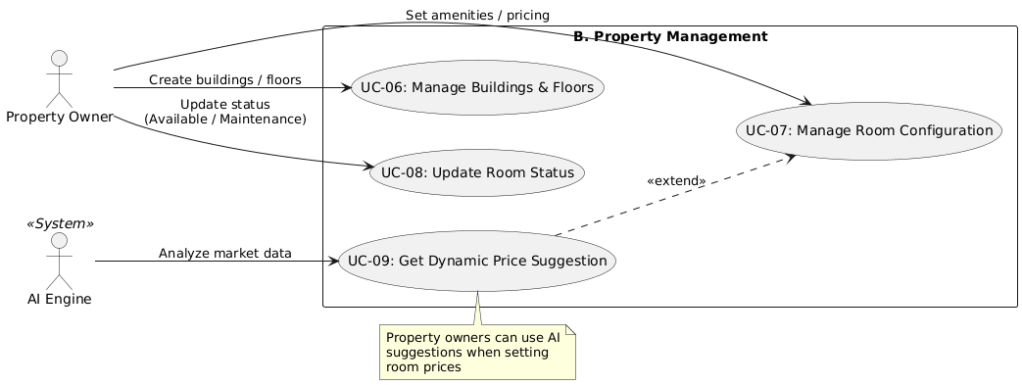

##### **B.1 Analysis of Include and Extend Relationships** The use case “Get Dynamic Price Suggestion (UC-09)” extends “Manage Room Configuration (UC-07)” to represent an optional and conditional behavior within the Property Management module.

This relationship indicates that AI-based price suggestions are provided only when the property owner explicitly requests pricing assistance during room configuration. The base use case remains complete and fully functional without the extension, ensuring system flexibility and modularity.

Using the <<extend>> relationship accurately models real-world business processes and supports scalability by allowing advanced AI features to be integrated without impacting core functionality.

#### C. Search, Booking & Contracts

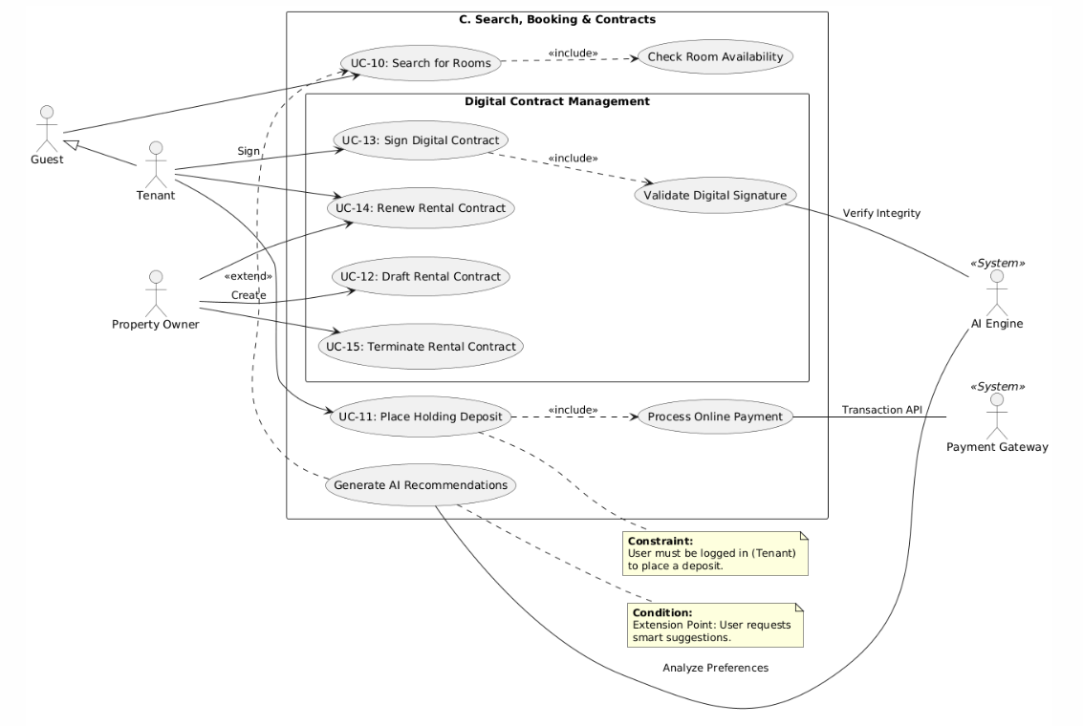

##### C.1.Analysis of Include and Extend Relationships

**Include Relationships (<<include>>)**

* Base Use Case: UC-10: Search for Rooms
  + Included Use Case: Check Room Availability
  + Rationale: This is a mandatory validation. The system must automatically filter out or flag rooms that are currently occupied. The search function cannot return valid results without checking the real-time status of the rooms.
* Base Use Case: UC-11: Place Holding Deposit
  + Included Use Case: Process Online Payment
  + Rationale: This is a transactional dependency. Placing a deposit is fundamentally a financial action. The use case is not considered complete until the system successfully processes the payment via the Payment Gateway.
* Base Use Case: UC-13: Sign Digital Contract
  + Included Use Case: Validate Digital Signature
  + Rationale: This is a security and legal requirement. When a tenant applies a digital signature, the system must technically validate the integrity of that signature (hash check) to ensure non-repudiation and legal validity.

**Extend Relationships (<<extend>>)**

* Base Use Case: UC-10: Search for Rooms
  + Extending Use Case: Generate AI Recommendations
  + Rationale: This is an optional/advanced feature. Users can perform a standard search using manual filters (location, price). The AI recommendation logic is only triggered if the user requests "Smart Suggestions" or if the system detects specific browsing patterns to offer personalized results.

##### C.2.Actor Analysis and Generalization

**Generalization Relationships (Inheritance)**

* Parent Actor: Guest (Unauthenticated User)
* Child Actor: Tenant (Authenticated User)
* Relationship Logic:
  + Inheritance: The Tenant actor inherits all permissions and capabilities of the Guest actor.
  + Explanation: A Guest can browse and search for rooms (UC-10). Once a user logs in and becomes a tenant, they retain the ability to search but gain additional privileges, such as placing deposits (UC-11) and signing contracts (UC-13). This relationship simplifies the diagram by avoiding redundant links for the search functionality.

**Secondary Actors (System Actors)**

* AI Engine (<<System>>)
  + Role: Intelligent Processing Service.
  + Responsibility: It operates in the background to analyze user data for Recommendations (linked to UC-10) and to verify technical security for Digital Signatures (linked to UC-13).
* Payment Gateway (<<System>>)
  + Role: External Financial Service.
  + Responsibility: It handles the actual fund transfer and returns the transaction status (Success/Fail). It is strictly required for the Process Online Payment step (linked to UC-11).

#### D. Operations & Billing

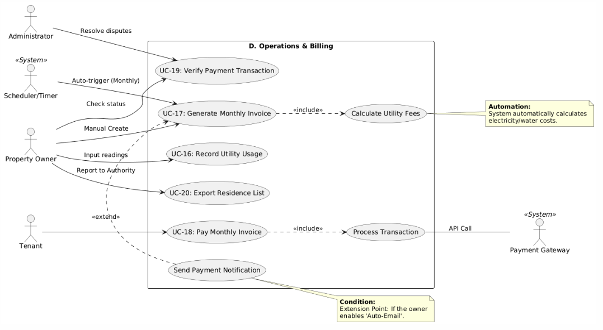

##### D.1.Analysis of Include and Extend Relationships

**Include Relationships (<<include>>)**

* Base Use Case: UC-17: Generate Monthly Invoice Included Use Case: Calculate Utility Fees
  + Rationale: This is a computational dependency. An invoice cannot be generated without the total amount due. The system must retrieve the recorded utility usage (from UC-16) and calculate the costs based on unit prices to include them in the final invoice.
* Base Use Case: UC-18: Pay Monthly Invoice Included Use Case: Process Transaction
  + Rationale: This is a mandatory functional execution. The user action "Pay Invoice" implies a transfer of funds. The system must execute the transaction via the external Payment Gateway to validate the payment status (Success/Fail) before marking the invoice as paid.

**Extend Relationships (<<extend>>)**

* Base Use Case: UC-17: Generate Monthly Invoice Extending Use Case: Send Payment Notification Rationale: This is a conditional automation feature. After the invoice is generated, the system can optionally send an email or push notification to the tenant. This occurs only if the "Auto-Notify" setting is enabled by the Property Owner or the System Administrator.

##### D.2.Actor Analysis and Generalization

**Secondary Actors (System Actors)**

* Payment Gateway (<<System>>) Role: External Financial Service Provider. Responsibility: It acts as the intermediary for financial transactions. It receives payment requests from the system (linked to UC-18), processes the credit card/banking details, and returns the transaction result.
* Scheduler/Timer (<<System>>) Role: Time-based Automation Trigger. Responsibility: It replaces human input for recurring tasks. It automatically triggers the "Generate Monthly Invoice" use case (UC-17) on a specific date (e.g., the 1st of every month) to ensure billing consistency without manual intervention from the owner.

#### E. Maintenance & Services

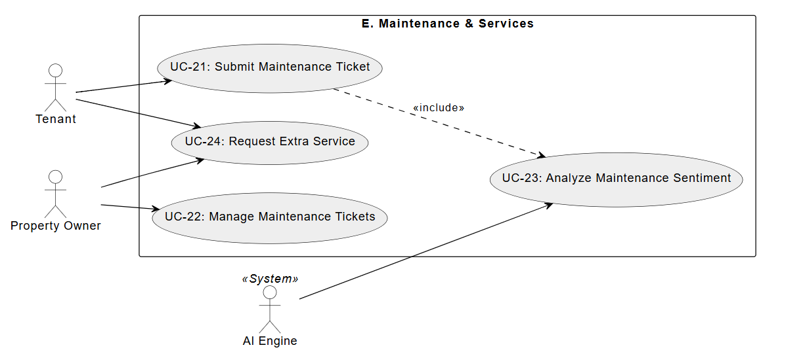

##### E.1. Analysis of Include and Extend Relationships

**Include Relationships (<<include>>)**

* **Base Use Case:** UC-21: Submit Maintenance Ticket
  + **Included Use Case:** UC-23: Analyze Maintenance Sentiment
  + **Rationale:** This is a data processing dependency. When a tenant submits a ticket with a textual description, the system *automatically and mandatorily* invokes the AI Engine to analyze the content. The sentiment score (Positive/Negative/Urgent) must be generated and attached to the ticket before it is queued for the Property Owner.
* **Base Use Case:** UC-24: Request Extra Service
  + **Included Use Case:** Calculate Service Fee
  + **Rationale:** This is a computational dependency. Before a service request (e.g., Cleaning, Laundry) can be finalized, the system must retrieve the service pricing configuration and calculate the total estimated cost to display to the tenant for confirmation.

**Extend Relationships (<<extend>>)**

* **Base Use Case:** UC-22: Manage Maintenance Tickets
  + **Extending Use Case:** Send Status Notification
  + **Rationale:** This is a conditional automation feature. When the Property Owner updates the status of a ticket (e.g., from "In Progress" to "Resolved"), the system can optionally trigger an email or push notification to inform the tenant. This ensures the tenant is updated without the owner needing to manually send a message.
* **Base Use Case:** UC-21: Submit Maintenance Ticket
  + **Extending Use Case:** Upload Evidence Image
  + **Rationale:** This is an optional enhancement. While a text description is mandatory, the tenant *may choose* to upload an image to provide visual proof of the issue. The system extends the base submission flow to handle file uploading and storage if this option is selected.

##### E.2. Actor Analysis and Generalization

**Secondary Actors (System Actors)**

* **AI Engine (<<System>>)**
  + **Role:** Intelligent Data Processor.
  + **Responsibility:** It acts as an internal service provider for natural language processing. It receives raw text data from the maintenance tickets (linked to UC-21), performs sentiment analysis, and returns a classification result to help the Property Owner prioritize urgent issues.
* **Notification Service (<<System>>)**
  + **Role:** Automated Communication Relay.
  + **Responsibility:** It handles the delivery of alerts triggered by system events. In this module, it is responsible for alerting the Property Owner when a new ticket is submitted (UC-21) and alerting the Tenant when a ticket status is updated (UC-22), ensuring real-time awareness for both parties.

#### F. Communication & Engagement

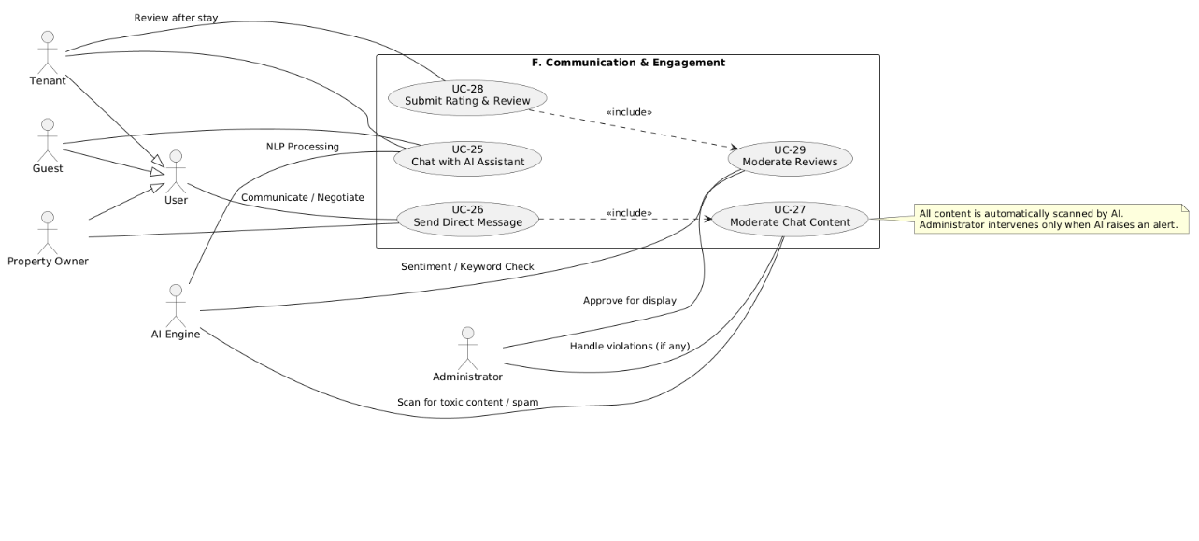

##### F.1. Analysis of Include and Extend Relationships

**Include Relationships (<<include>>)**

**Base Use Case:** UC-26: Send Direct Message  
**Included Use Case:** UC-27: Moderate Chat Content  
**Rationale:**This is a mandatory moderation dependency. Every direct message must be automatically scanned by the AI Engine for toxic language, spam, sensitive data, or policy violations before it can be delivered. The message flow cannot continue unless moderation is completed.

**Base Use Case:** UC-28: Submit Rating & Review  
**Included Use Case:** UC-29: Moderate Reviews  
**Rationale:**This is a mandatory validation dependency. When a tenant submits a rating and review, the system must analyze the content using AI before publishing. The review is screened for inappropriate language, fake content, or violations, and only approved reviews are displayed.

**Extend Relationships (<<extend>>)**

**Base Use Case:** UC-27: Moderate Chat Content  
**Extending Use Case:** Handle Violations  
**Rationale:**This is a conditional control feature. If the AI Engine detects or flags prohibited content, the system extends the flow by involving the Administrator to review and take action (delete, warn, block, or suspend). This extension only occurs when violations are detected.

**Base Use Case:** UC-29: Moderate Reviews  
**Extending Use Case:** Manual Review by Administrator  
**Rationale:**This is a conditional supervision feature. When AI is uncertain or flags a review as suspicious, the system extends the process to allow the Administrator to manually approve or reject the review.

##### F.2. Actor Analysis and Generalization

**Primary Actors**

**Tenant**Role: Main service user.  
Responsibility:

* Chat with AI Assistant (UC-25)
* Send Direct Message (UC-26)
* Submit Rating & Review (UC-28)

**Guest**Role: Information seeker.  
Responsibility:

* Chat with AI Assistant (UC-25)

**Property Owner**Role: Service provider.  
Responsibility:

* Send and receive Direct Message (UC-26)

**Administrator**Role: System supervisor.  
Responsibility:

* Handle flagged chat content (UC-27)
* Approve or reject flagged reviews (UC-29)

Secondary Actors (System Actors)

**AI Engine (<>)**Role: Intelligent Content Processor.  
Responsibility:

* Perform NLP processing for chatbot conversations (UC-25)
* Scan messages for toxic content and spam (UC-27)
* Analyze sentiment and keywords in reviews (UC-29)

**Actor Generalization**

**User (General Actor)**Role: Abstract system user.  
Specialized Actors:

* Tenant —|> User
* Guest —|> User
* Property Owner —|> User

**Rationale:**Tenant, Guest, and Property Owner share common system access as users but differ in permissions and functions. Generalization reduces duplication and clarifies shared behavior.

#### 

#### G. Analytics & Dashboard

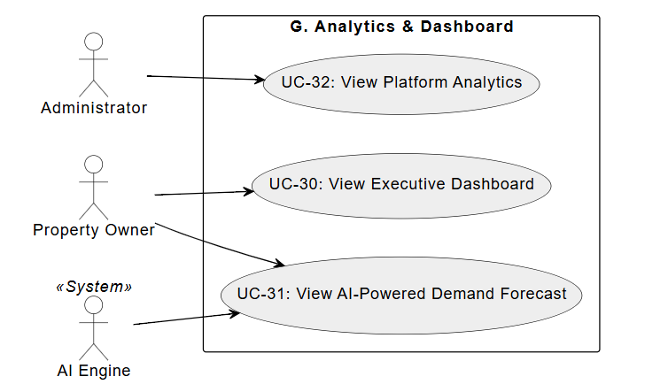

##### G.1. Analysis of Include and Extend Relationships

**Include Relationships (<<include>>)**

* **Base Use Case:** UC-31: View AI-Powered Demand Forecast
  + **Included Use Case:** Process Time-Series Data
  + **Rationale:** This is a computational dependency. To display a forecast chart, the system cannot simply read raw data. It must *mandatorily* invoke the predictive algorithms (Regressions/ARIMA) to process historical booking logs and calculate future trends before rendering the visual output to the Property Owner.
* **Base Use Case:** UC-32: View Platform Analytics
  + **Included Use Case:** Aggregate System Metrics
  + **Rationale:** This is a performance optimization dependency. Due to the massive volume of system-wide data, the dashboard does not query individual records in real-time. Instead, it relies on a background aggregation process (Daily Snapshot) to sum up total users, revenue, and traffic. The "View" use case includes fetching this pre-calculated dataset.

**Extend Relationships (<<extend>>)**

* **Base Use Case:** UC-30: View Executive Dashboard
  + **Extending Use Case:** Filter by Time Range
  + **Rationale:** This is an optional interaction. The dashboard loads with a default view (e.g., "Current Month"). The user *may optionally* choose to extend the functionality by selecting a specific custom date range (e.g., "Last Quarter") to analyze performance over a different period.
* **Base Use Case:** UC-30: View Executive Dashboard
  + **Extending Use Case:** Export Financial Report
  + **Rationale:** This is a feature enhancement. After viewing the KPIs on the screen, the Property Owner can optionally choose to download the data as a PDF or Excel file for offline accounting purposes.

##### G.2. Actor Analysis and Generalization

**Secondary Actors (System Actors)**

* **AI Engine (<<System>>)**
  + **Role:** Predictive Analyst.
  + **Responsibility:** It acts as the core intelligence provider for the forecasting module. It receives historical transaction data from the system (linked to UC-31), applies machine learning models to identify seasonal patterns, and returns the predicted occupancy rates and revenue estimates.
* **Analytics Service (<<System>>)**
  + **Role:** Background Data Aggregator.
  + **Responsibility:** It operates as a scheduled service (Cron Job) that runs during off-peak hours. Its responsibility is to traverse the operational databases, calculate complex metrics (Total GMV, User Growth Rate), and store them in a lightweight "Stats Table" or Cache, enabling fast loading times for the Administrator's Dashboard (UC-32).

### II.5.2.2 Use case descriptions

#### a. Use case descriptions

| **ID** | **Use Case** | **Actors** | **Use Case Description** |
| --- | --- | --- | --- |
| 01 | Register New Account | Guest | The Guest provides personal details (email, password, role selection) to create a new account as a Tenant or Property Owner. |
| 02 | Log In to System | All Users | Users authenticate their identity using credentials to access the system based on their role (RBAC). |
| 03 | Verify User Identity (KYC) | Tenant, Owner, Administrator, AI Engine | The user uploads ID documents and a selfie. The AI Engine performs OCR and face matching. The Administrator may manually review if AI flags the attempt. |
| 04 | Manage User Profile | Tenant, Owner | Users view and update their personal information, contact details, and change passwords. |
| 05 | Manage User Accounts | Administrator | The Administrator views the list of users, bans/unbans accounts, and oversees the verification status. |
| 06 | Manage Buildings & Floors | Property Owner | The Owner creates, updates, or deletes building information and defines the floor structure within the system. |
| 07 | Manage Room Configuration | Property Owner | The Owner configures specific room details (capacity, amenities, price, photos) and assigns them to a floor. |
| 08 | Update Room Status | Property Owner, System (Timer) | The Owner manually updates status (Maintenance/Available) or the System automatically updates it based on booking/contract events. |
| 09 | Get Dynamic Price Suggestion | Property Owner, AI Engine | The Owner requests the AI Engine to analyze data and suggest an optimal rental price range for a room. |
| 10 | Search for Rooms | Guest, Tenant, AI Engine | Users search for rooms using filters (location, price). The AI Engine may rank results or provide recommendations based on history. |
| 11 | Place Holding Deposit | Tenant, Payment Gateway | The tenant pays a deposit to reserve a room for a specific period. The system updates the room status to "Deposited". |
| 12 | Draft Rental Contract | Property Owner | The Owner creates a digital contract, auto-filling tenant and room data, and sets the lease terms. |
| 13 | Sign Digital Contract | Tenant | The tenant reviews the drafted contract and digitally signs it to activate the rental agreement. |
| 14 | Renew Rental Contract | Property Owner, Tenant | The Owner initiates a renewal for an expiring contract, and the Tenant confirms the new terms. |
| 15 | Terminate Rental Contract | Property Owner | The Owner executes the liquidation protocol, calculating refunds or penalties when a tenant moves out. |
| 16 | Record Utility Usage | Property Owner | The Owner inputs the old and new index readings for electricity and water meters. |
| 17 | Generate Monthly Invoice | Property Owner (System Auto) | The system calculates costs based on utility usage and rent, creating a consolidated invoice for the tenant. |
| 18 | Pay Monthly Invoice | Tenant, Payment Gateway | The tenant selects an invoice and performs an online payment via the integrated Payment Gateway. |
| 19 | Verify Payment Transaction | Property Owner, Administrator | The Owner or Admin reviews uploaded payment proofs or confirms transaction status returned by the Payment Gateway. |
| 20 | Export Residence List | Property Owner, Administrator | The user exports a list of current tenants with their details for Temporary Residence Registration compliance. |
| 21 | Submit Maintenance Ticket | Tenant | The Tenant reports a facility issue (e.g., broken AC) with descriptions and photos. |
| 22 | Manage Maintenance Tickets | Property Owner | The Owner views tickets, assigns tasks to external services, and updates the ticket status (Open -> Resolved). |
| 23 | Analyze Maintenance Sentiment | Property Owner, AI Engine | The AI Engine analyzes the text of maintenance tickets to determine tenant sentiment (Positive/Negative). |
| 24 | Request Extra Service | Tenant | The tenant browses the marketplace and books additional services (cleaning, laundry). |
| 25 | Chat with AI Assistant | Guest, Tenant, AI Engine | Users ask the AI Chatbot questions regarding policies or availability, and the AI responds with natural language. |
| 26 | Send Direct Message | Tenant, Owner, Administrator | Users send real-time text or image messages to other users within the platform. |
| 27 | Moderate Chat Content | AI Engine, Administrator | The AI Engine scans messages for prohibited content/PII. Admin reviews flagged content if necessary. |
| 28 | Submit Rating & Review | Tenant | The tenant rates the room/owner and writes a review after a stay or contract completion. |
| 29 | Moderate Reviews | AI Engine, Administrator | The AI Engine detects toxic content in reviews. Valid reviews are published; toxic ones are hidden for Admin review. |
| 30 | View Executive Dashboard | Property Owner | The Owner views charts regarding revenue, occupancy rates, and outstanding debts. |
| 31 | View Demand Forecast | Property Owner, AI Engine | The Owner views future occupancy predictions generated by the AI Engine based on historical data. |
| 32 | View Platform Analytics | Administrator | The Administrator monitors system-wide health, total user growth, and platform revenue. |

##### 1. UC-01: Register New Account Functional Description Template

| UC ID and Name: | UC-01: Register New Account | | |
| --- | --- | --- | --- |
| Created By: | Do Thanh Tin | Date Created: | 14/01/2026 |
| Primary Actor: | Guest | Secondary Actors: | Authentication Service |
| Trigger: | The Guest selects the “Register” function on the Property Management System. | | |
| Description: | This Use Case allows a Guest to create a new account in the Property Management System with the role of Tenant or Property Owner by providing the required registration credentials. | | |
| Preconditions: | The Guest is not authenticated in the system. The Property Management System is operational. | | |
| Postconditions: | A new user account is successfully created and stored in the system. The user role (Tenant or Property Owner) is correctly assigned. | | |
| Normal Flow: | The Guest accesses the account registration function. The system displays the registration form. The Guest enters the required information (e.g., email address, password, and user role). The Guest submits the registration request. The system validates the provided information. The system creates a new user account with the selected role. The system notifies the Guest of successful account registration. | | |
| Alternative Flows: | **A1 – Invalid input (Step 5):**  - The system detects missing or invalid information.  - The system prompts guests to correct the input.  **A2 – Email already exists (Step 6):**  - The system detects that the email is already registered.  - The system rejects registration and notifies guests. | | |
| Exceptions: | System error occurs during the registration process. Authentication service is unavailable or unresponsive. | | |
| Priority: | High – Must Have | | |
| Frequency of Use: | Frequent, especially when new users join the system. | | |
| Business Rules: | Each email address must be unique within the system. The Guest must select exactly one role: Tenant or Property Owner during registration. | | |
| Other Information: | Not applicable. | | |
| Assumptions: | The Guest provides accurate and valid registration information. The system ensures secure storage and handling of user credentials. | | |

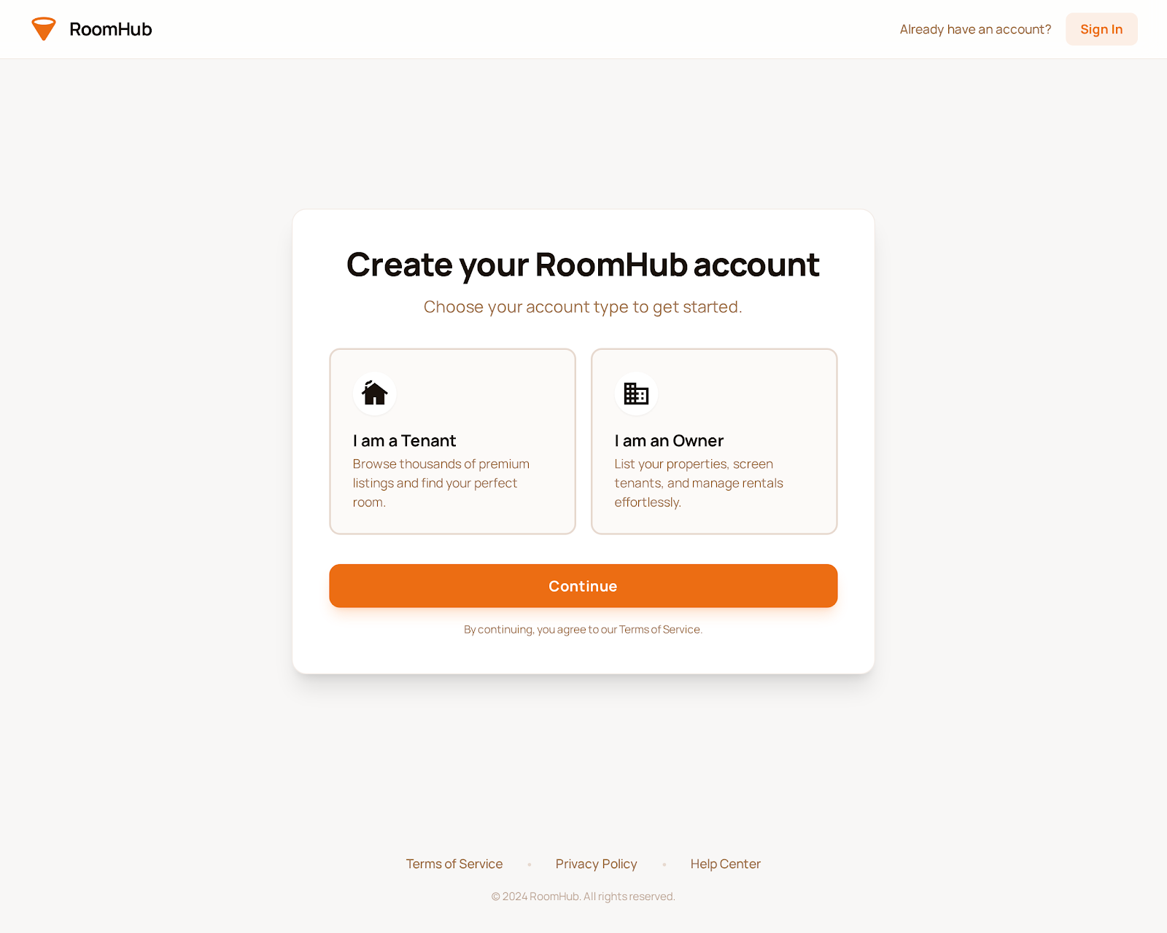

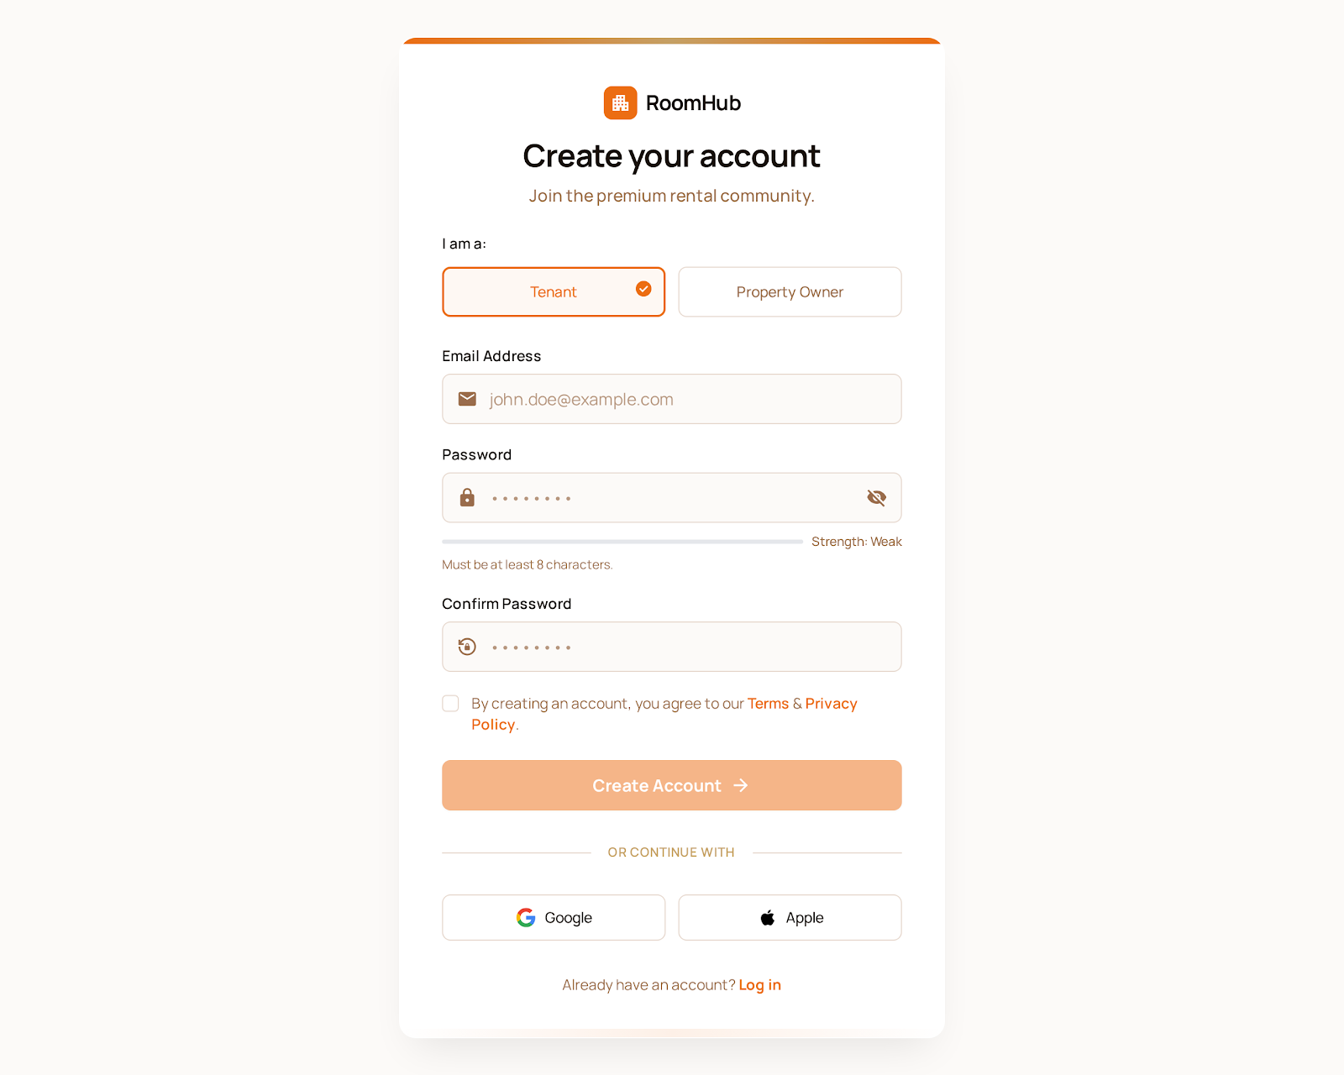

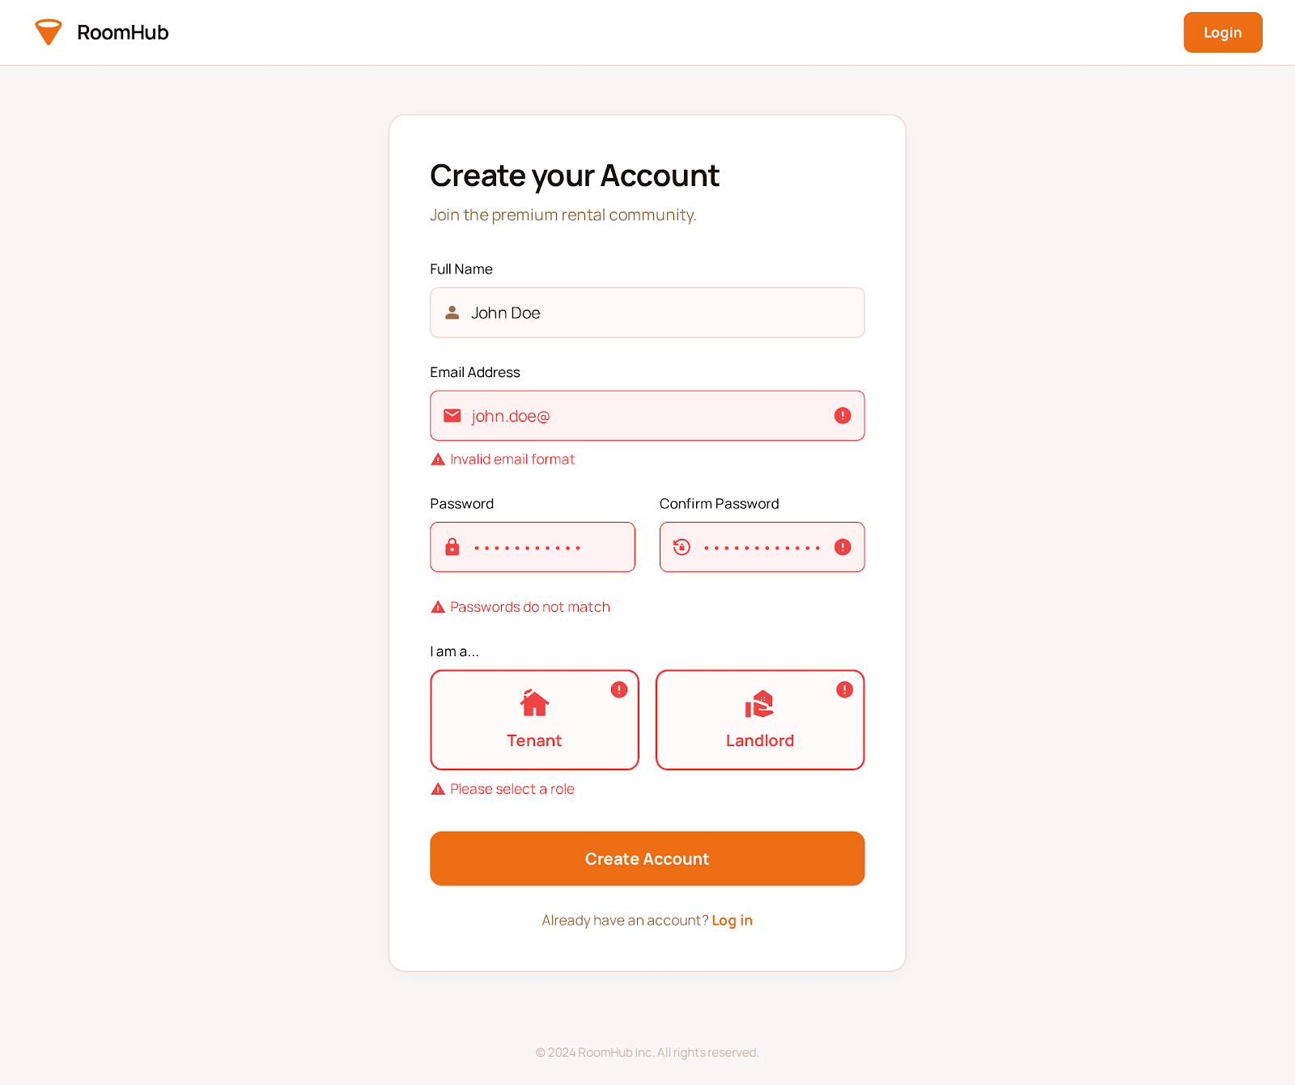

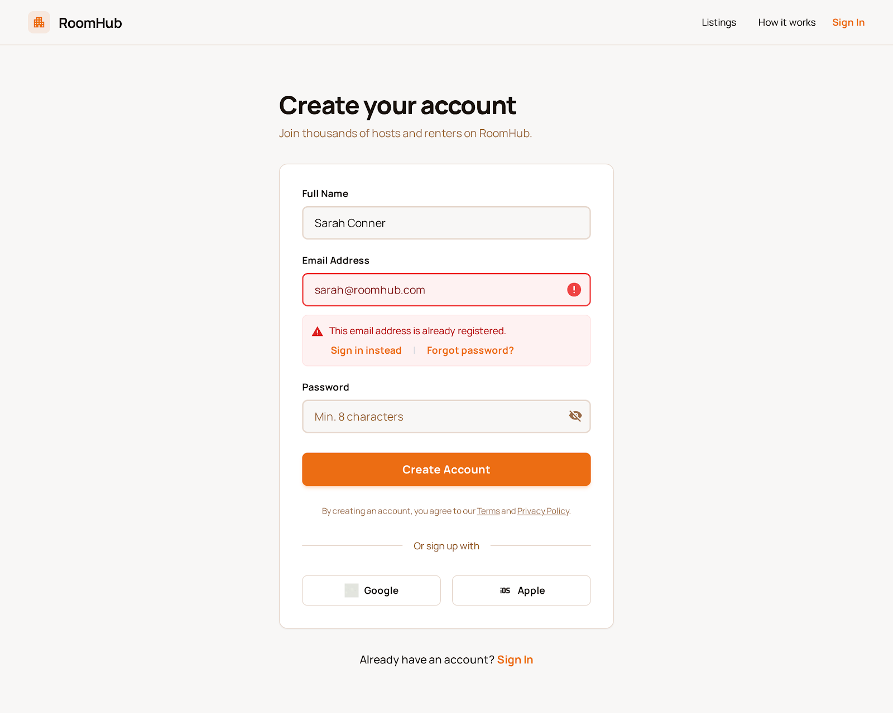

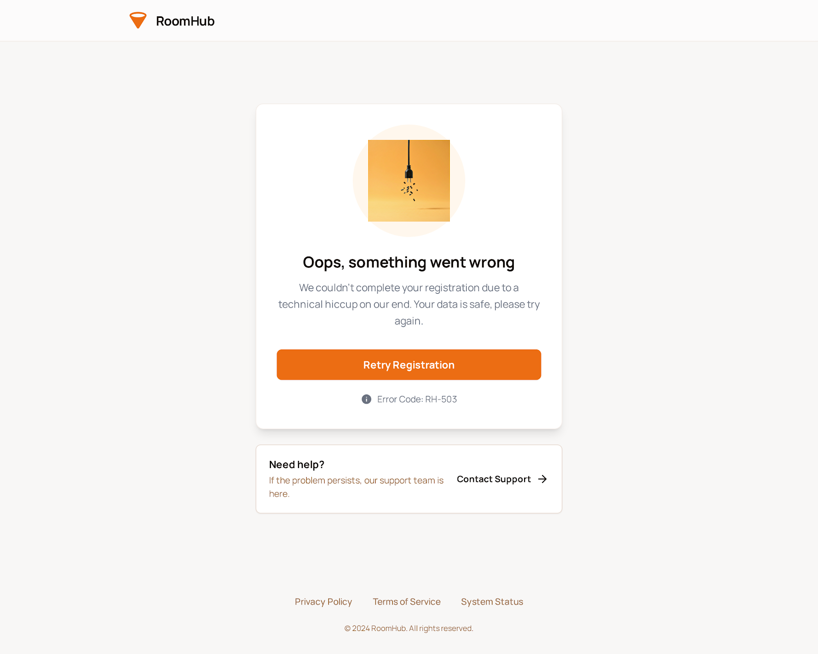



##### 2. UC-02: Log In to System Functional Description Template

| UC ID and Name: | UC-02: Log In to System | | |
| --- | --- | --- | --- |
| Created By: | Do Thanh Tin | Date Created: | January 14, 2026 |
| Primary Actor: | All Users | Secondary Actors: | Authentication Service, Role-Based Access Control (RBAC) Module |
| Trigger: | The user selects the “Log In” function on the system. | | |
| Description: | Authenticates users using their credentials and grants access to system features according to their assigned roles. | | |
| Preconditions: | - User has a valid registered account.  - System and authentication services are operational. | | |
| Postconditions: | - The user is successfully authenticated.  - The system grants access to features allowed for the user’s role.  - User session is initialized. | | |
| Normal Flow: | 1. The user selects the Log In function.  2. The system displays the login form.  3. User enters username/email and password.  4. User submits login credentials.  5. System validates credentials with Authentication Service.  6. System checks user role via RBAC module.  7. The system grants access to authorized features.  8. The system confirms successful login to the user. | | |
| Alternative Flows: | **A1 – Invalid credentials (Step 5):**  - The system detects incorrect username/email or password.  - The system displays an error message and prompts the user to retry.  **A2 – Account locked (Step 5):**  - The system detects that the account is locked due to multiple failed attempts.  - The system notifies the user and suggests password reset or contacting support.  **A3 – Role missing or undefined (Step 6):**  - The system detects that the user role is undefined or unauthorized.  - System denies access and logs the event. | | |
| Exceptions: | - Authentication service unavailable.  - System error occurs while checking credentials or roles.  - Network failure during login process. | | |
| Priority: | High – Must Have | | |
| Frequency of Use: | Very frequent; all registered users log in regularly. | | |
| Business Rules: | - Users must have valid credentials to access the system.  - RBAC determines accessible features based on user role.  - Maximum login attempts are limited (e.g., 5 attempts) to prevent brute-force attacks. | | |
| Other Information: | N/A | | |
| Assumptions: | - Users remember their credentials.  - System time and security services are synchronized.  - Network connectivity is stable during login. | | |

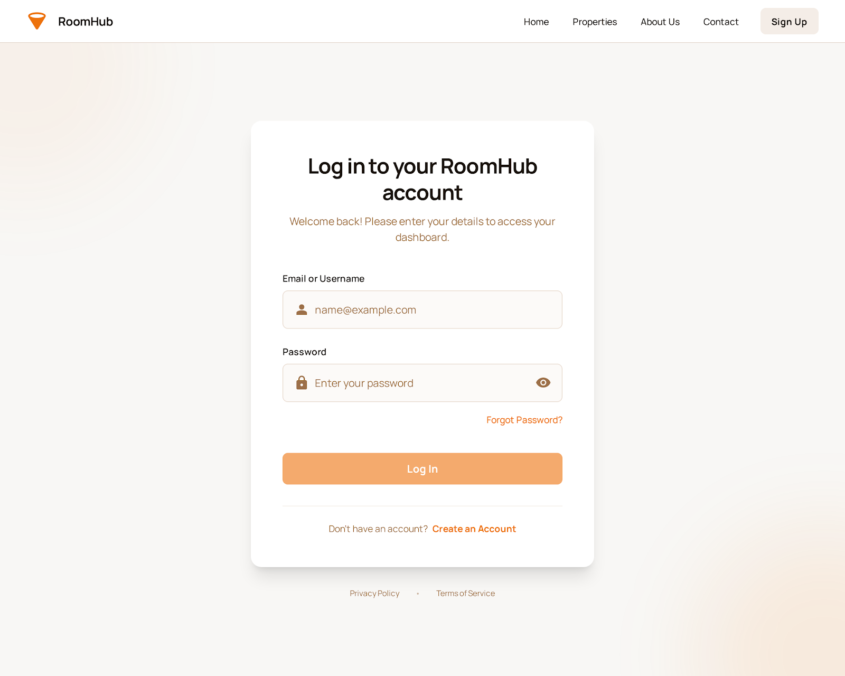

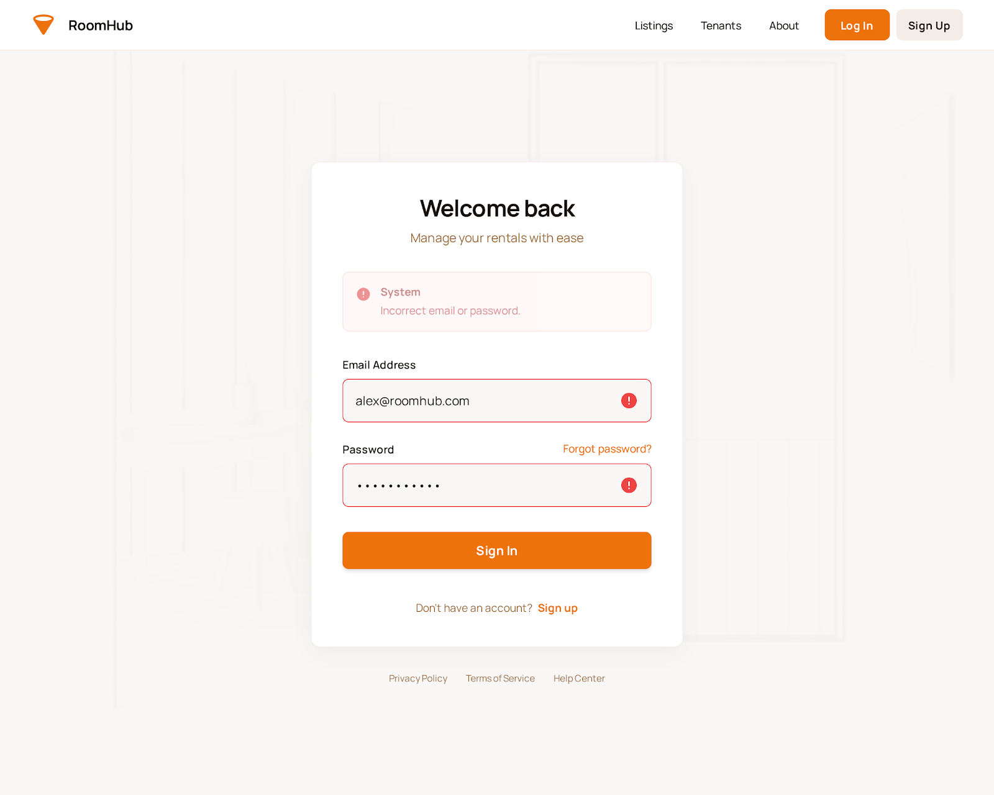

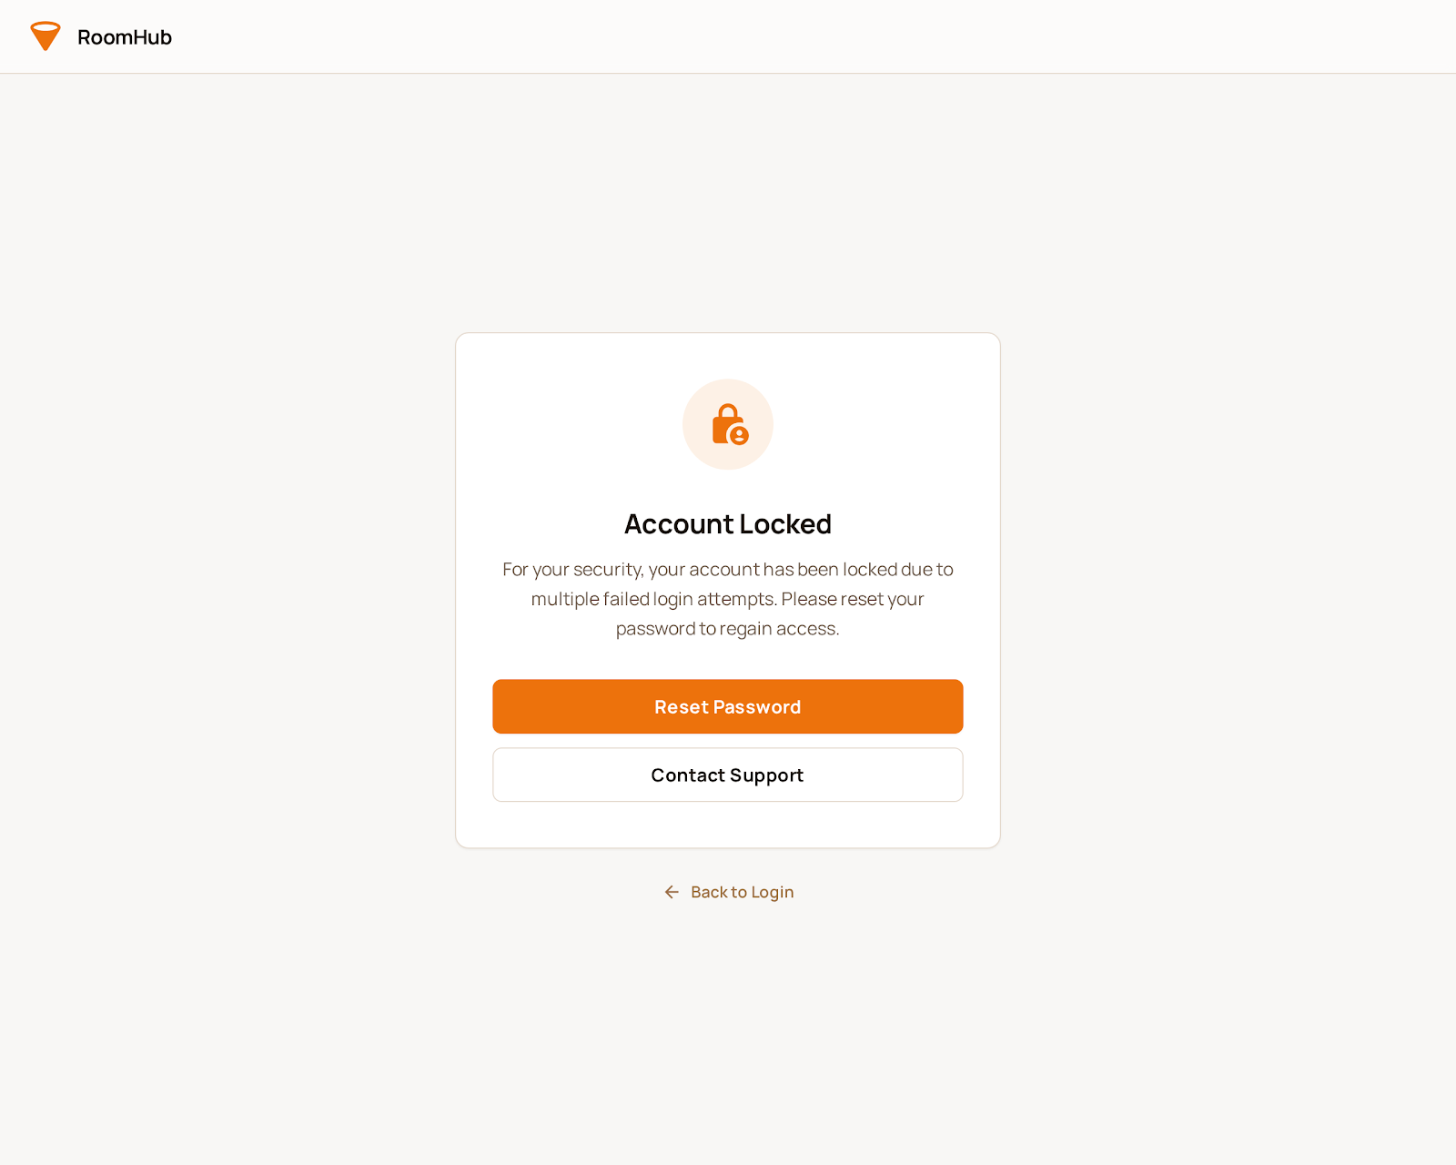





##### 3. UC-03: Verify User Identity (KYC)

**Functional Description Template**

| UC ID and Name: | UC-03: Verify User Identity (KYC) | | |
| --- | --- | --- | --- |
| Created By: | Do Thanh Tin | Date Created: | January 14, 2026 |
| Primary Actor: | Tenant, Owner | Secondary Actors: | AI Engine, System Administrator |
| Trigger: | The user initiates identity verification via the system. | | |
| Description: | Processes user identity verification through ID document upload and facial recognition handled by the AI Engine. | | |
| Preconditions: | - The user has a registered account.  - The system and AI Engine are operational.  - User has valid government-issued ID documents. | | |
| Postconditions: | - User identity is verified and status updated in the system.  - Verified users gain access to additional system functionalities.  - Verification results are securely stored. | | |
| Normal Flow: | 1. The user selects the “Verify Identity” function.  2. The system displays identity verification forms.  3. The user uploads required ID documents and captures a facial image.  4. The system sends documents and facial images to AI Engine.  5. AI Engine processes data and performs facial recognition.  6. System receives verification results.  7. System updates user status as Verified or Pending Verification.  8. The system notifies the user of the verification result. | | |
| Alternative Flows: | **A1 – Invalid ID document (Step 4):**  - System or AI Engine detects invalid or unreadable ID.  - The system requests the user to re-upload a valid ID.  **A2 – Facial recognition mismatch (Step 5):**  - AI Engine cannot match face with ID.  - System flags verification as failed and requests retry.  **A3 – Verification pending manual review (Step 6):**  - AI Engine cannot automatically verify identity.  - System marks verification as Pending and notifies Admin for review. | | |
| Exceptions: | - AI Engine unavailable or fails to process data.  - System error storing verification results.  - Network failure during upload or AI processing. | | |
| Priority: | High – Must Have | | |
| Frequency of Use: | Moderate; used during account setup or when KYC is required. | | |
| Business Rules: | - Users must complete KYC to access role-specific features.  - The system must securely store all uploaded documents and facial data.  - Manual review may be triggered if AI cannot verify identity automatically. | | |
| Other Information: | - KYC may be required periodically for compliance.  - AI Engine follows company-approved verification standards. | | |
| Assumptions: | - Users provide authentic ID documents.  - Users have devices capable of capturing facial images.  - Network connection is stable during upload and processing.  - AI Engine accuracy is sufficient for automated verification. | | |

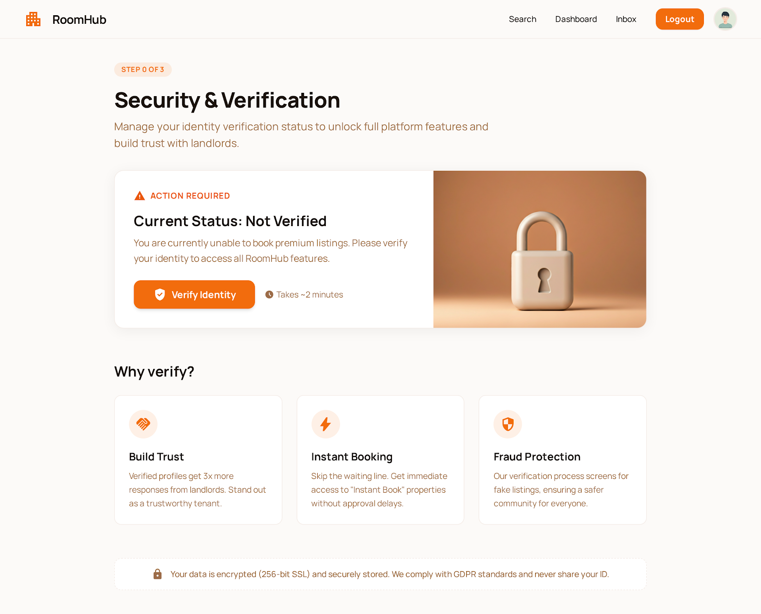

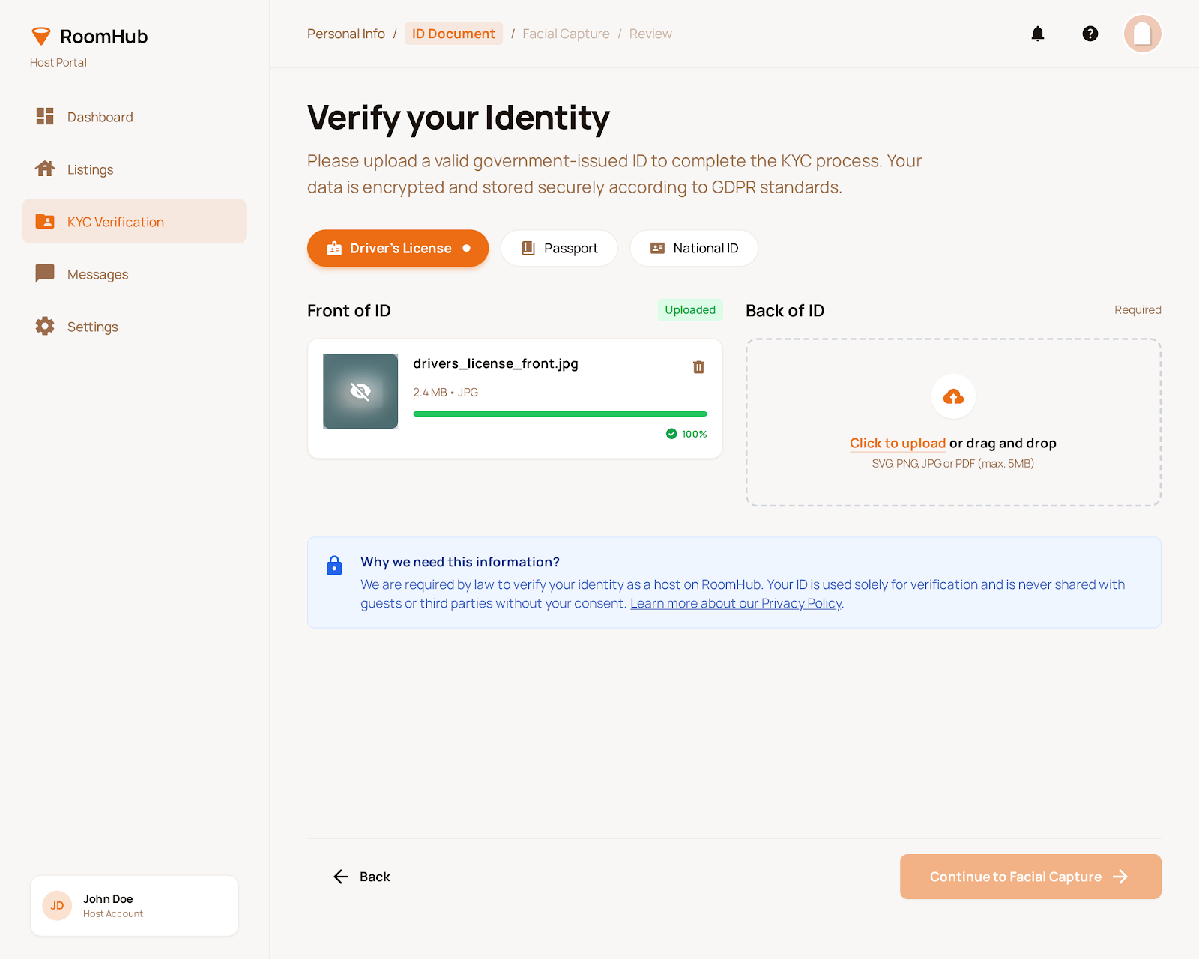

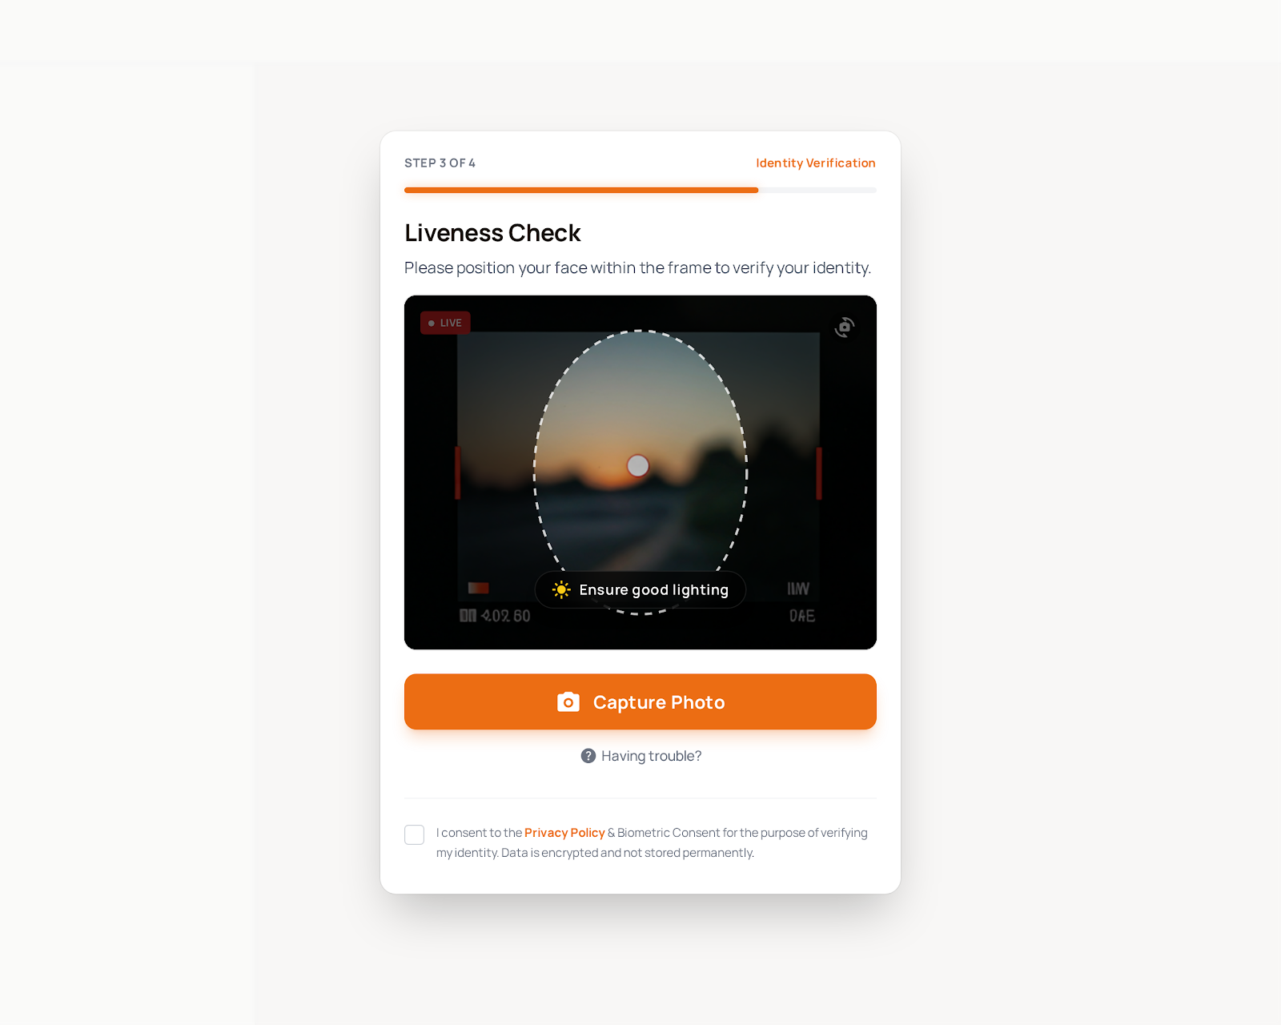

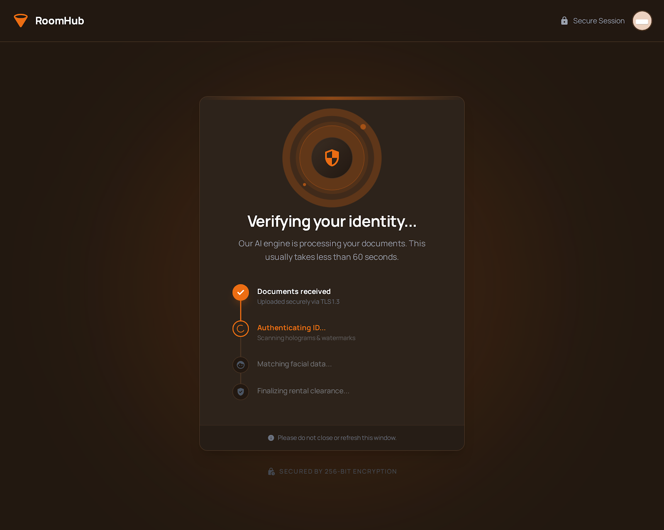

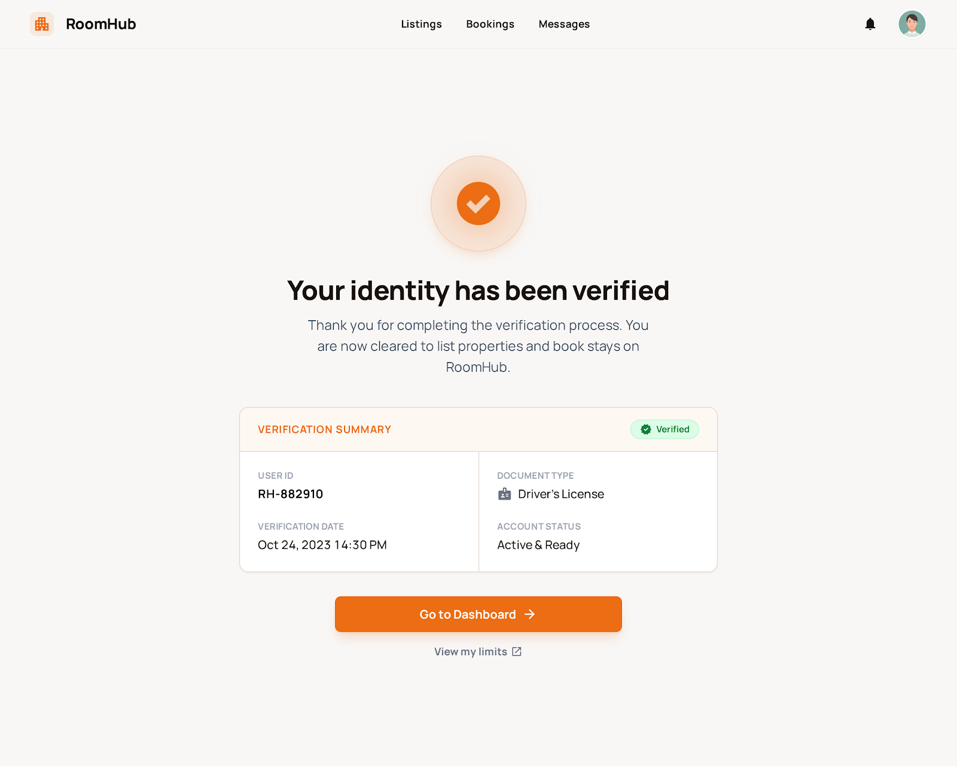

##### 4. UC-04: Manage User Profile Functional Description Template

| UC ID and Name: | UC-04: Manage User Profile | | |
| --- | --- | --- | --- |
| Created By: | Do Thanh Tin | Date Created: | January 14, 2026 |
| Primary Actor: | Tenant, Owner | Secondary Actors: | Authentication Service, System Administrator |
| Trigger: | User selects the “Manage Profile” function in the system. | | |
| Description: | Enables users to view and update personal information, contact details, and security settings. | | |
| Preconditions: | - User has a registered and authenticated account.  - System is operational. | | |
| Postconditions: | - User profile information is updated and stored securely.  - System reflects changes immediately for authorized features.  - Audit log records the profile update. | | |
| Normal Flow: | 1. User selects “Manage Profile”.  2. System displays current profile information.  3. User edits personal details, contact information, or security settings.  4. User submits changes.  5. System validates input data.  6. System updates profile information in the database.  7. System confirms successful update to the user. | | |
| Alternative Flows: | **A1 – Invalid input (Step 5):**  - System detects incorrect or missing information.  - System prompts user to correct data.  **A2 – Unauthorized changes (Step 4/5):**  - System detects user attempts to change restricted fields.  - System rejects the update and logs the attempt.  **A3 – Partial update failure (Step 6):**  - System encounters error updating some fields.  - System rolls back changes and notifies the user. | | |
| Exceptions: | - System database error.  - Network failure during submission.  - Authentication service unavailable. | | |
| Priority: | High – Must Have | | |
| Frequency of Use: | Frequent; users update profile occasionally or when required by system policies. | | |
| Business Rules: | - Users can update only authorized fields.  - All changes must be validated for format and completeness.  - Audit log must record every profile modification. | | |
| Other Information: | - Profile updates may trigger notifications for verification.  - System may enforce password or security updates periodically. | | |
| Assumptions: | - User provides accurate and valid information.  - System has sufficient security to protect personal data.  - User has access to required devices for updates. | | |

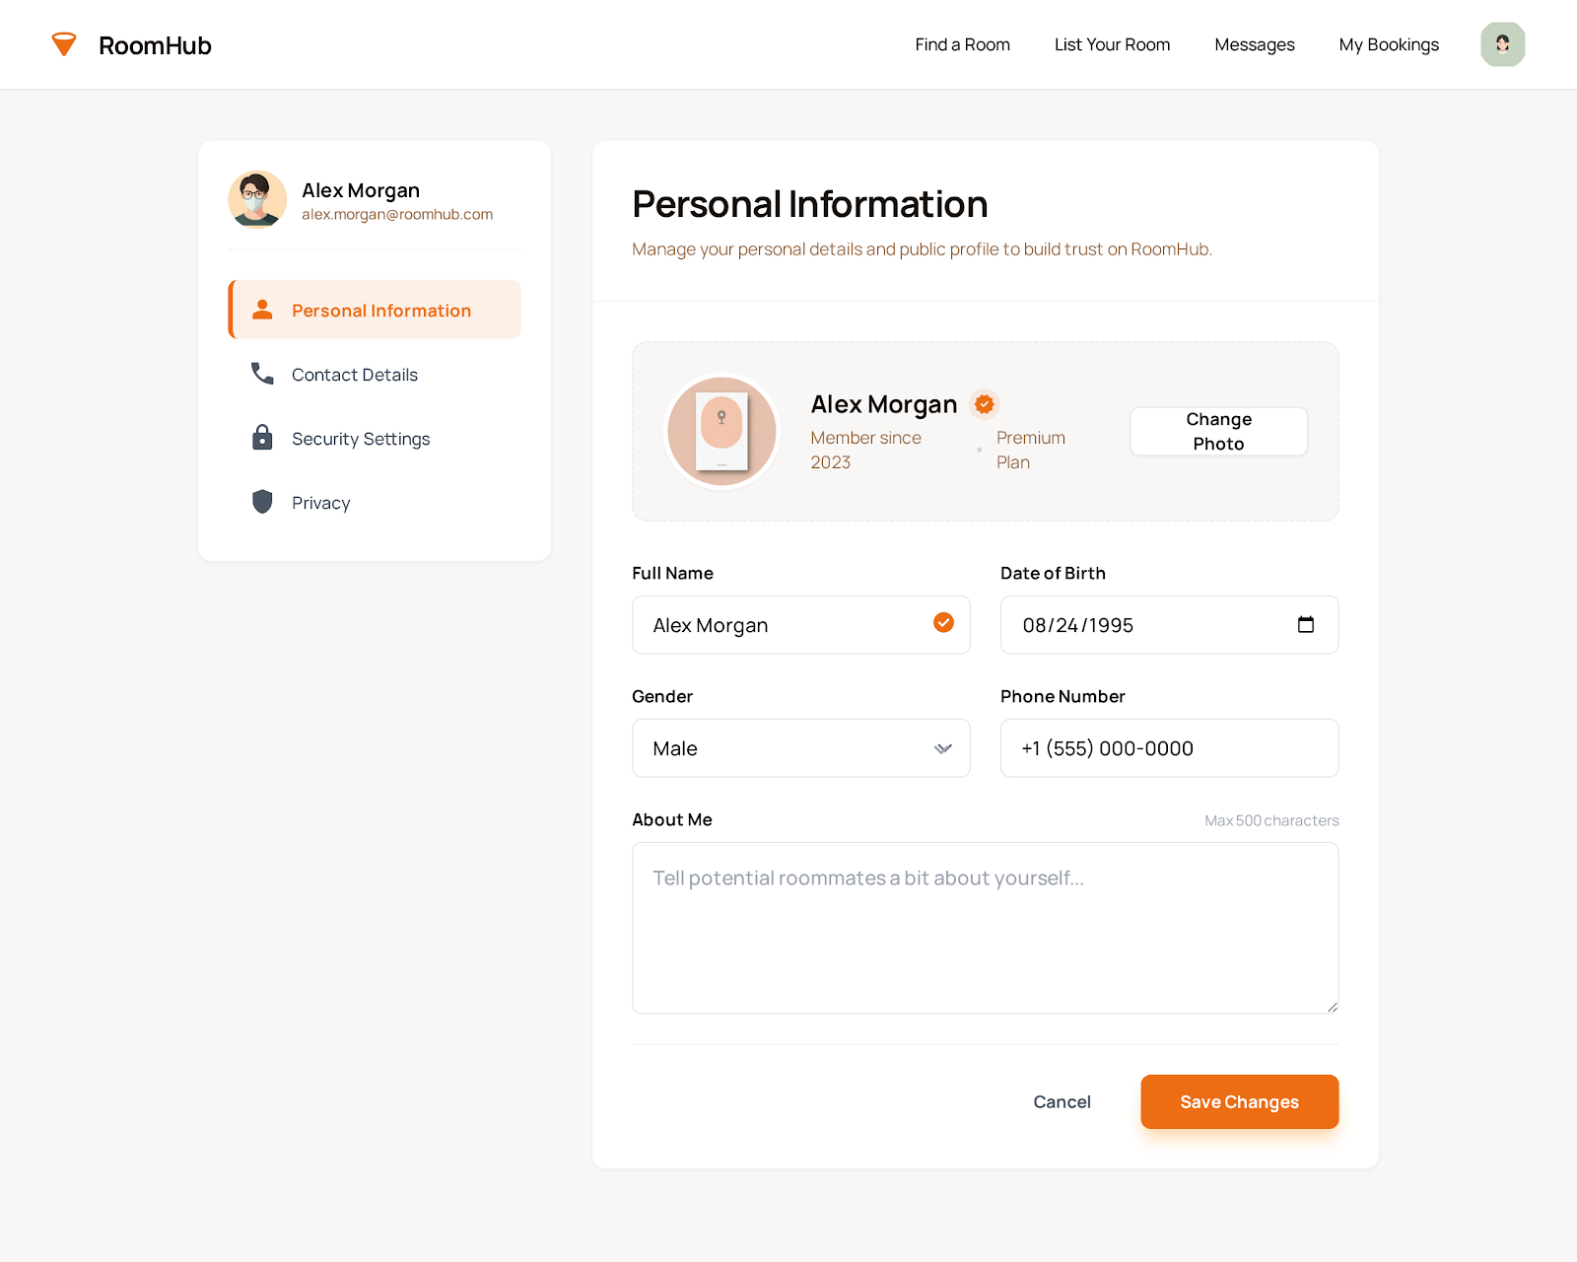

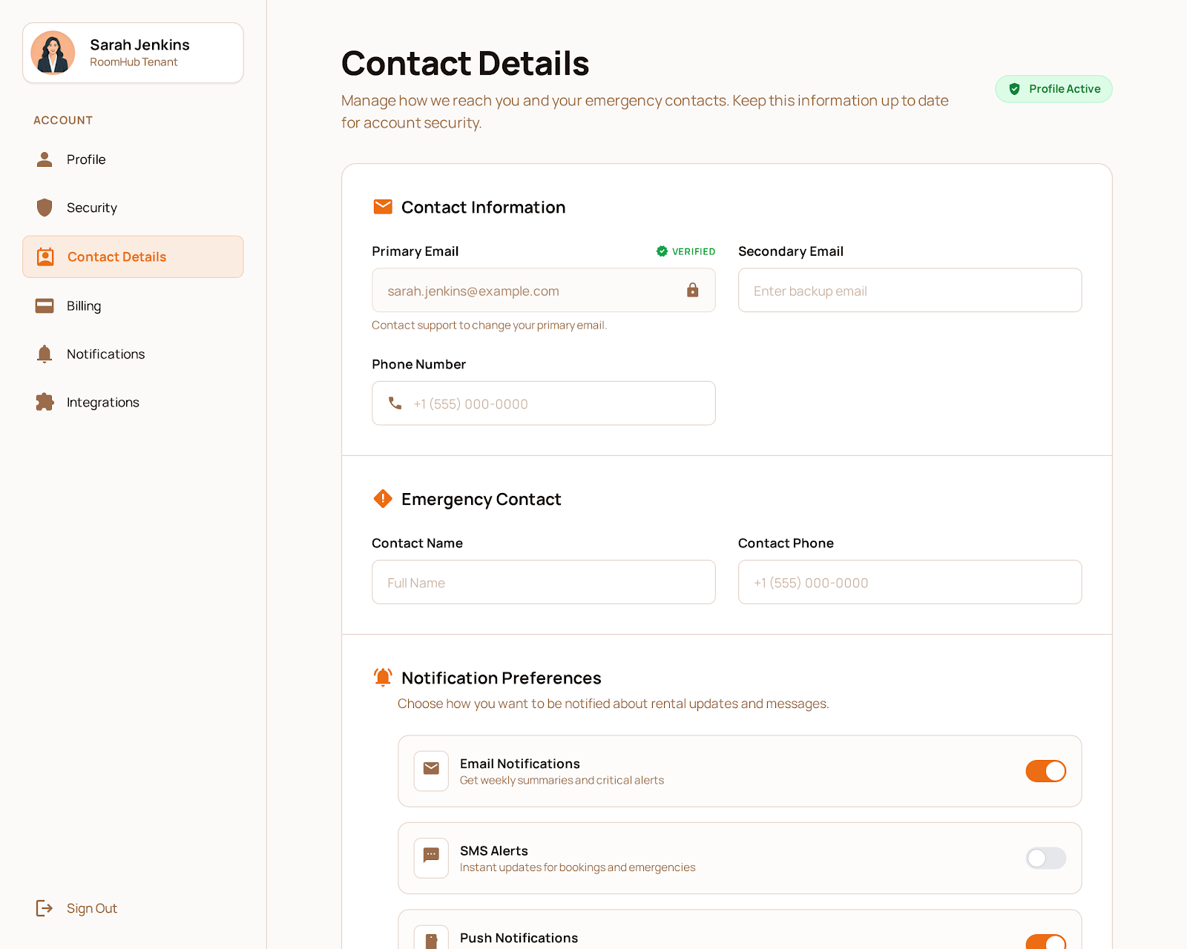

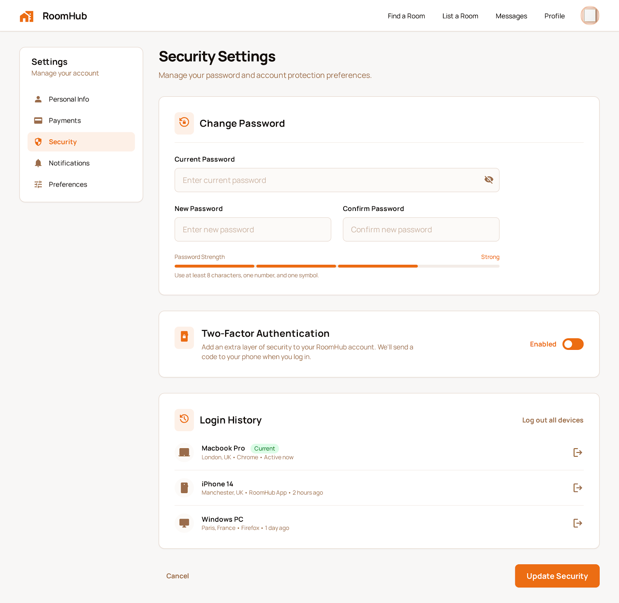





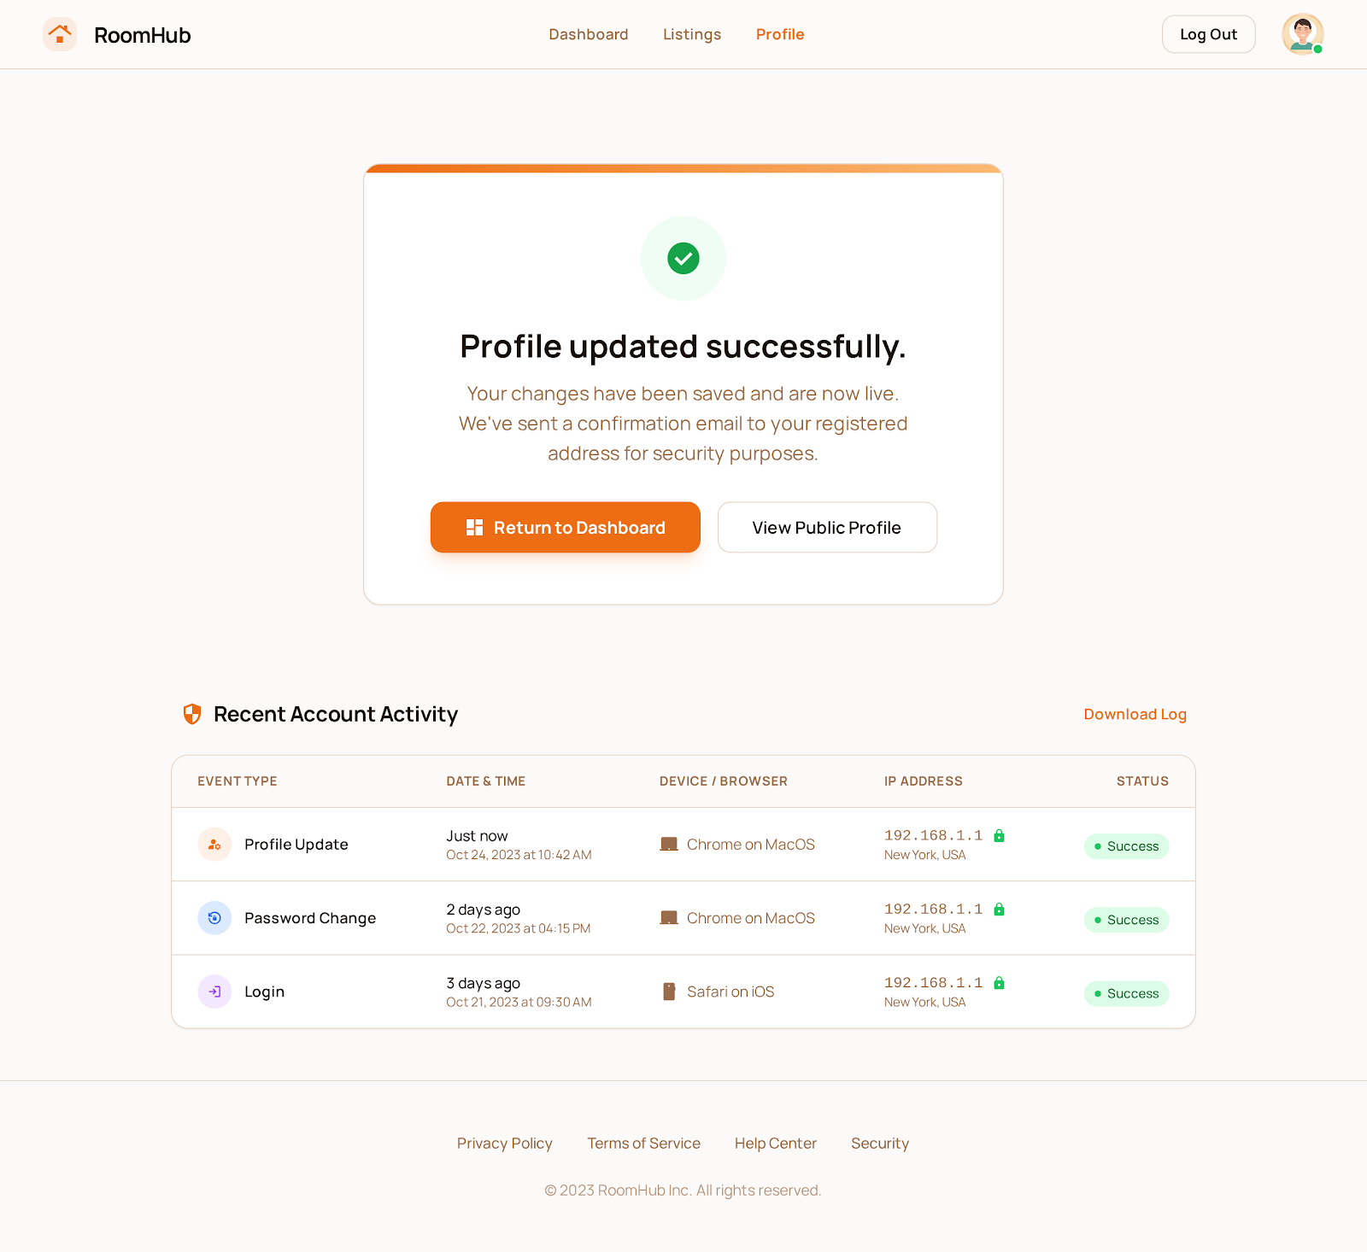

##### 5. UC-05: Manage User Accounts Functional Description Template

| UC ID and Name: | UC-05: Manage User Accounts | | |
| --- | --- | --- | --- |
| Created By: | Do Thanh Tin | Date Created: | January 14, 2026 |
| Primary Actor: | Administrator | Secondary Actors: | Authentication Service, KYC Verification Module |
| Trigger: | Administrator selects the “Manage User Accounts” function. | | |
| Description: | Allows the administrator to monitor user status, ban or unban accounts, and oversee KYC approval processes. | | |
| Preconditions: | - Administrator is authenticated and has proper privileges.  - System is operational.  - User accounts exist in the system. | | |
| Postconditions: | - User statuses are updated according to administrator actions.  - Banned accounts cannot access the system.  - KYC verification results are reviewed and approved/rejected.  - Audit log records all administrative actions. | | |
| Normal Flow: | 1. Administrator selects “Manage User Accounts”.  2. System displays a list of user accounts with status and KYC verification state.  3. Administrator reviews user accounts.  4. Administrator selects account(s) to ban/unban.  5. Administrator reviews pending KYC submissions.  6. Administrator approves or rejects KYC requests.  7. System updates user statuses and KYC results.  8. System confirms administrative actions. | | |
| Alternative Flows: | **A1 – Attempt to ban/unban unauthorized account (Step 4):**  - System detects insufficient privileges.  - System rejects action and notifies administrator.  **A2 – KYC verification requires manual review (Step 6):**  - System flags accounts that cannot be auto-verified.  - Administrator reviews flagged accounts and approves/rejects.  **A3 – Partial update failure (Step 7):**  - System encounters error updating some accounts.  - System rolls back affected changes and logs the issue. | | |
| Exceptions: | - System database error.  - Network failure during account update.  - Authentication or KYC service unavailable. | | |
| Priority: | High – Must Have | | |
| Frequency of Use: | Regular; performed as part of system administration and compliance monitoring. | | |
| Business Rules: | - Only administrators with proper privileges can manage accounts.  - Banned accounts cannot log in until unbanned.  - KYC must be approved before user gains full access.  - All administrative actions must be logged for audit purposes. | | |
| Other Information: | - Administrator actions may trigger notifications to users.  - System may enforce periodic review of user accounts for compliance. | | |
| Assumptions: | - Administrator is trained and authorized.  - System securely tracks all account and KYC changes.  - Network and services are operational during administrative tasks. | | |

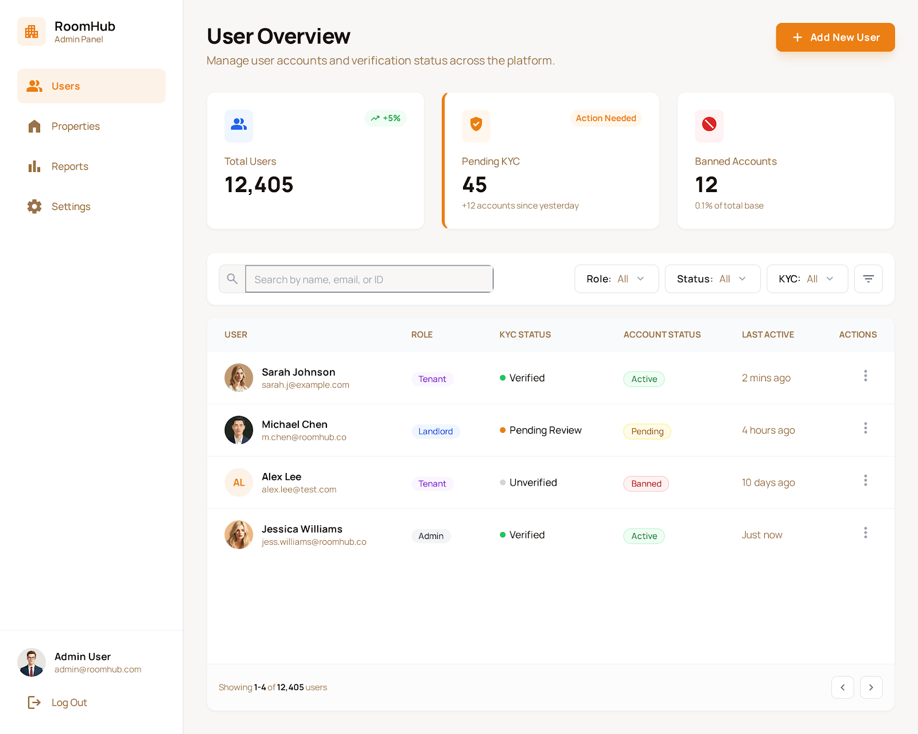

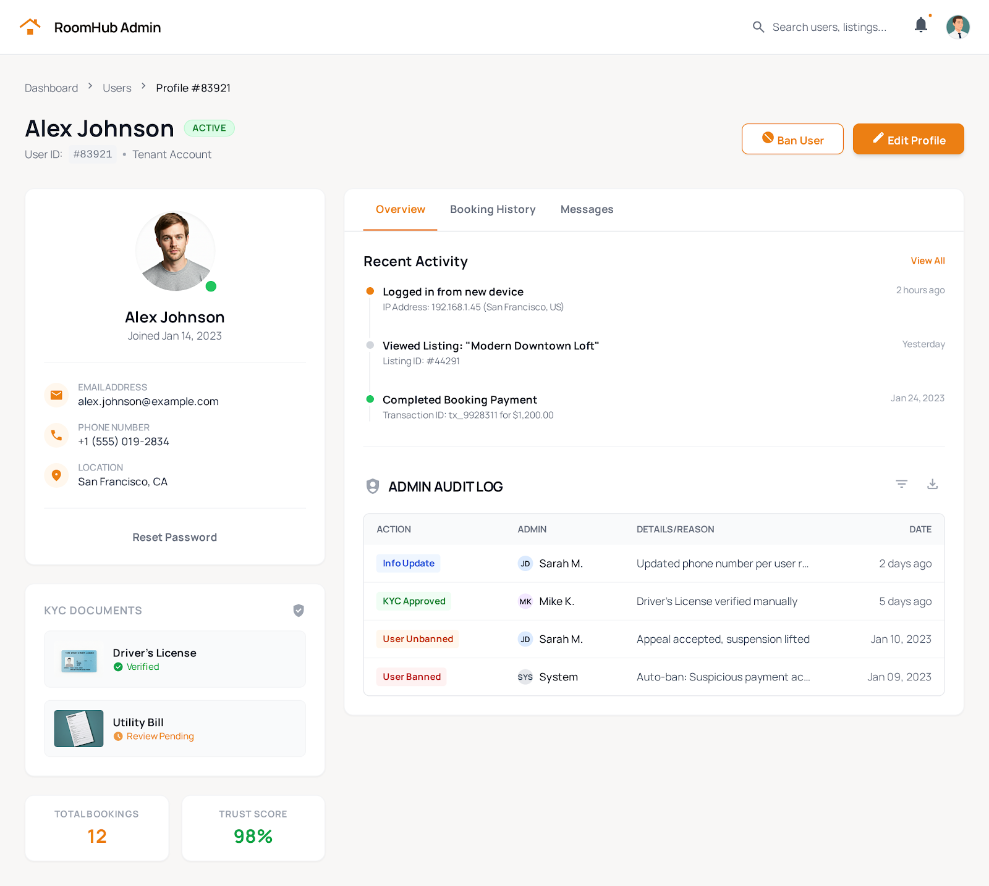



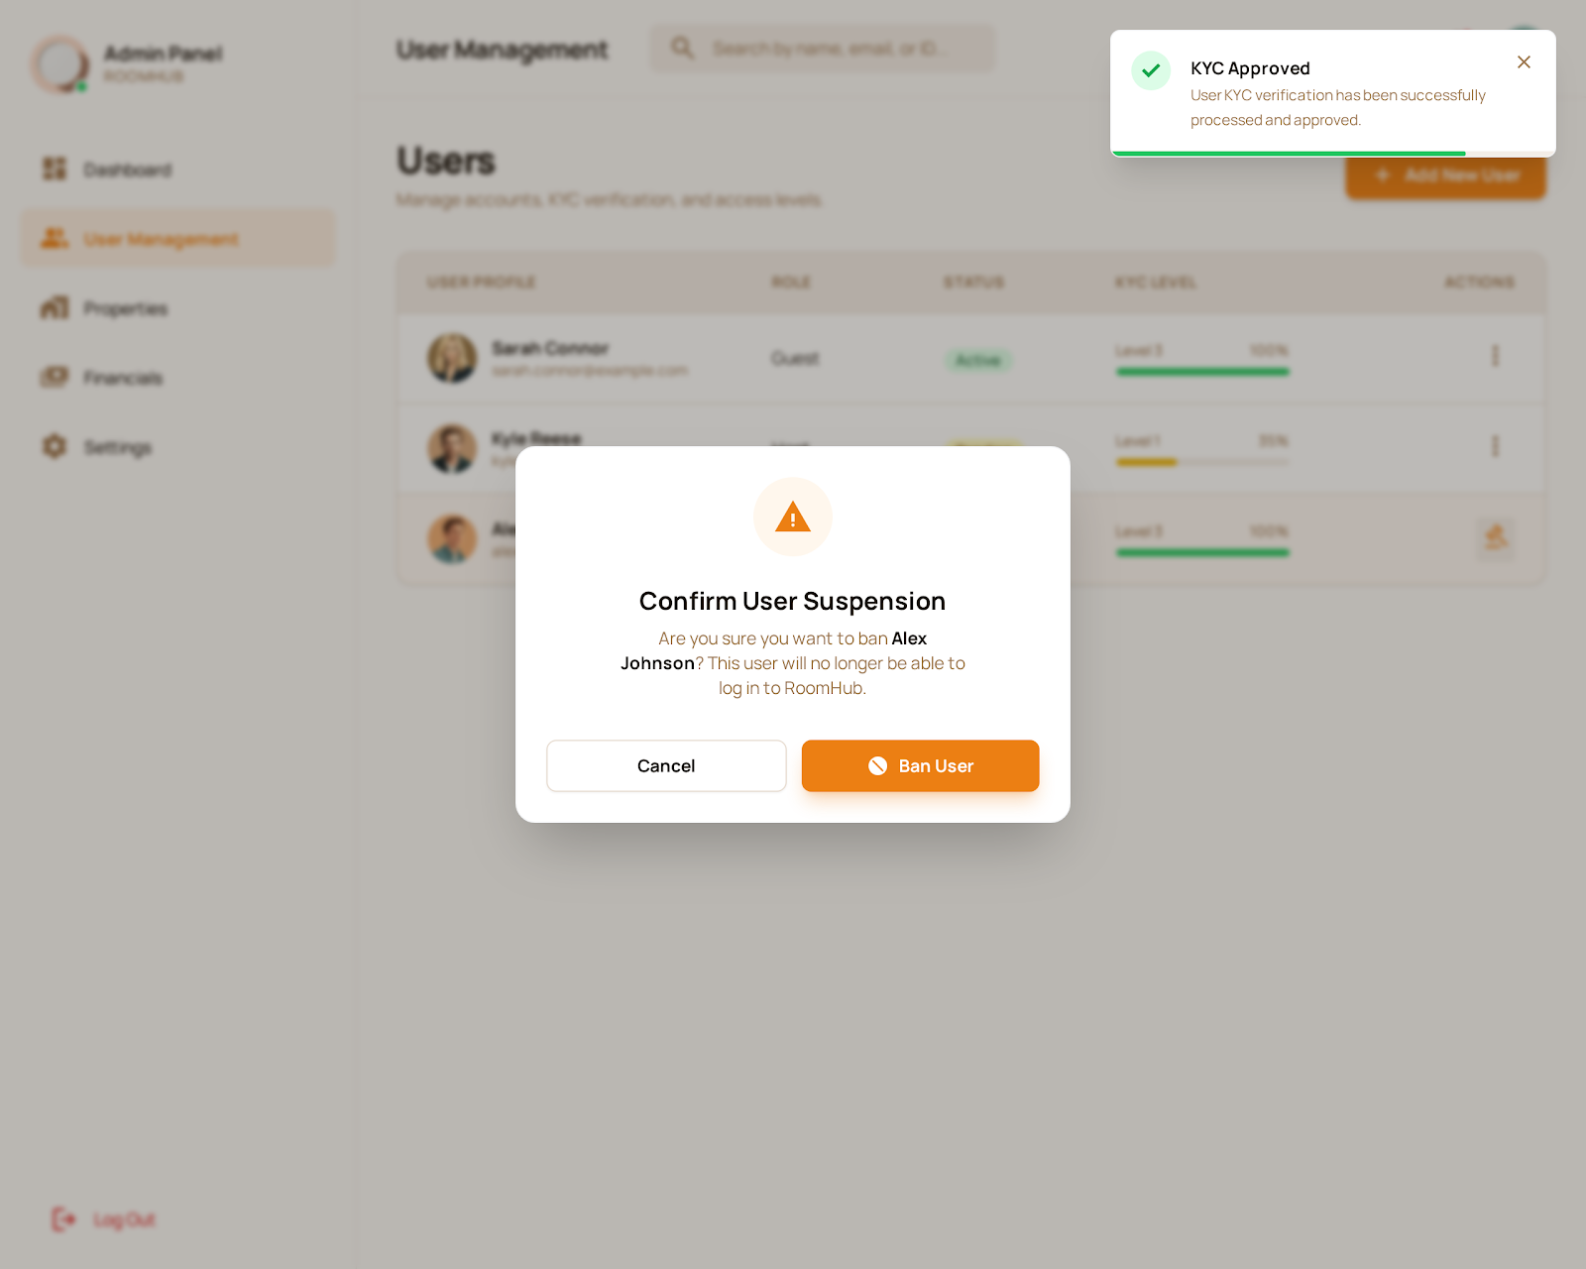

##### 6. UC-06: Manage Buildings & Floors Functional Description Template

| UC ID and Name: | UC-06: Manage Buildings & Floors | | |
| --- | --- | --- | --- |
| Created By: | Do Thanh Tin | Date Created: | January 14, 2026 |
| Primary Actor: | Property Owner | Secondary Actors: | System Administrator |
| Trigger: | Property Owner selects the “Manage Buildings & Floors” function. | | |
| Description: | Enables Property Owners to define and manage the physical structure of their properties, including creating buildings and floor layouts. | | |
| Preconditions: | - Property Owner has a registered and authenticated account.  - System is operational.  - Property Owner has at least one property registered in the system. | | |
| Postconditions: | - Buildings and floors are created and stored in the system.  - Floor layouts are associated with the correct building.  - System reflects updates in property management views. | | |
| Normal Flow: | 1. Property Owner selects “Manage Buildings & Floors”.  2. System displays existing buildings and floors for the owner’s properties.  3. Property Owner selects to add, edit, or delete a building.  4. Property Owner adds floor layouts to the selected building.  5. System validates the structure and layout data.  6. System updates the building and floor information in the database.  7. System confirms successful update to the Property Owner. | | |
| Alternative Flows: | **A1 – Invalid layout input (Step 5):**  - System detects missing or inconsistent floor information.  - System prompts Property Owner to correct the input.  **A2 – Duplicate building name (Step 4):**  - System detects building name conflict.  - System requests a unique name before creating the building.  **A3 – Delete building with associated floors (Step 3):**  - System warns Property Owner about associated floors.  - Property Owner confirms deletion, or cancels the action. | | |
| Exceptions: | - System database error.  - Network failure during building/floor update.  - Unauthorized access attempt by non-owner. | | |
| Priority: | High – Must Have | | |
| Frequency of Use: | Moderate; performed when adding or modifying properties. | | |
| Business Rules: | - Each building must have a unique name within a property.  - Floors must be associated with a valid building.  - Only property owners with proper privileges can manage buildings and floors. | | |
| Other Information: | - System may enforce naming conventions or floor numbering standards.  - Changes to building/floor structures may impact tenant assignments or listings. | | |
| Assumptions: | - Property Owner provides accurate building and floor information.  - System securely stores all building and floor data.  - Owner understands property structure requirements. | | |

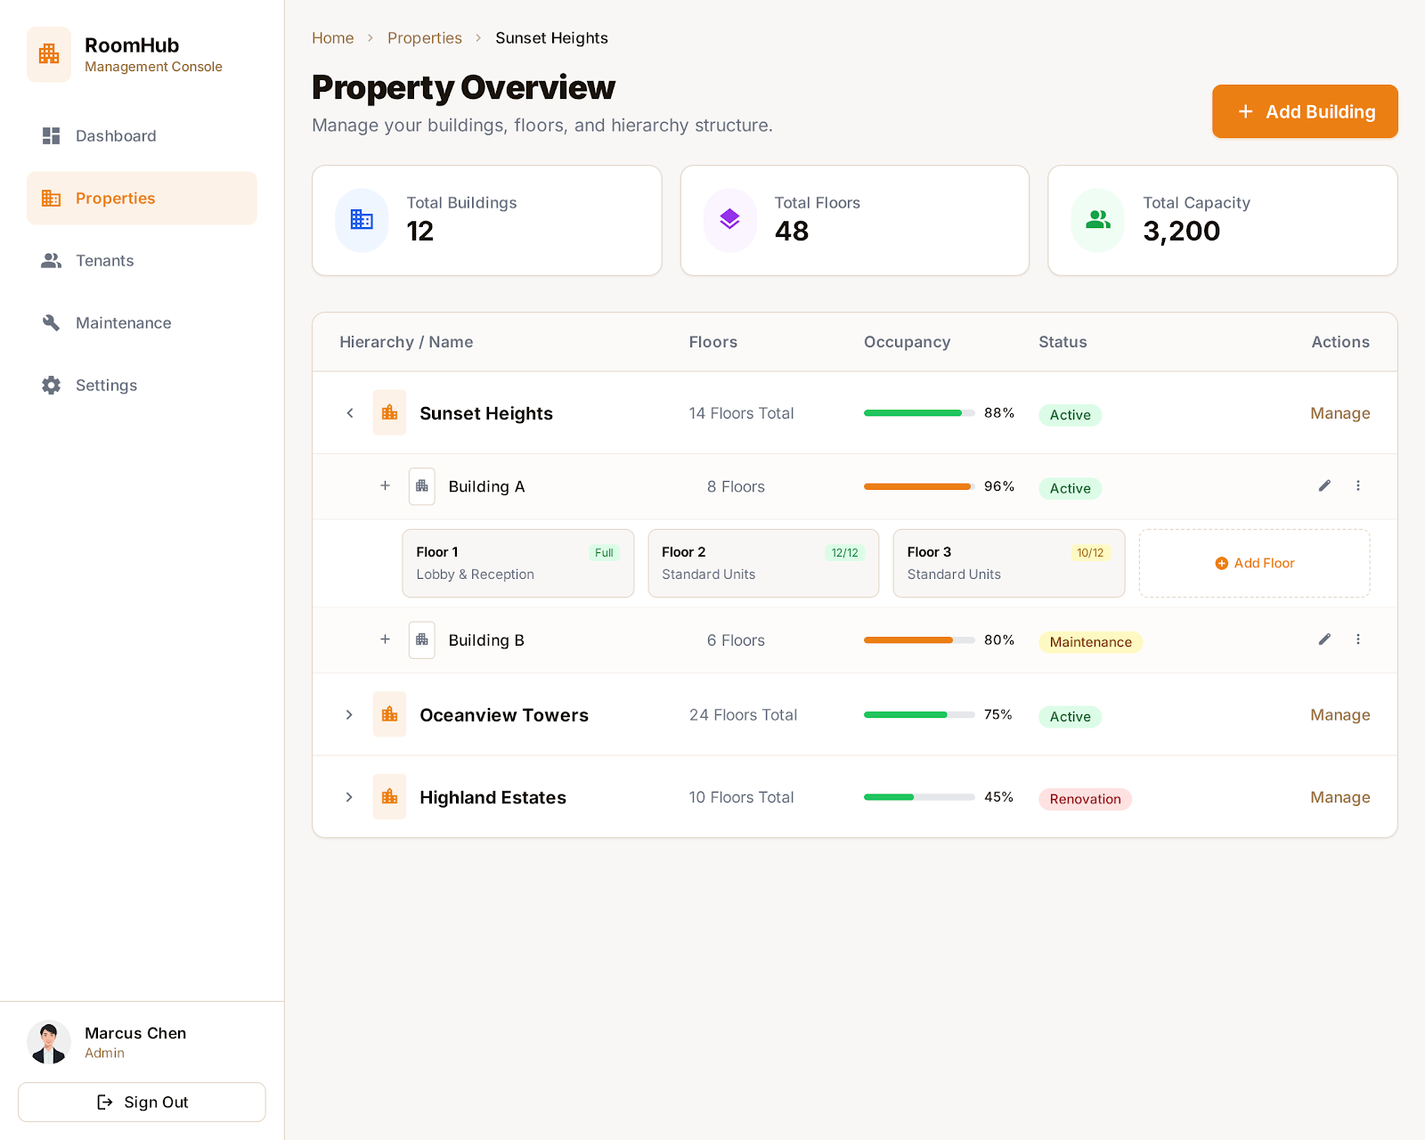

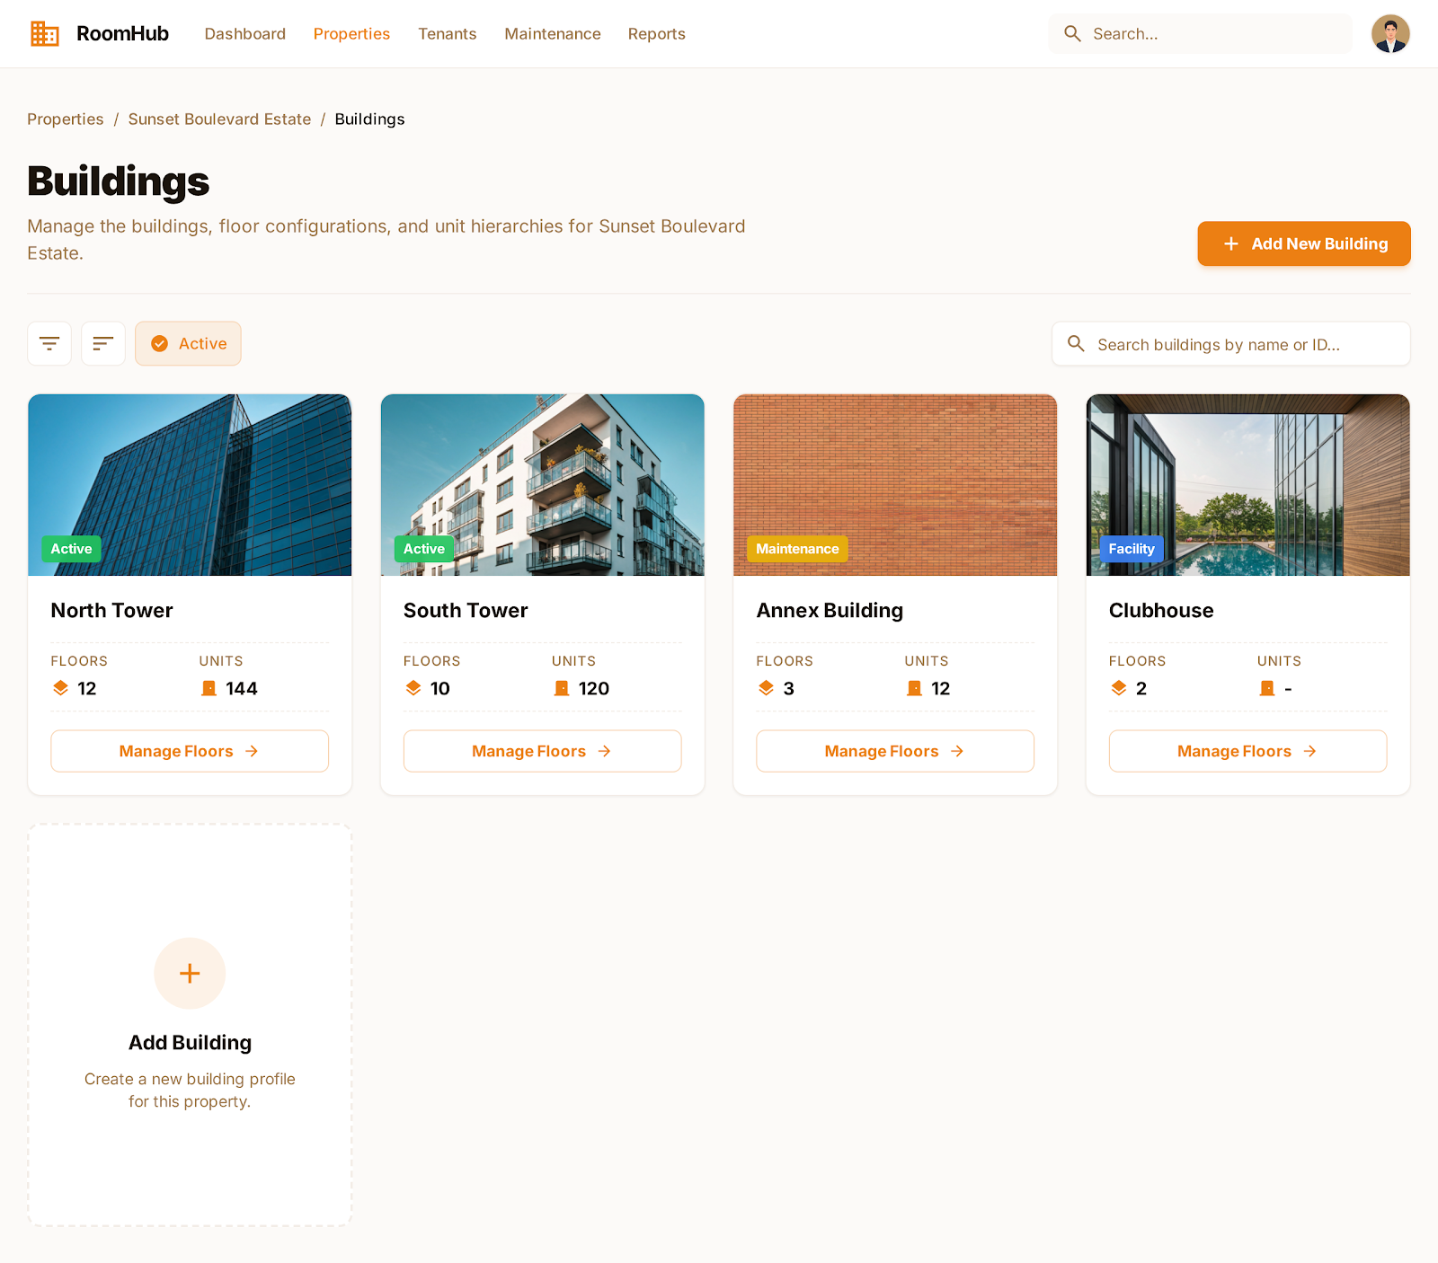

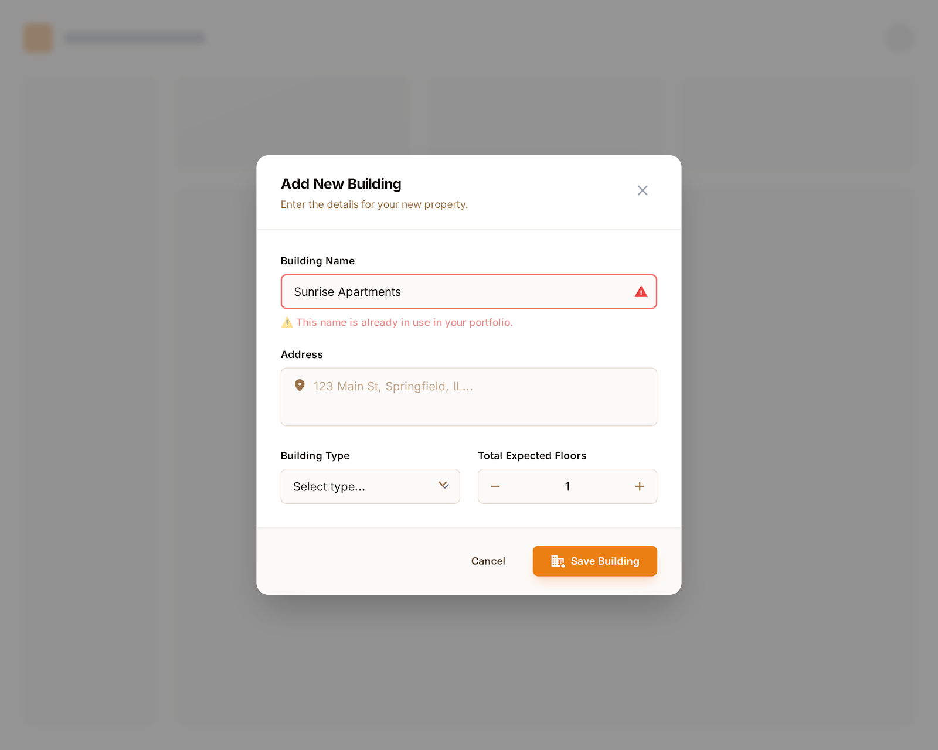

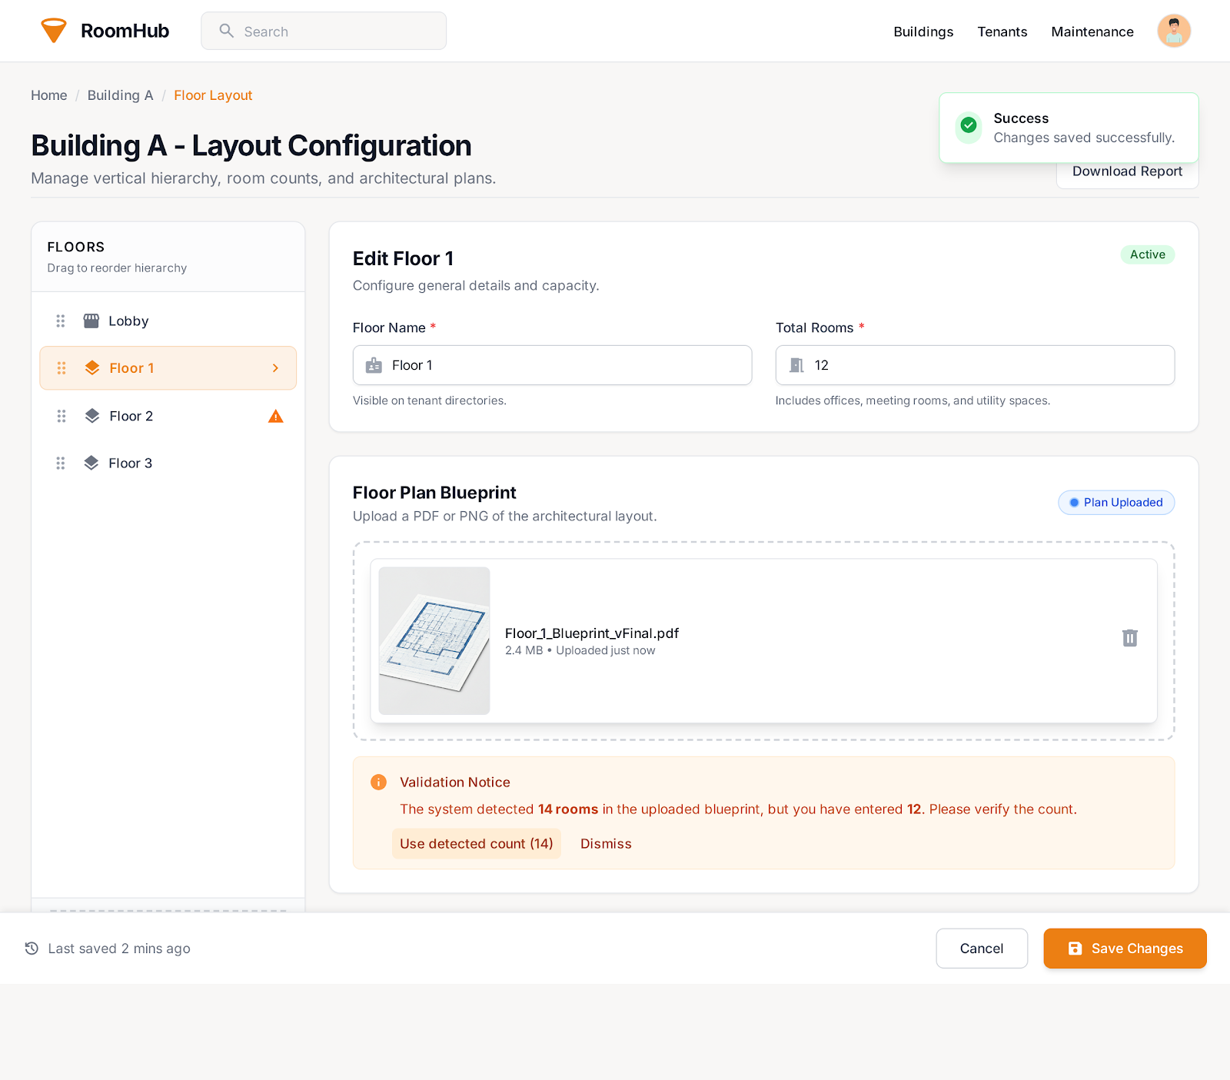



##### 7. UC-07: Manage Room Configuration

**Functional Description Template**

| UC ID and Name: | UC-07: Manage Room Configuration | | |
| --- | --- | --- | --- |
| Created By: | Do Thanh Tin | Date Created: | January 14, 2026 |
| Primary Actor: | Property Owner | Secondary Actors: | System Administrator, Media Storage Service |
| Trigger: | Property Owner selects the “Manage Room Configuration” function. | | |
| Description: | Allows Property Owners to configure room-specific details, including capacity, amenities, base price, and photos. | | |
| Preconditions: | - Property Owner has a registered and authenticated account.  - Property and building information already exist in the system.  - System is operational. | | |
| Postconditions: | - Room information is updated and stored in the system.  - Photos and amenities are linked to the room correctly.  - System reflects updated room configuration in listings and management views. | | |
| Normal Flow: | 1. Property Owner selects “Manage Room Configuration”.  2. System displays existing rooms and their configurations.  3. Property Owner selects a room to add, edit, or delete.  4. Property Owner updates room details: capacity, amenities, base price, and photos.  5. System validates the entered data.  6. System updates room information in the database.  7. System confirms successful update to the Property Owner. | | |
| Alternative Flows: | **A1 – Invalid input (Step 5):**  - System detects missing or invalid room information.  - System prompts Property Owner to correct the data.  **A2 – Duplicate room identifier (Step 4):**  - System detects a room with the same identifier already exists.  - System requests a unique room identifier.  **A3 – Photo upload failure (Step 4/5):**  - System encounters an error storing photos.  - System notifies Property Owner and allows retry or skip. | | |
| Exceptions: | - System database error.  - Network failure during update.  - Unauthorized access by non-owner. | | |
| Priority: | High – Must Have | | |
| Frequency of Use: | Moderate; performed when configuring rooms or updating amenities and pricing. | | |
| Business Rules: | - Room identifiers must be unique within a building.  - Base price must be numeric and positive.  - Only authorized property owners can manage room configurations.  - Photos must meet system format and size requirements. | | |
| Other Information: | - Room configuration changes may affect availability and booking information.  - System may enforce minimum and maximum capacity constraints. | | |
| Assumptions: | - Property Owner provides accurate room details.  - Photos are properly formatted and suitable for display.  - Network and system services are operational during updates. | | |

##### 

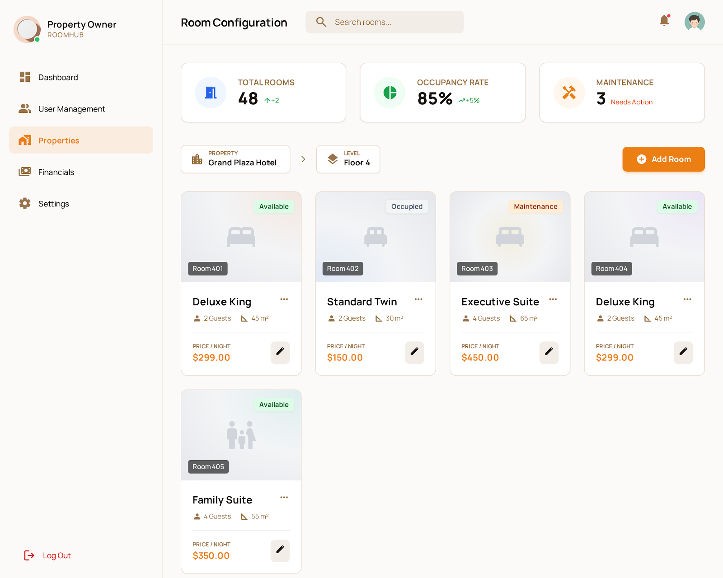

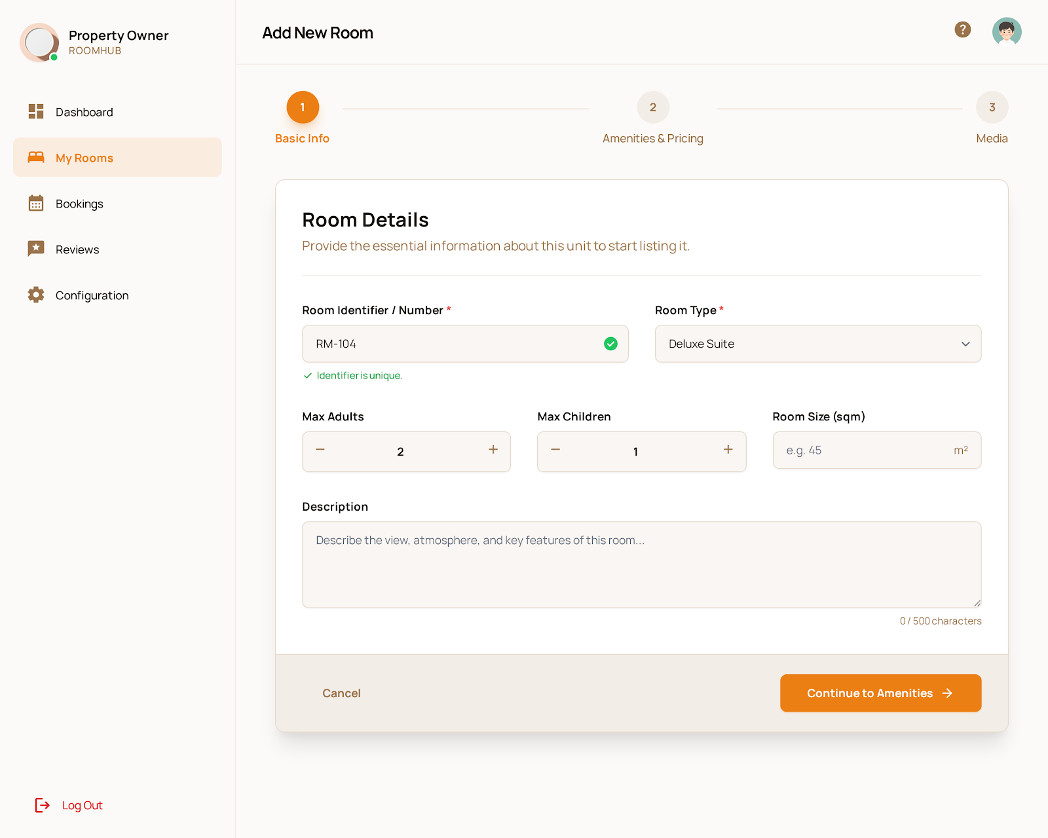

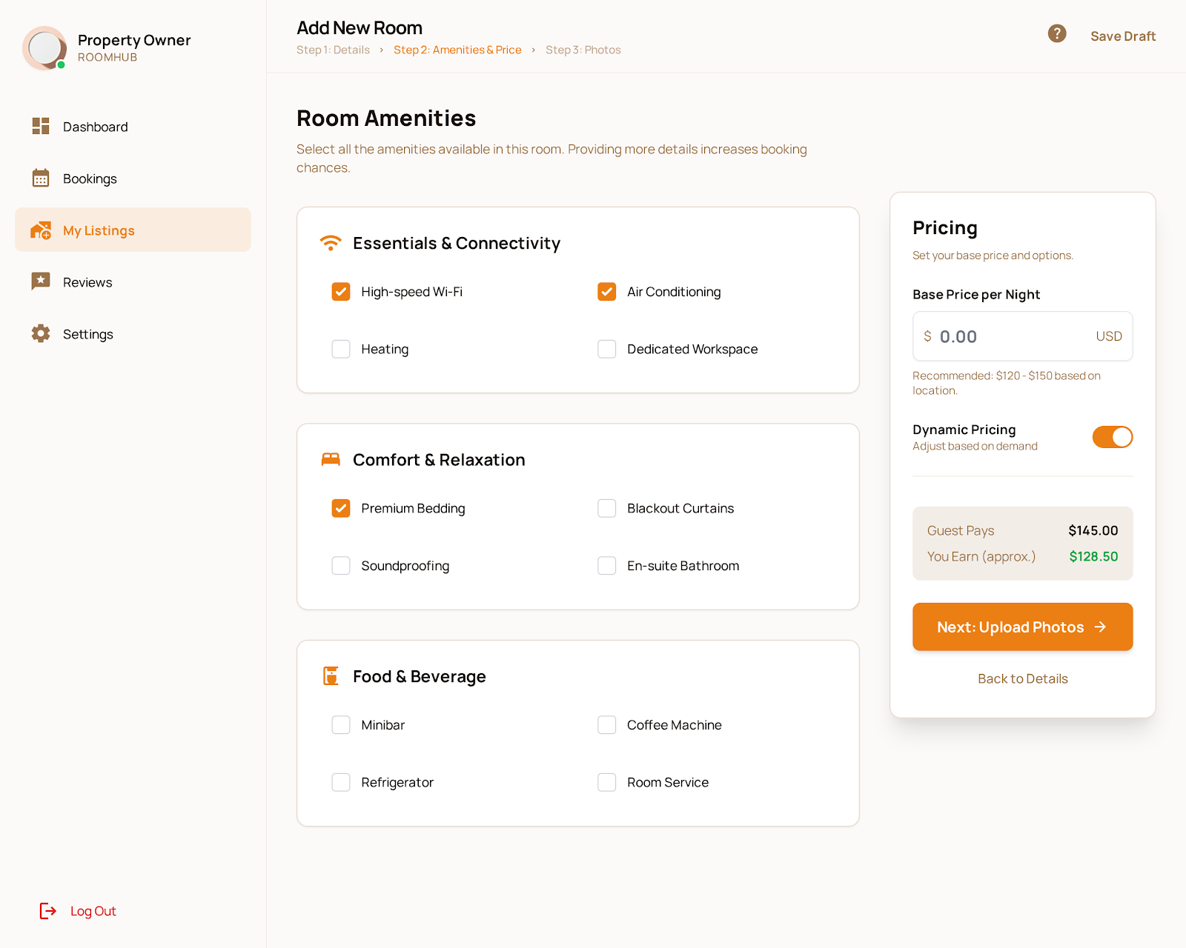

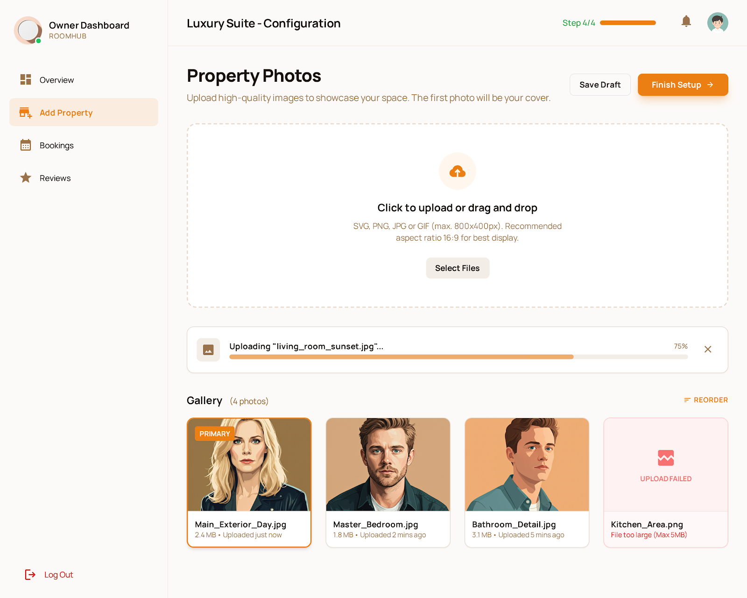

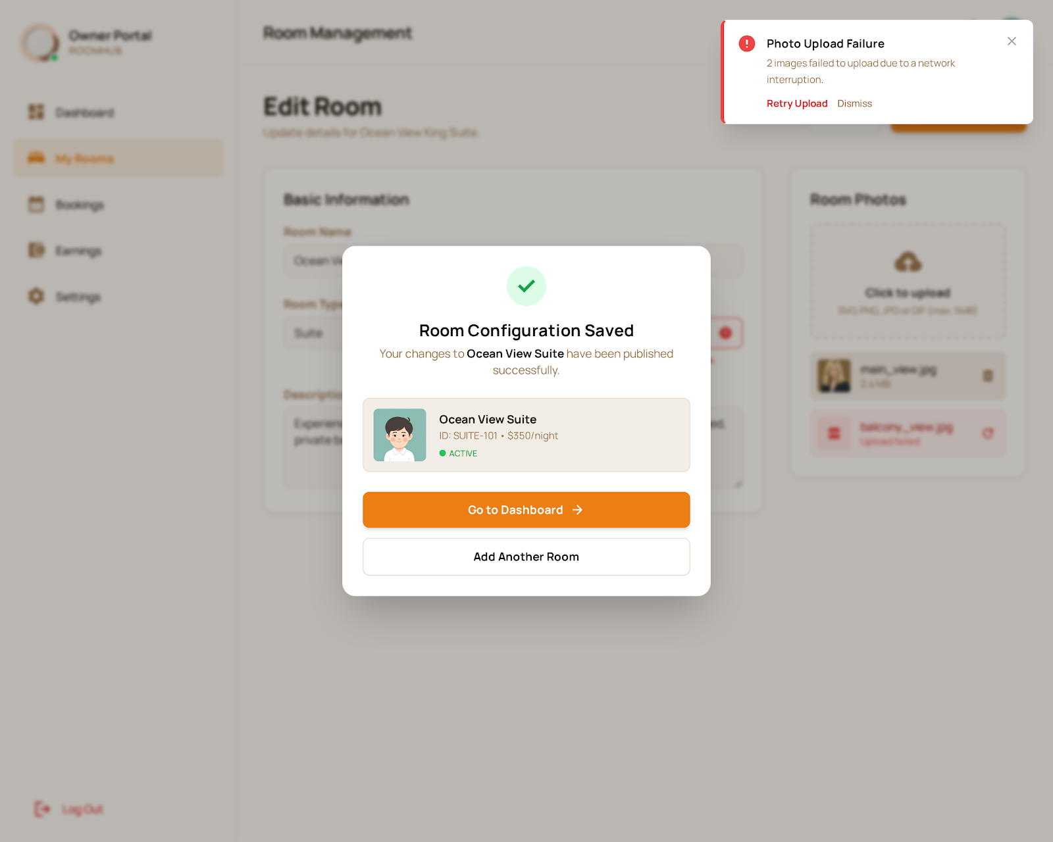

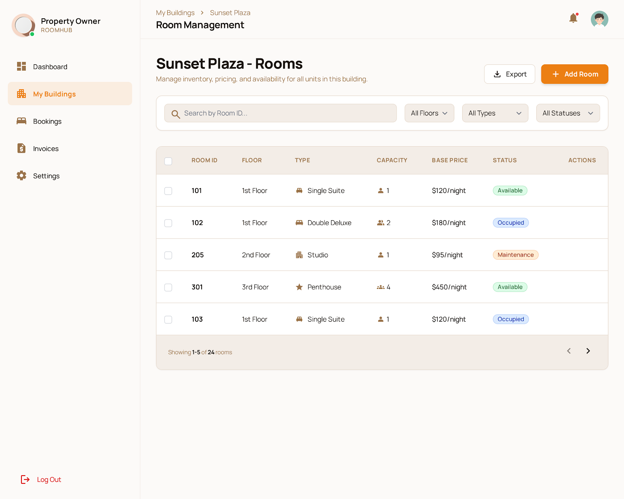

##### 8. UC-08: Update Room Status

**Functional Description Template**

| UC ID and Name: | UC-08: Update Room Status | | |
| --- | --- | --- | --- |
| Created By: | Do Thanh Tin | Date Created: | January 14, 2026 |
| Primary Actor: | Property Owner | Secondary Actors: | System, Booking Engine, Maintenance Module |
| Trigger: | Property Owner manually updates room status or system triggers an automatic status change. | | |
| Description: | Allows Property Owners to update the lifecycle status of a room (e.g., Available, Maintenance, Occupied) either manually or automatically based on system events. | | |
| Preconditions: | - Property Owner has a registered and authenticated account.  - Rooms have been created and configured in the system.  - System and relevant modules are operational. | | |
| Postconditions: | - Room status is updated in the system.  - Status changes are reflected in availability views and booking modules.  - Audit log records the status change. | | |
| Normal Flow: | 1. Property Owner selects “Update Room Status”.  2. System displays current status of all rooms.  3. Property Owner selects a room to update.  4. Property Owner chooses new status (Available, Occupied, Maintenance, etc.).  5. System validates the new status.  6. System updates the room status in the database.  7. System confirms the status update to the Property Owner.  8. System triggers notifications to relevant modules (e.g., booking engine). | | |
| Alternative Flows: | **A1 – Invalid status transition (Step 5):**  - System detects an invalid status change (e.g., from Occupied directly to Available).  - System prompts Property Owner to correct the status.  **A2 – Automatic update failure (Step 6/8):**  - System fails to update room status automatically due to module error.  - System logs the error and notifies administrator. | | |
| Exceptions: | - System database error.  - Network failure during update.  - Unauthorized access by non-owner. | | |
| Priority: | High – Must Have | | |
| Frequency of Use: | Frequent; performed daily or triggered automatically by system events. | | |
| Business Rules: | - Only authorized Property Owners can update room status.  - Room status must follow allowed lifecycle transitions.  - Status updates must be logged for auditing. | | |
| Other Information: | - Status changes may affect availability for tenants and booking modules.  - System may integrate with IoT sensors for automatic status updates. | | |
| Assumptions: | - Property Owner has accurate knowledge of room condition.  - System notifications are reliable.  - Automatic triggers are configured correctly. | | |

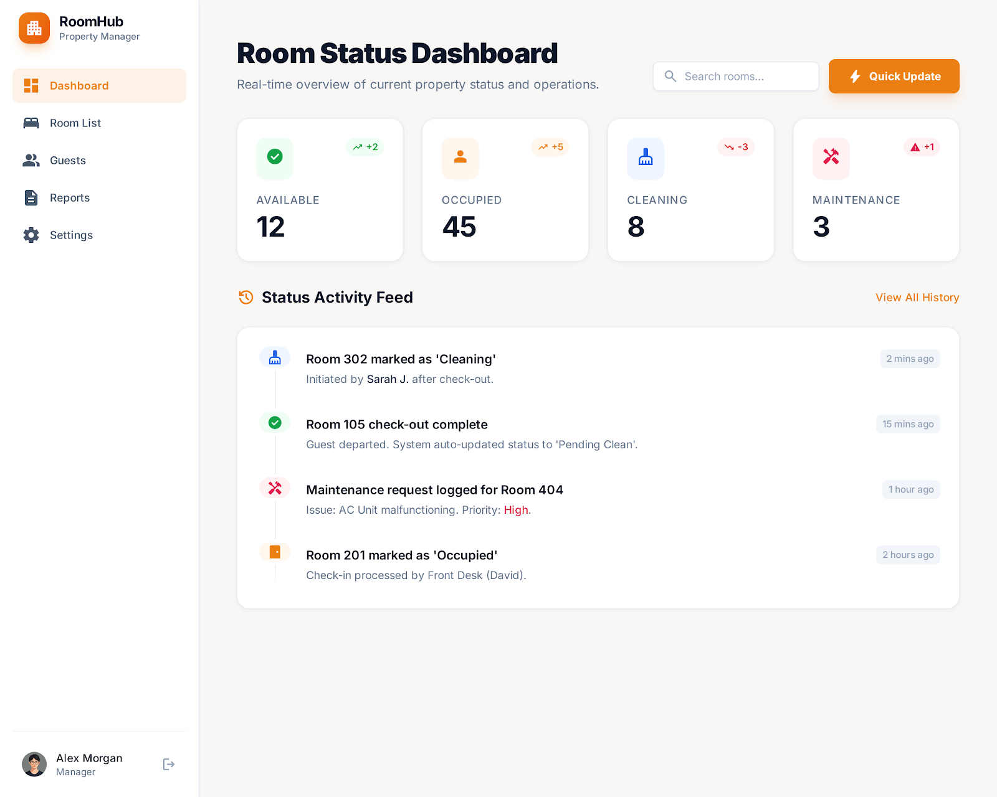

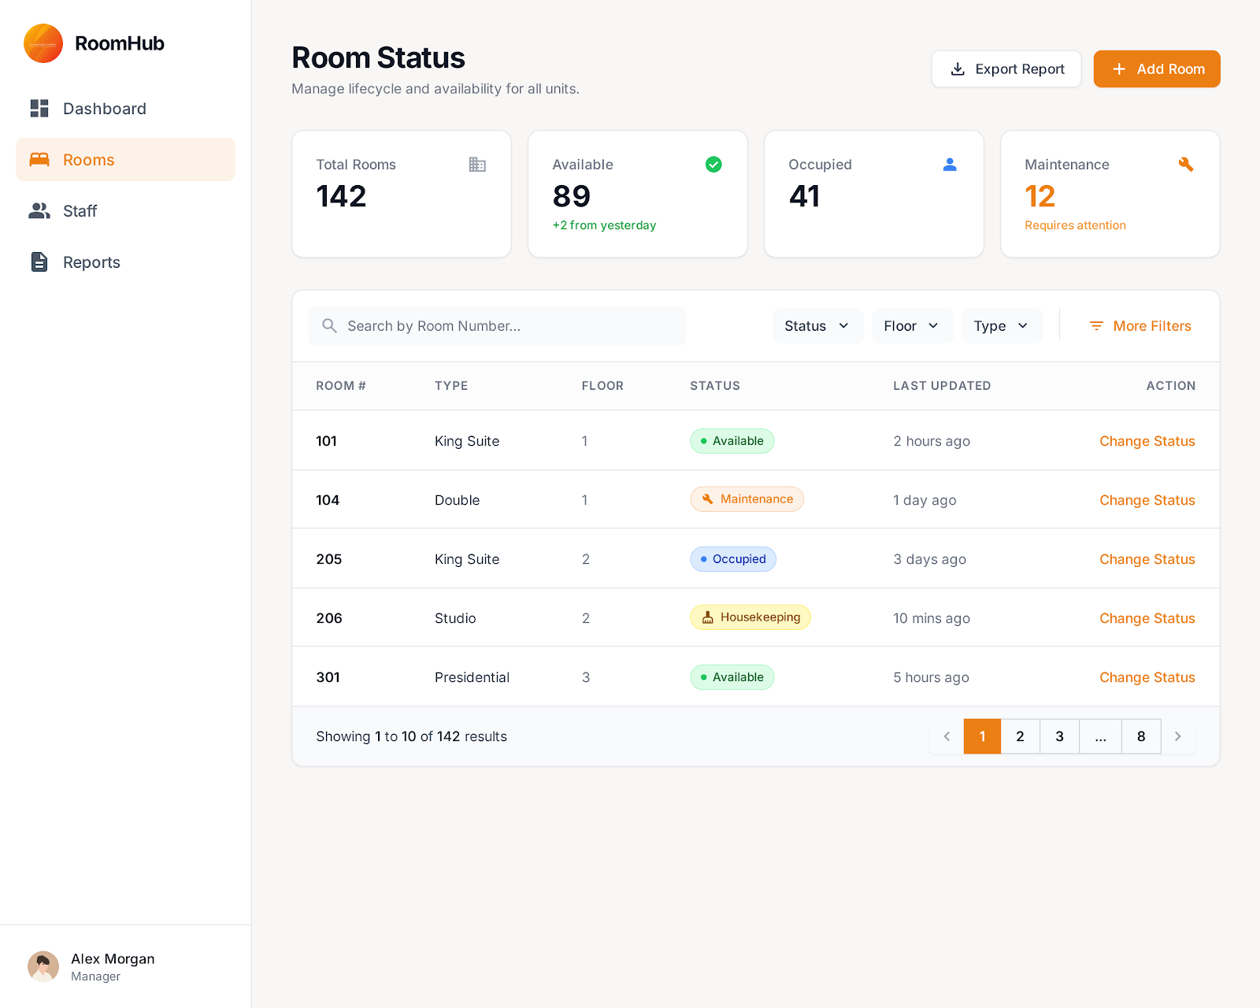

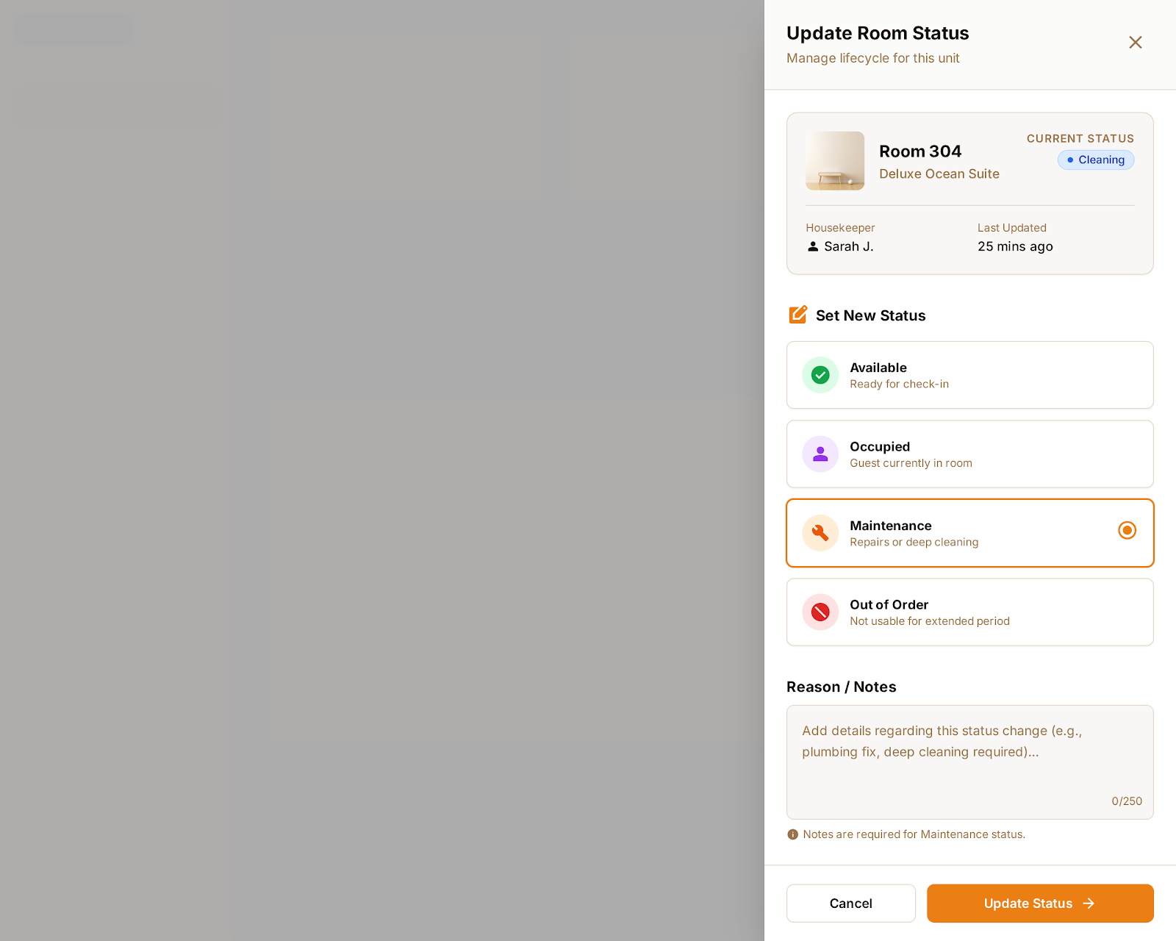

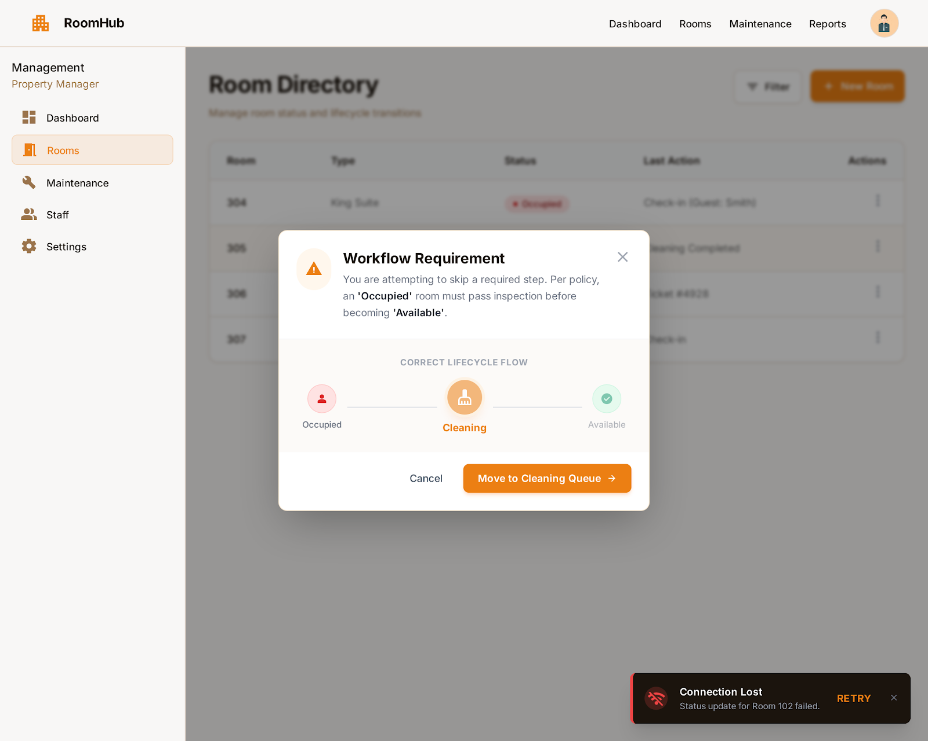

##### 9. UC-09: Get Dynamic Price Suggestion

**Functional Description Template**

| UC ID and Name: | UC-09 – Get Dynamic Price Suggestion | | |
| --- | --- | --- | --- |
| Created By: | Nguyen Hong An | Date Created: | January 14, 2026 |
| Primary Actor: | Property Owner | Secondary Actors: | AI Engine, Market Data Service, System |
| Trigger: | Property Owner requests a price suggestion for a room or updates room information. | | |
| Description: | The system uses AI to analyze market data, demand trends, room features, and historical rental data to suggest an optimal rental price range to the property owner. | | |
| Preconditions: | - Property Owner is logged in.  - Room information (location, size, type, amenities) is available.  - Market and historical data sources are accessible. | | |
| Postconditions: | - A suggested price range and recommended price are displayed.  - The suggestion is recorded for reference (if logging is enabled). | | |
| Normal Flow: | 1.Property Owner selects a room or creates a new room listing.  2.Property Owner clicks “Get Price Suggestion”.  3.The system collects room data and related market data.  4.AI Engine analyzes the data.  5.AI Engine returns a suggested price range.  6.The system displays the suggested price to the Property Owner.  7.Property Owner accepts, edits, or ignores the suggestion. | | |
| Alternative Flows: | **AF1:** If market data is limited, the system uses internal historical data to estimate the price.  **AF2:** Property Owner provides additional preferences (e.g., rent fast, maximize profit), and the system recalculates the suggestion.  **AF3:** The system shows multiple scenarios (low, medium, high price options). | | |
| Exceptions: | - AI Engine is unavailable → system shows a temporary error and asks to try again later.  - Room data is incomplete → system requests the owner to complete missing information.  - Market data service fails → system uses backup data sources. | | |
| Priority: | High – Must Have | | |
| Frequency of Use: | Occasionally (when creating or updating room listings, or reviewing prices). | | |
| Business Rules: | - Suggested price must be within reasonable range of local market prices.  - The system cannot change the rental price automatically without owner confirmation.  - Every suggestion must be logged with timestamp and user ID.  - Pricing strategy (fast rent, profit max, balanced) can be config | | |
| Other Information: | - The system may display comparison with similar rooms.  - Explanation of why the price is suggested can be shown. | | |
| Assumptions: | - Market data is accurate and updated regularly.  - Final pricing decision is always made by the Property Owner. | | |

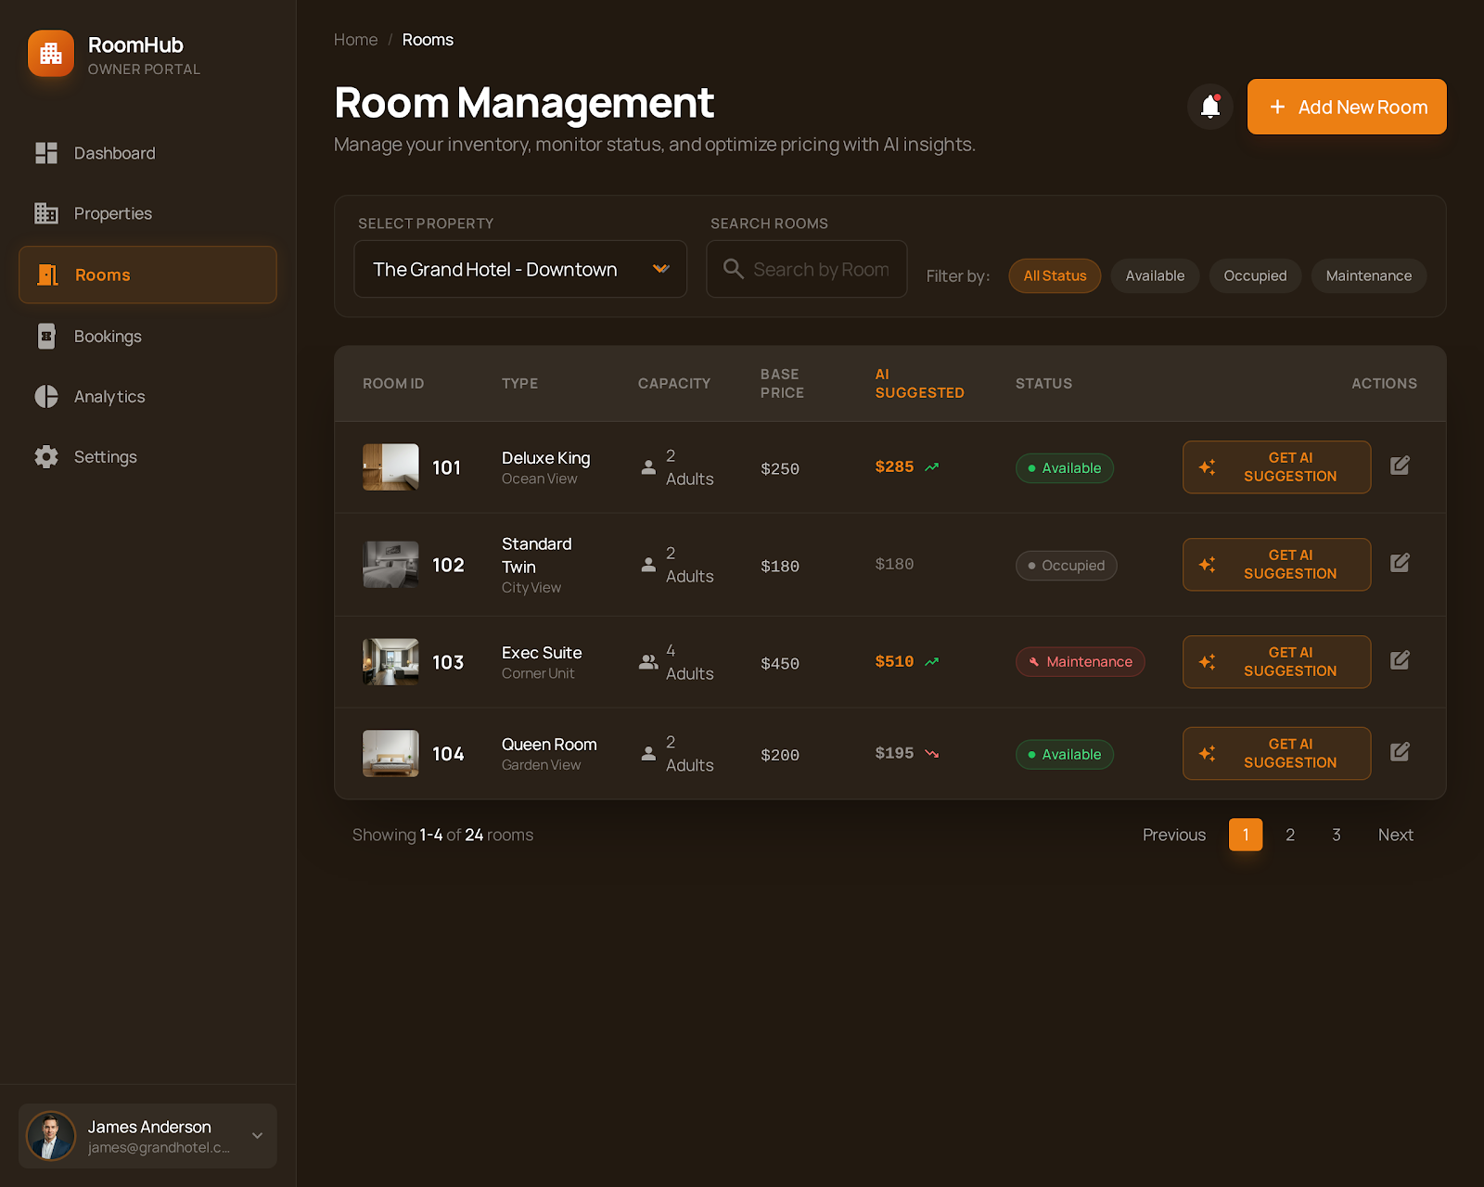

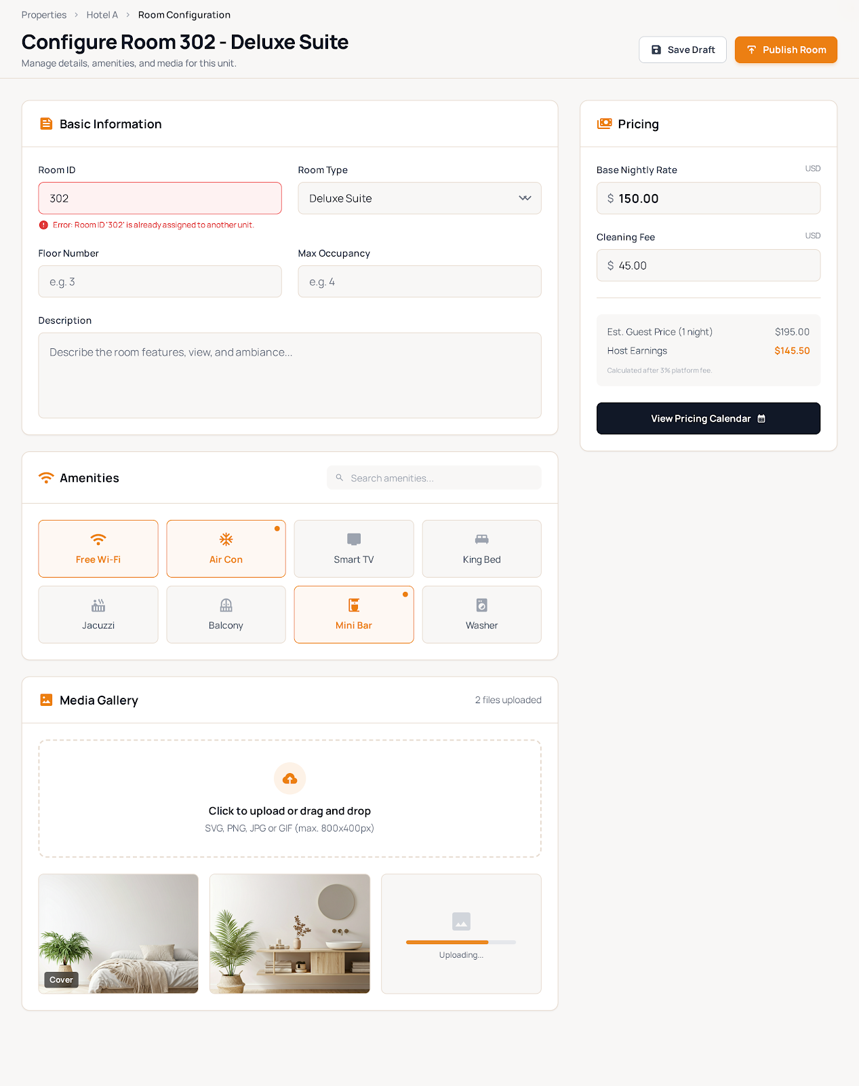

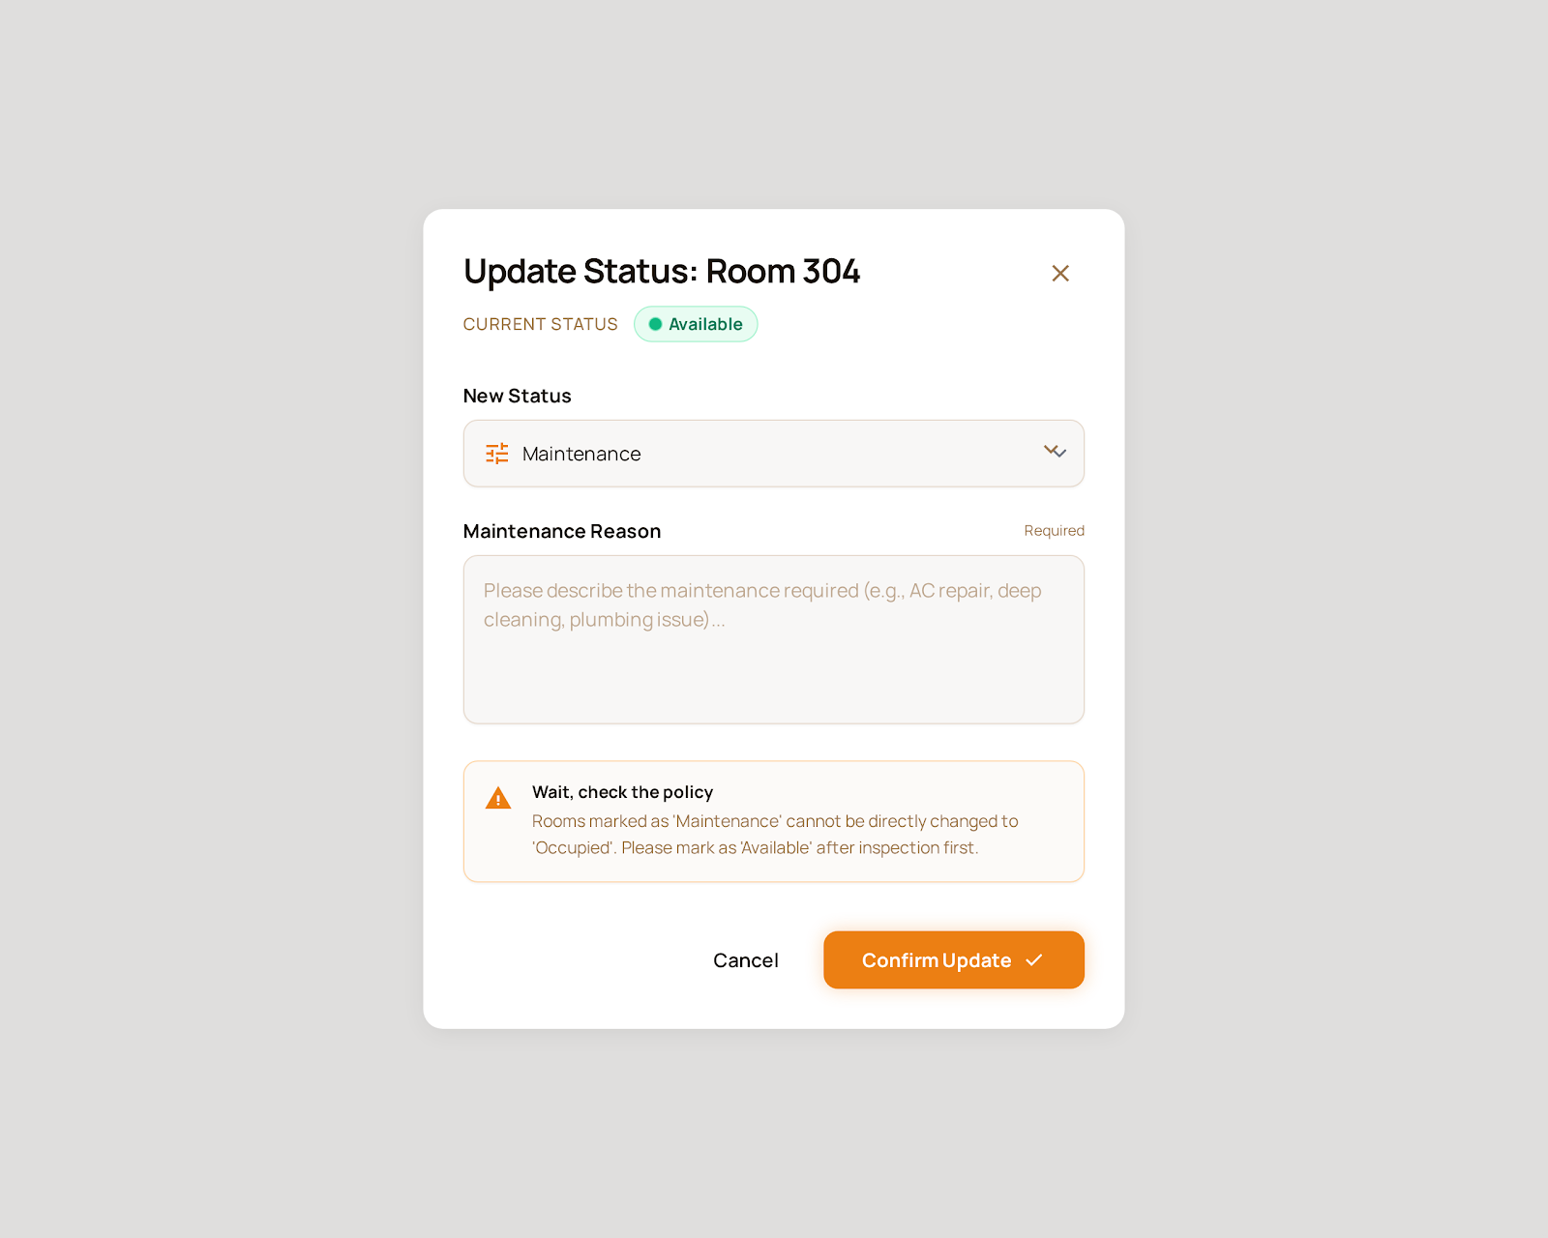

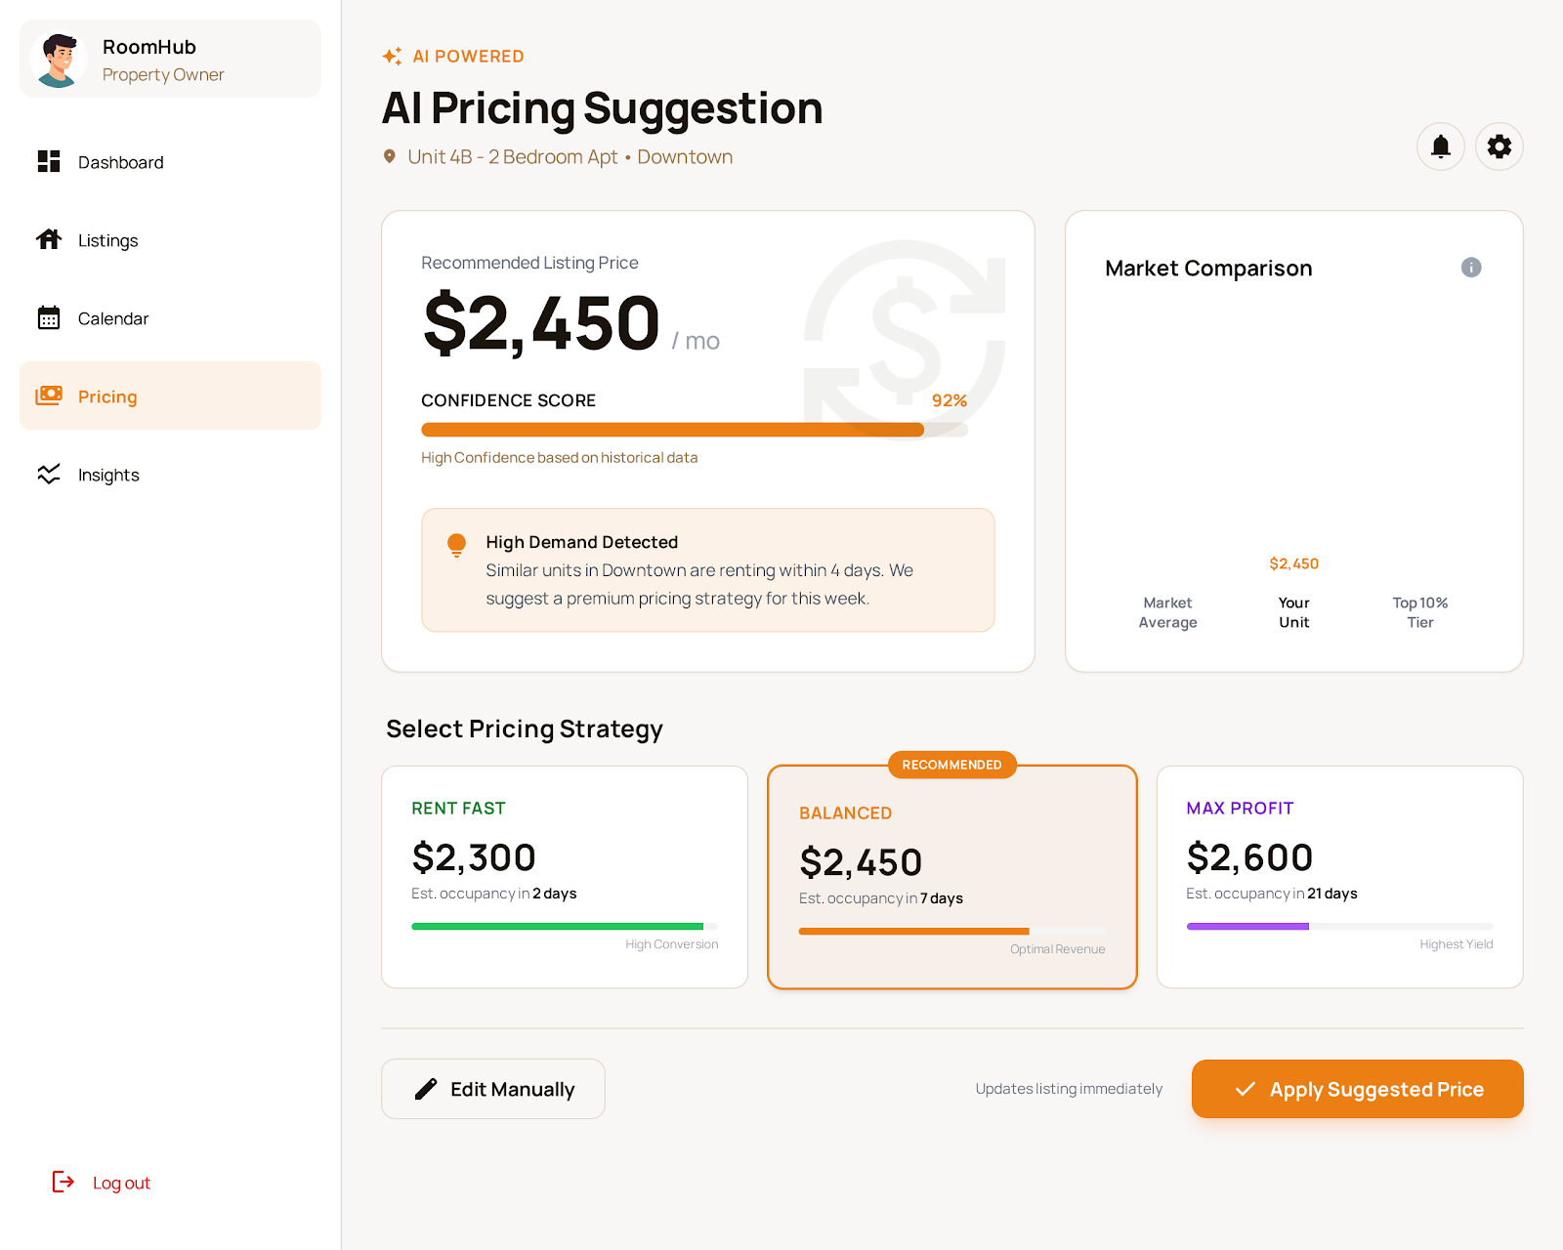

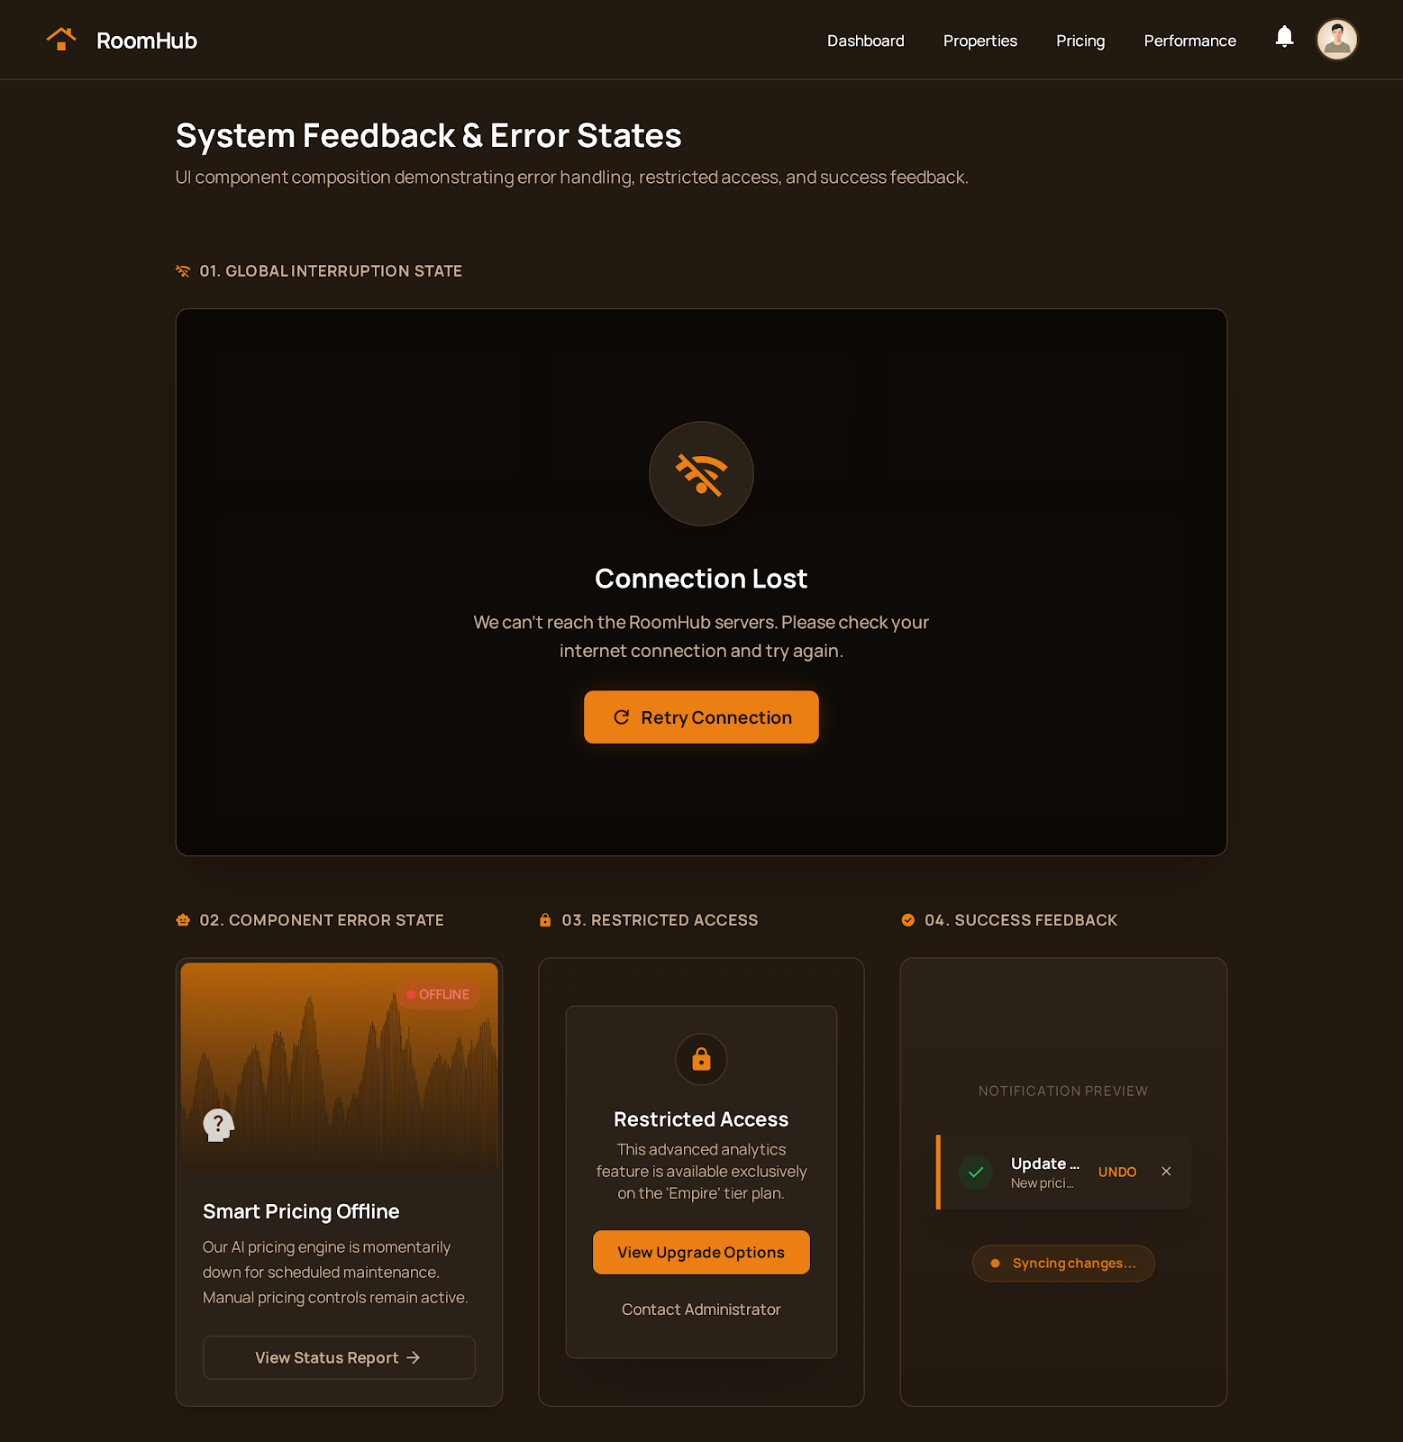

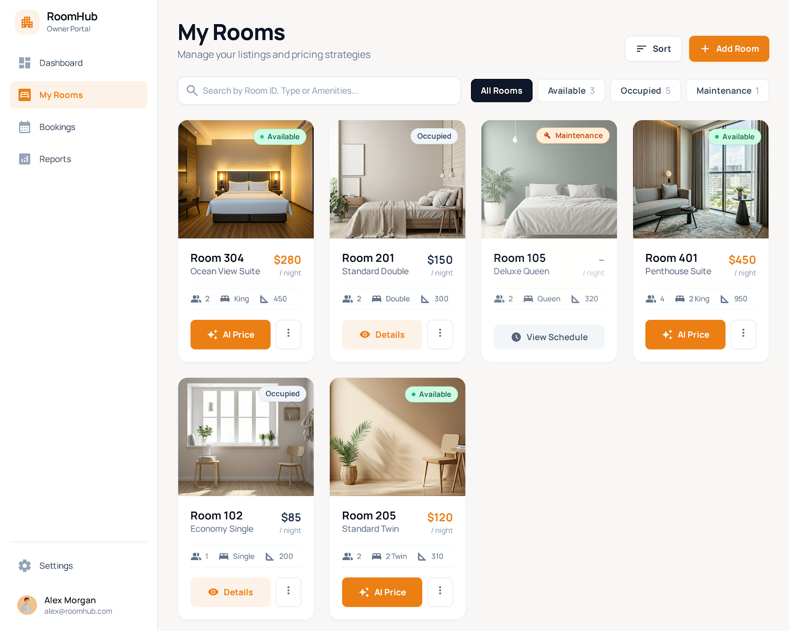

##### 10. **UC-10: Search for Rooms**

**Functional Description Template**

| UC ID and Name: | UC-10 – Search for Rooms | | |
| --- | --- | --- | --- |
| Created By: | Nguyen Hong An | Date Created: | January 14, 2026 |
| Primary Actor: | Guest, Tenant | Secondary Actors: | System, AI Recommendation Engine |
| Trigger: | User opens the search page or enters search criteria to find rooms. | | |
| Description: | The system allows users to search for available rooms using filters such as location, price range, room type, and amenities, and also provides AI-based room recommendations. | | |
| Preconditions: | - The system is running and accessible.  - Room listings exist in the system.  - Filters and search engine are configured. | | |
| Postconditions: | - A list of matching rooms is displayed.  - AI-recommended rooms are highlighted or shown separately. | | |
| Normal Flow: | 1.Guest/Tenant opens the room search page.  2.User enters search criteria (location, price range, amenities, etc.).  3.User clicks “Search”.  4.The system filters rooms based on the criteria.  5.The AI engine analyzes user behavior and preferences.  6.The system displays the search results and recommended rooms.  7.User selects a room to view details. | | |
| Alternative Flows: | **- AF1:** User performs search without filters → system shows all available rooms.  **- AF2:** User changes filters → system refreshes results in real time.  **- AF3:** User sorts results by price, distance, or rating. | | |
| Exceptions: | - No rooms match the criteria → system shows “No results found” message.  - Search service is unavailable → system shows an error and asks to retry.  - Invalid filter values → system requests correction. | | |
| Priority: | High – Must Have | | |
| Frequency of Use: | Very frequent, especially by new users and active tenants. | | |
| Business Rules: | - Only available rooms are shown by default.  - Search results must follow filter and sorting rules.  - AI recommendations are based on user behavior and similar users.  - Expired or inactive listings are excluded. | | |
| Other Information: | - Map view and list view can be supported.  - Recently viewed rooms can influence recommendations. | | |
| Assumptions: | - Room data is updated regularly.  - Users may search without logging in. | | |

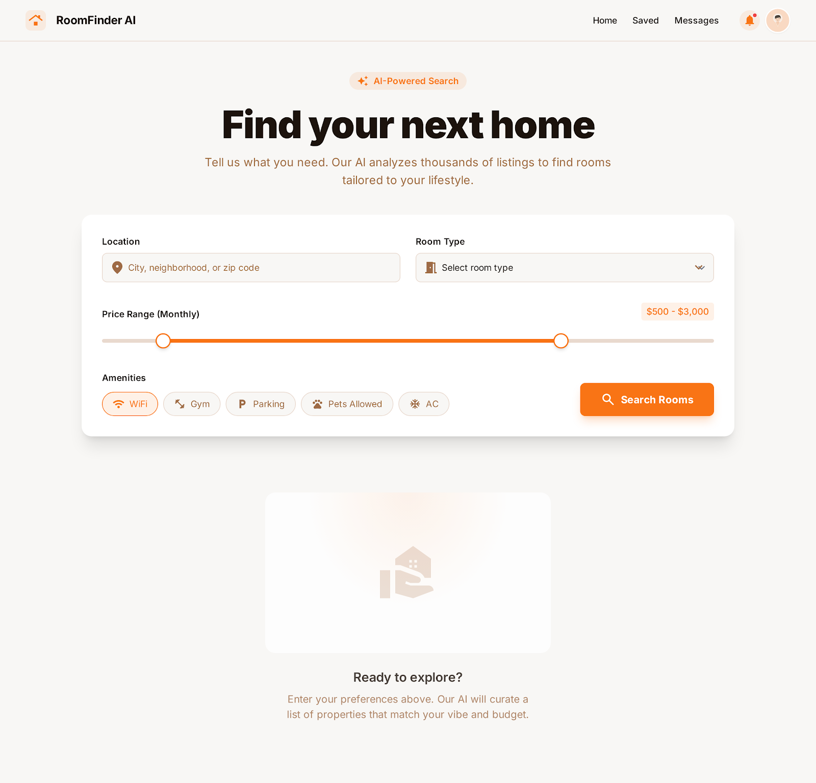

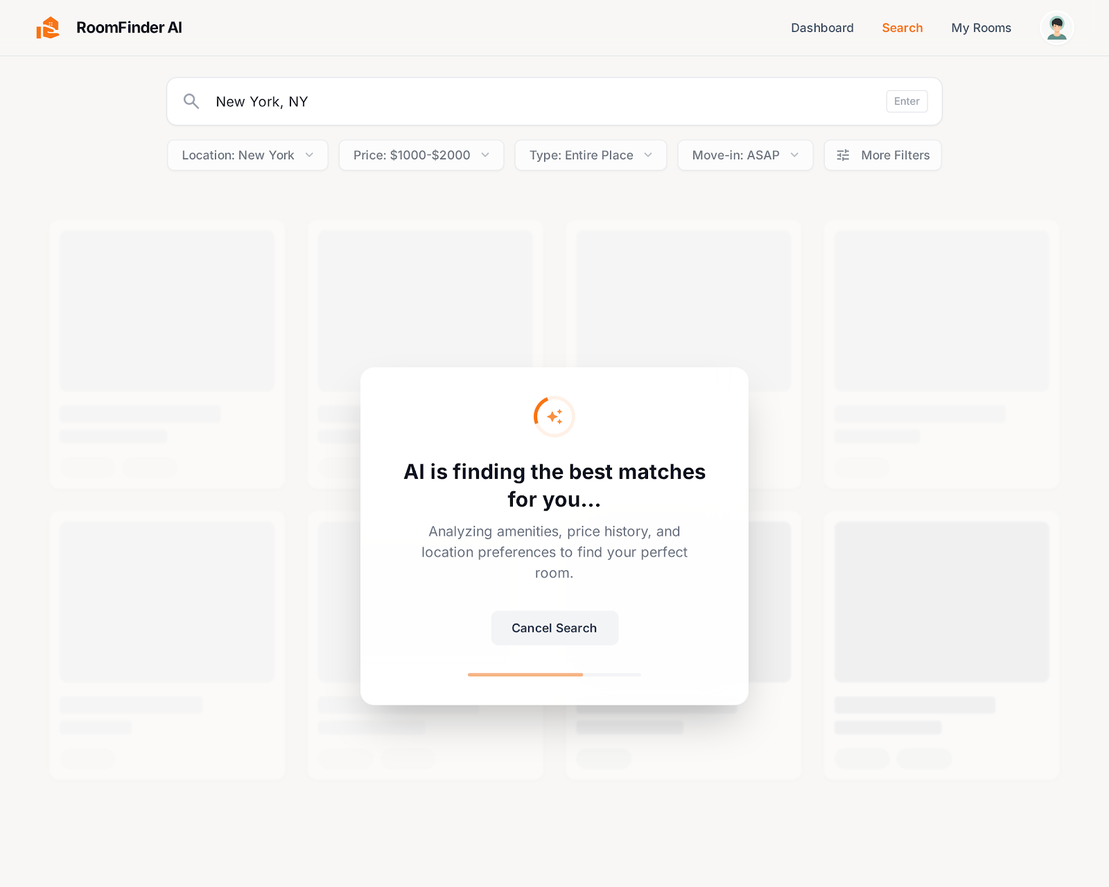

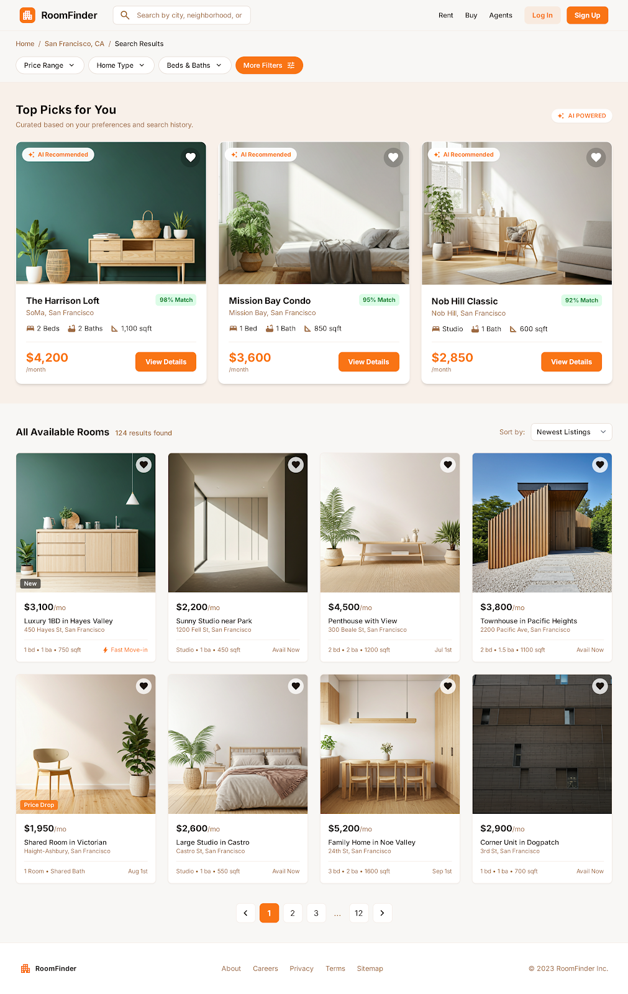

##### 11. **UC-11: Place Holding Deposit**

**Functional Description Template**

| UC ID and Name: | UC-11 – Place Holding Deposit | | |
| --- | --- | --- | --- |
| Created By: | Nguyen Hong An | Date Created: | January 14, 2026 |
| Primary Actor: | Tenant | Secondary Actors: | Payment Gateway, System, Property Owner |
| Trigger: | Tenant chooses to reserve a room by placing a holding deposit. | | |
| Description: | The system allows a tenant to pay a holding deposit to temporarily reserve a room for a specified duration, preventing other users from booking it during that time. | | |
| Preconditions: | - Tenant is logged in.  - The selected room is available.  - Holding deposit policy is defined (amount, duration, refund rules).  - Payment method is available. | | |
| Postconditions: | - Deposit payment is recorded successfully.  - Room status changes to “On Hold”.  - Reservation expiration time is set.  - Property Owner is notified. | | |
| Normal Flow: | 1.Tenant views room details.  2.Tenant clicks “Place Holding Deposit”.  3.System shows deposit amount, hold duration, and refund policy.  4.Tenant confirms and selects payment method.  5.System redirects to Payment Gateway.  6.Payment Gateway processes the transaction.  7.System receives payment confirmation.  8.System marks room as “On Hold” until expiration time.  9.System notifies Tenant and Property Owner. | | |
| Alternative Flows: | **- AF1:** Tenant cancels before payment → no reservation is created.  **- AF2:** Tenant changes payment method and retries.  **- AF3:** Tenant completes contract signing before hold expires → room status becomes “Booked”. | | |
| Exceptions: | - Payment fails → system shows error and room remains available.  - Room becomes unavailable before payment completes → system cancels transaction.  - Network or payment gateway error → system asks tenant to retry. | | |
| Priority: | High – Must Have | | |
| Frequency of Use: | Occasional, depends on tenant booking activity. | | |
| Business Rules: | - Only one active holding deposit per room at a time.  - Hold duration is fixed or configurable (e.g., 24–72 hours).  - Deposit amount is defined by the owner or system policy.  - Refund rules must be clearly displayed before payment.  - Room automatically becomes available if hold expires without further action. | | |
| Other Information: | - Countdown timer can be shown to tenant.  - Email/app notifications are sent before hold expires. | | |
| Assumptions: | - Tenant understands and agrees to holding deposit rules.  - Payment gateway is reliable and supports refunds. | | |

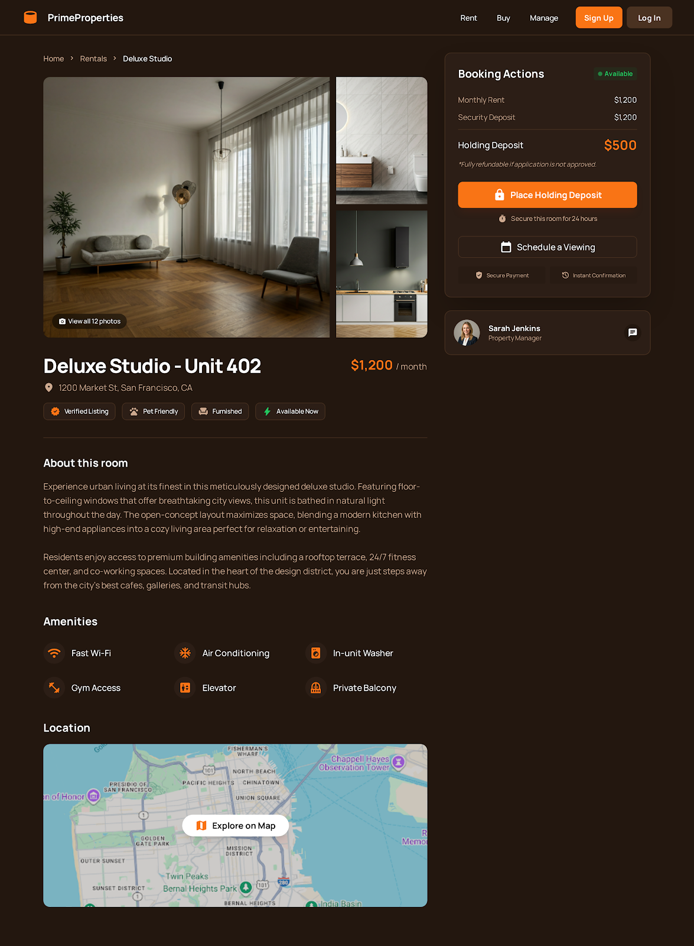

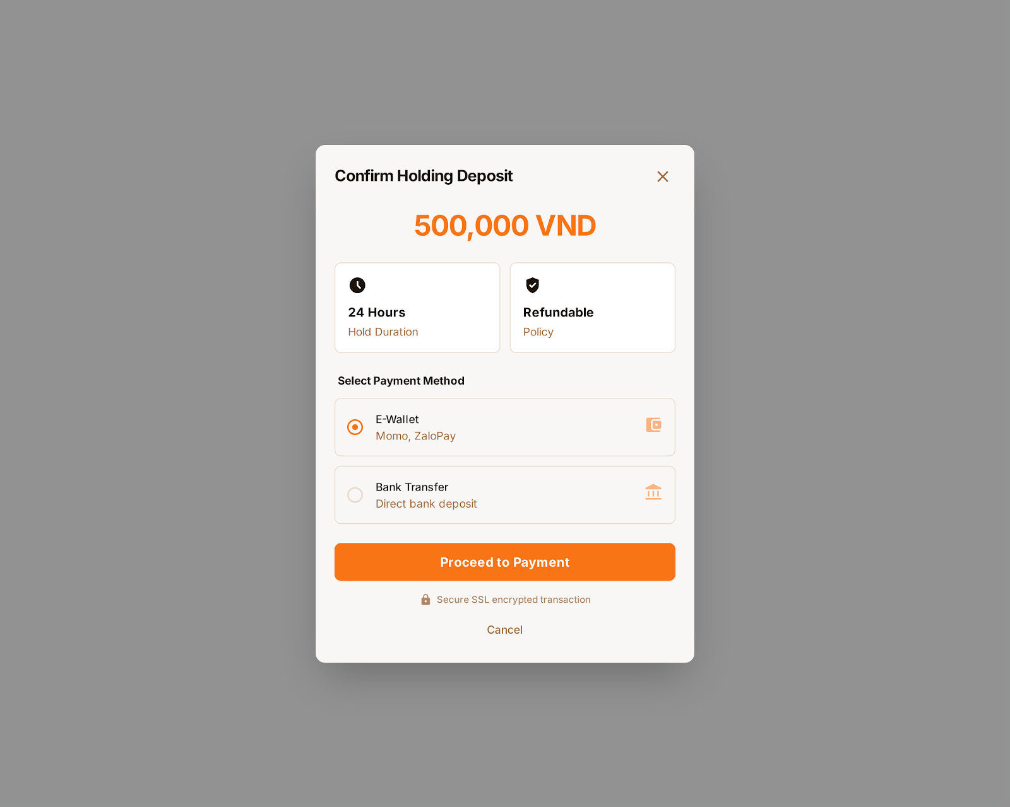

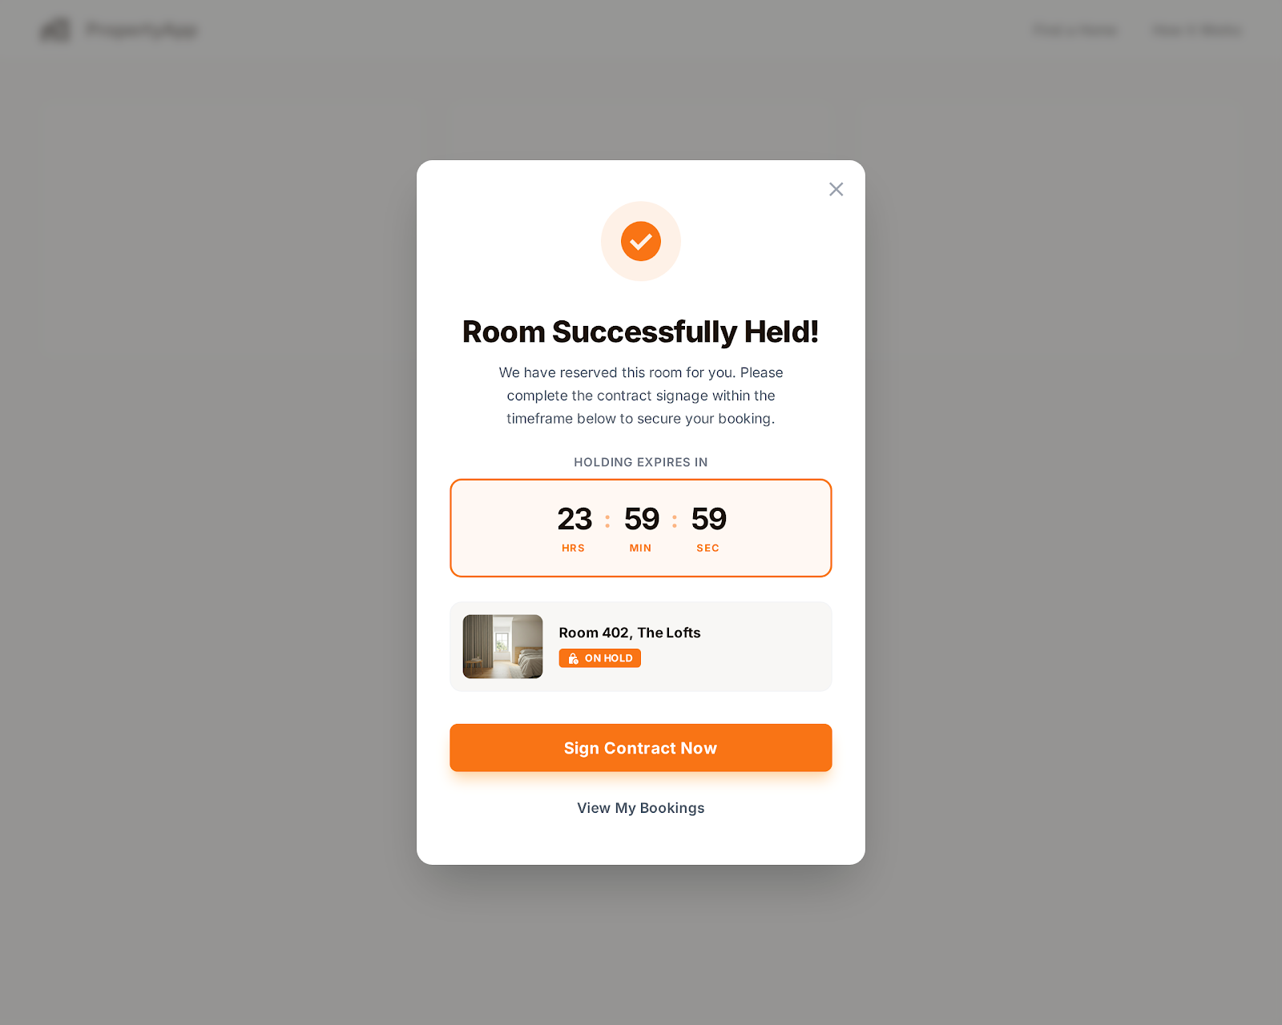

##### 12. UC-12: Draft Rental Contract

**Functional Description Template**

| UC ID and Name: | UC-12 – Draft Rental Contract | | |
| --- | --- | --- | --- |
| Created By: | Nguyen Hong An | Date Created: | January 14, 2026 |
| Primary Actor: | Property Owner | Secondary Actors: | System, Template/Document Service, Tenant (data source), (Optional) Legal/Compliance Rules Engine |
| Trigger: | Property Owner decides to create a rental contract for a selected tenant and room (after approval/booking/holding deposit). | | |
| Description: | The system generates a digital rental agreement (draft) by filling a contract template with tenant information, room details, pricing, and lease terms defined by the property owner. | | |
| Preconditions: | - Property Owner is logged in and has permission to manage the room.  - Tenant profile data is available (name, ID number, contact, etc.).  - Room details are available (address, room type, amenities, deposit, rent, utility policy).  - A contract template exists and is active.  - Lease terms (start date, duration, payment cycle, rules) are provided. | | |
| Postconditions: | - A draft contract is created and saved with status “Draft”.  - Contract contains populated tenant data, room details, and lease terms.  - The draft is available for review, editing, and sending to the tenant for signing. | | |
| Normal Flow: | 1.Property Owner selects a tenant and a room to create a contract.  2.Property Owner clicks “Draft Rental Contract”.  3.The system displays a form for lease terms (start date, end date, rent, deposit, payment method, utility rules, penalties).  4.Property Owner enters or confirms lease terms.  5.The system retrieves tenant data and room details.  6.The system applies the selected contract template and auto-fills fields.  7.The system generates the digital contract draft.  8.Property Owner reviews the draft and saves it.  9.The system stores the draft and sets status to “Draft”. | | |
| Alternative Flows: | **- AF1:** Owner edits template fields manually before saving (e.g., add special clauses).  **- AF2:** Owner selects a different contract template (e.g., short-term vs long-term).  **- AF3:** Missing tenant data → system prompts owner to request tenant update before drafting. | | |
| Exceptions: | - Template not found or inactive → system blocks drafting and asks to select/create a template.  - Required lease terms missing/invalid → system shows validation errors.  - System fails to generate document → system displays error and allows retry. | | |
| Priority: | High – Must Have | | |
| Frequency of Use: | Occasional (whenever a new lease is created). | | |
| Business Rules: | - Contract must include mandatory fields (tenant identity, property address, rent, deposit, lease period, payment schedule).  - Only Property Owner (or authorized staff) can create/edit drafts.  - Draft must not be legally binding until digitally signed by required parties.  - Each contract draft must have a unique contract ID/version.  - Changes after tenant signing require a new version or amendment workflow. | | |
| Other Information: | - Export options: PDF download, send via email/in-app.  - Audit trail logs who created/edited the draft and timestamps. | | |
| Assumptions: | - Tenant information provided is accurate and up to date.  - The selected template complies with local regulations (outside system responsibility unless compliance module exists). | | |

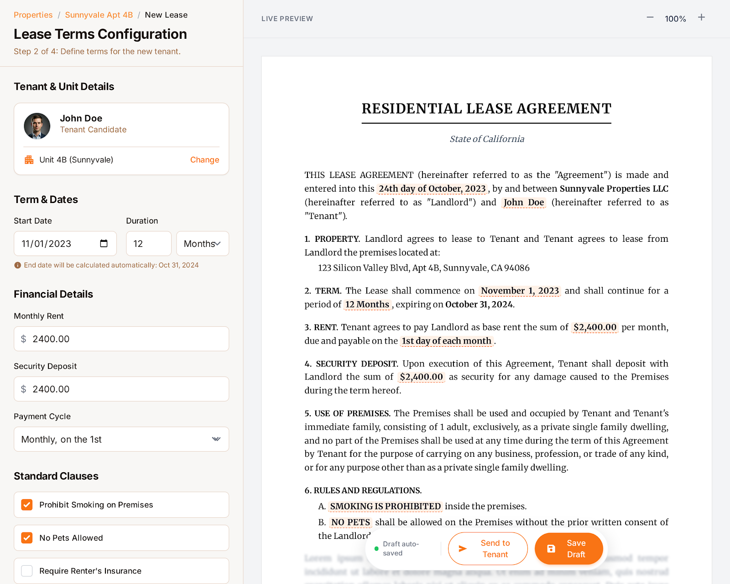

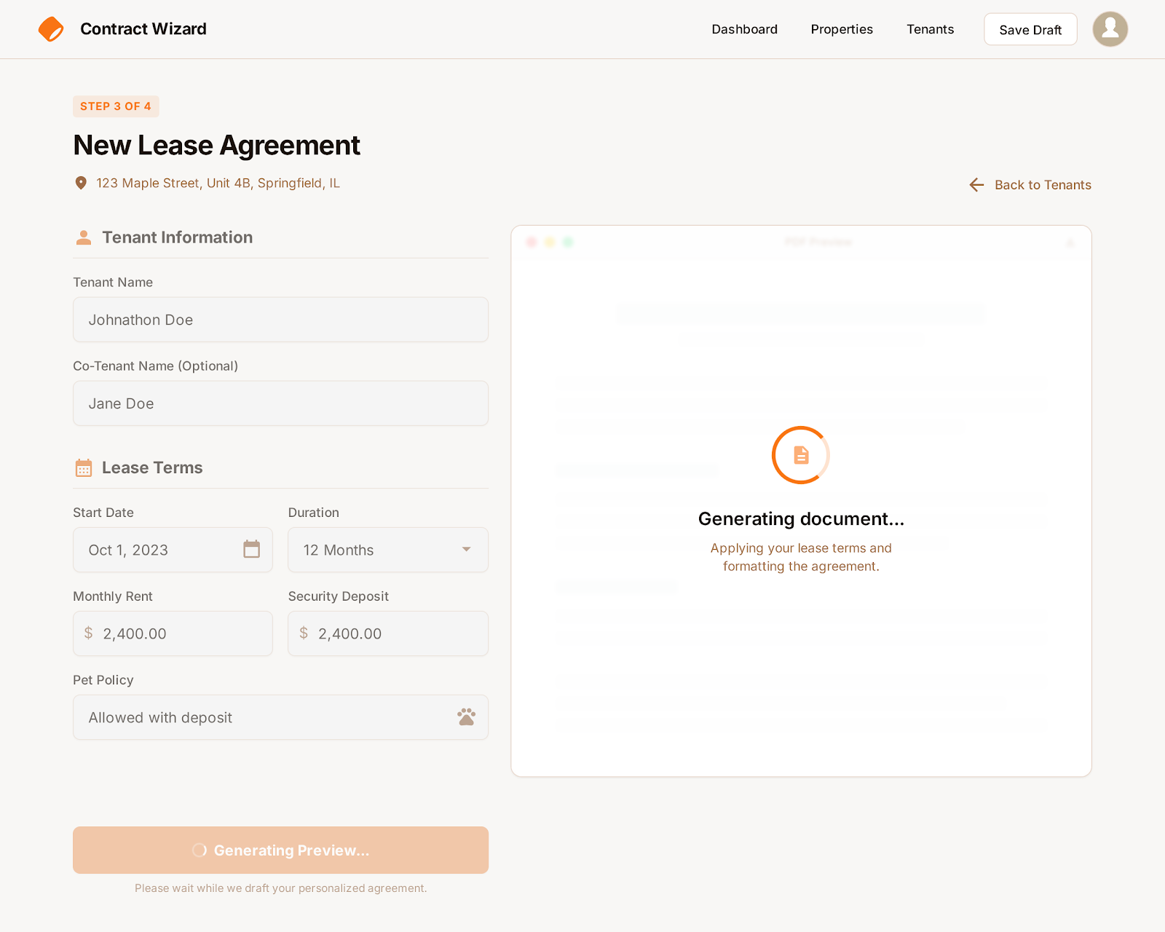

##### 13. **UC-13: Sign Digital Contract**

**Functional Description Template**

| UC ID and Name: | UC-13 – Sign Digital Contract | | |
| --- | --- | --- | --- |
| Created By: | Nguyen Hong An | Date Created: | January 14, 2026 |
| Primary Actor: | Tenant | Secondary Actors: | System, Digital Signature Service, Property Owner |
| Trigger: | Tenant receives a drafted rental contract and chooses to sign it. | | |
| Description: | The system allows the tenant to review the rental agreement and apply a digital signature to make the contract legally valid. | | |
| Preconditions: | - Tenant is logged in.  - A draft contract exists with status “Pending Signature”.  - Tenant has access to the contract.  - Digital signature service is available. | | |
| Postconditions: | - Contract status changes to “Signed by Tenant”.  - Tenant’s digital signature is attached to the contract.  - Property Owner is notified.  - Contract is locked from tenant-side editing. | | |
| Normal Flow: | 1.Tenant opens the contract notification.  2.System displays the full contract content.  3.Tenant reviews all terms.  4.Tenant clicks “Sign Contract”.  5.System asks for confirmation and identity verification (if required).  6.Tenant confirms and signs digitally.  7.Digital signature service processes and validates the signature.  8.System saves the signed contract and updates its status.  9.System notifies Property Owner. | | |
| Alternative Flows: | **- AF1:** Tenant downloads contract for offline review before signing.  **- AF2:** Tenant requests changes → system sends feedback to Property Owner and sets status to “Revision Requested”.  **- AF3:** Tenant signs on a different device after authentication. | | |
| Exceptions: | - Signature service unavailable → system shows error and asks to retry later.  - Authentication fails → system denies signing.  - Contract expired or invalid → system blocks signing and notifies both parties. | | |
| Priority: | High – Must Have | | |
| Frequency of Use: | Occasional (each time a new contract is created). | | |
| Business Rules: | - Only the assigned tenant can sign the contract.  - Signature must include timestamp and identity reference.  - Contract cannot be edited after tenant signs without creating a new version.  - Digital signature must comply with legal requirements configured by the system. | | |
| Other Information: | - Contract can be viewed anytime after signing.  - Signed version is stored securely and backed up. | | |
| Assumptions: | - Tenant understands the legal meaning of digital signing.  - Digital signatures are legally recognized in the target region. | | |

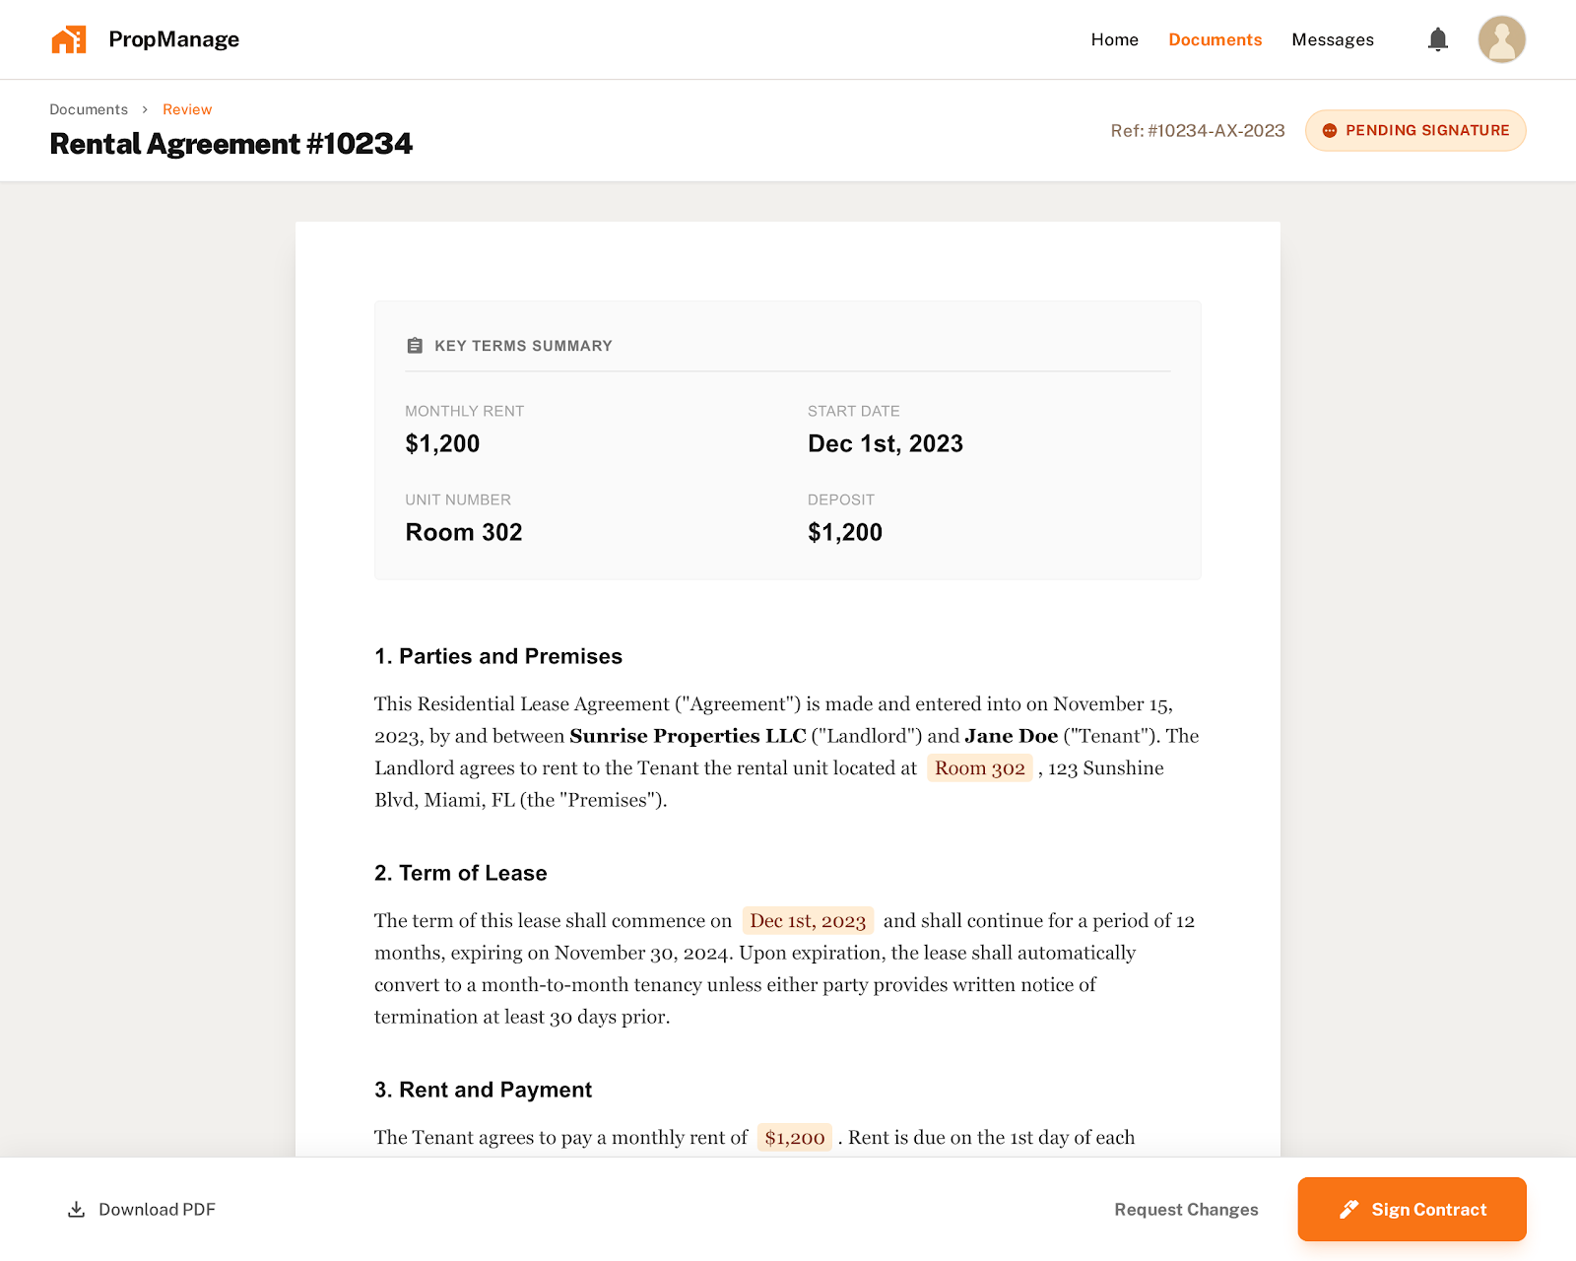

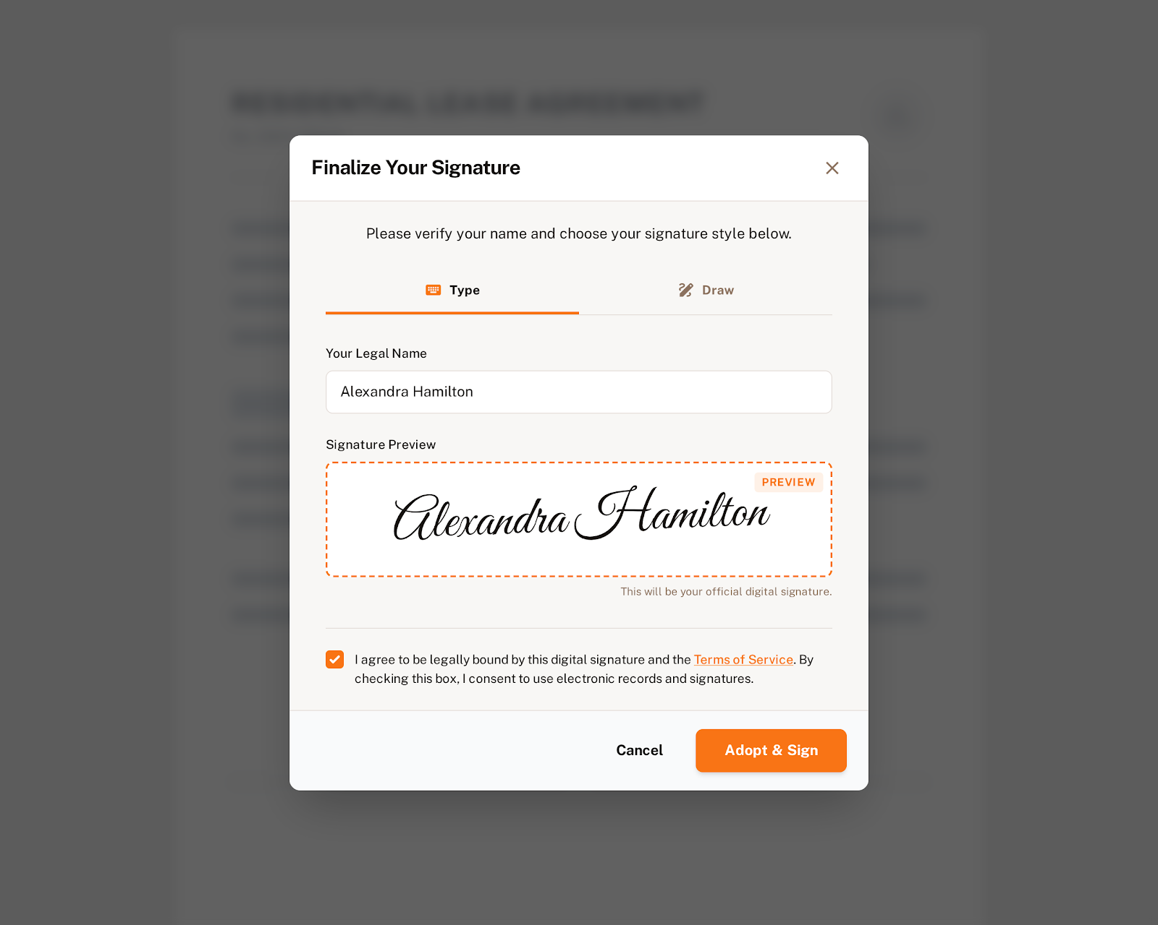

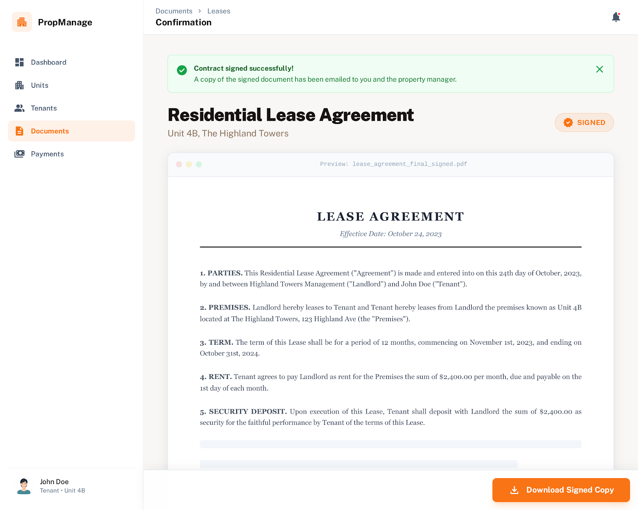

##### 14. **UC-14: Renew Rental Contract**

**Functional Description Template**

| UC ID and Name: | UC-14 – Renew Rental Contract | | |
| --- | --- | --- | --- |
| Created By: | Nguyen Hong An | Date Created: | January 14, 2026 |
| Primary Actor: | Property Owner, Tenant | Secondary Actors: | System, Notification Service, Digital Signature Service |
| Trigger: | The contract is nearing its end date, or one of the parties initiates a renewal. | | |
| Description: | The system supports renewing an existing rental contract by extending the lease duration and/or updating terms, and sends automatic renewal reminders to both parties. | | |
| Preconditions: | - An active contract exists.  - The contract is eligible for renewal (not terminated or expired).  - Both parties have valid accounts.  - Renewal policy is defined. | | |
| Postconditions: | - A renewed contract or contract amendment is created.  - New terms and dates are saved.  - Contract status is updated.  - Both parties are notified. | | |
| Normal Flow: | 1.System sends renewal reminder before contract end date.  2.Property Owner or Tenant clicks “Renew Contract”.  3.System displays current contract terms.  4.Initiator proposes new duration and/or updated terms.  5.Other party reviews the proposal.  6.Both parties agree to the new terms.  7.System generates renewal document/amendment.  8.Both parties sign digitally.  9.System updates contract status to “Renewed/Active”. | | |
| Alternative Flows: | **- AF1:** One party rejects renewal → contract continues until original end date.  **- AF2:** One party requests changes → system cycles back to negotiation.  **- AF3:** Renewal uses the same terms, only extending duration. | | |
| Exceptions: | - Contract already expired → system blocks renewal and suggests creating a new contract.  - Signature service unavailable → system delays signing and notifies users.  - One party does not respond before the deadline → contract expires as scheduled. | | |
| Priority: | High – Must Have | | |
| Frequency of Use: | Occasional (at the end of each lease period). | | |
| Business Rules: | - Renewal must reference the original contract.  - Both parties must sign for renewal to be valid.  - Renewal cannot start before the current contract ends (unless configured).  - The system must send reminders at configured intervals (e.g., 30, 15, 7 days before end). | | |
| Other Information: | - History of renewals is stored.  - Renewal terms can be compared with previous contract. | | |
| Assumptions: | - Both parties are willing and able to negotiate digitally.  - Digital signatures are legally valid. | | |

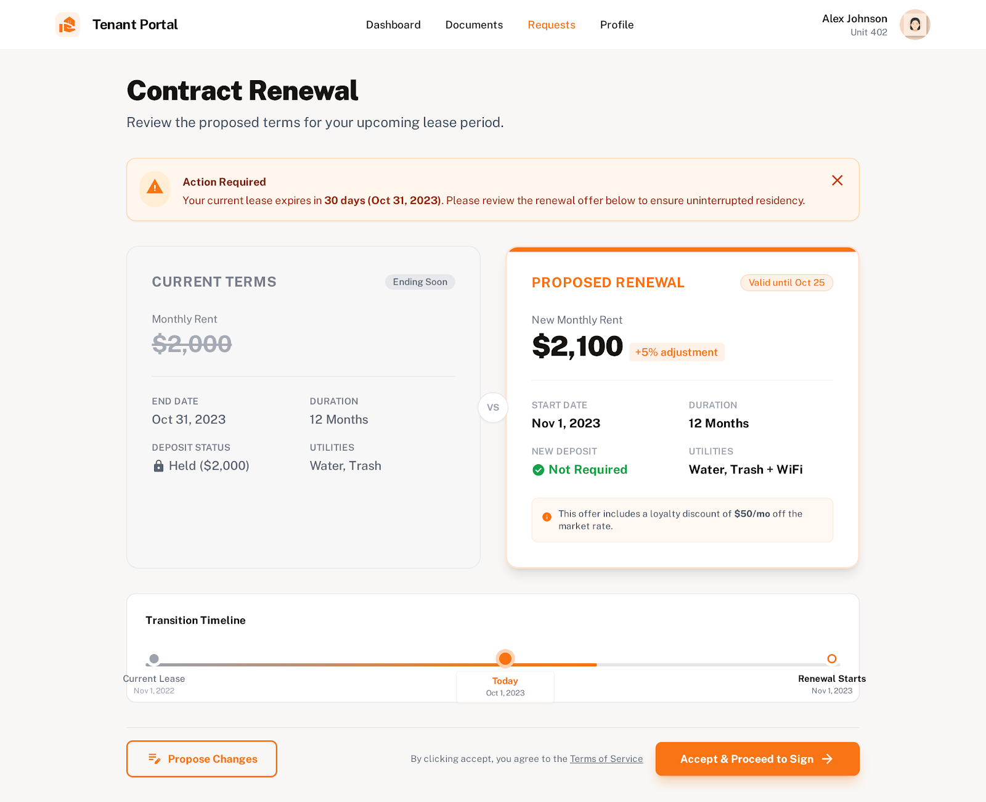

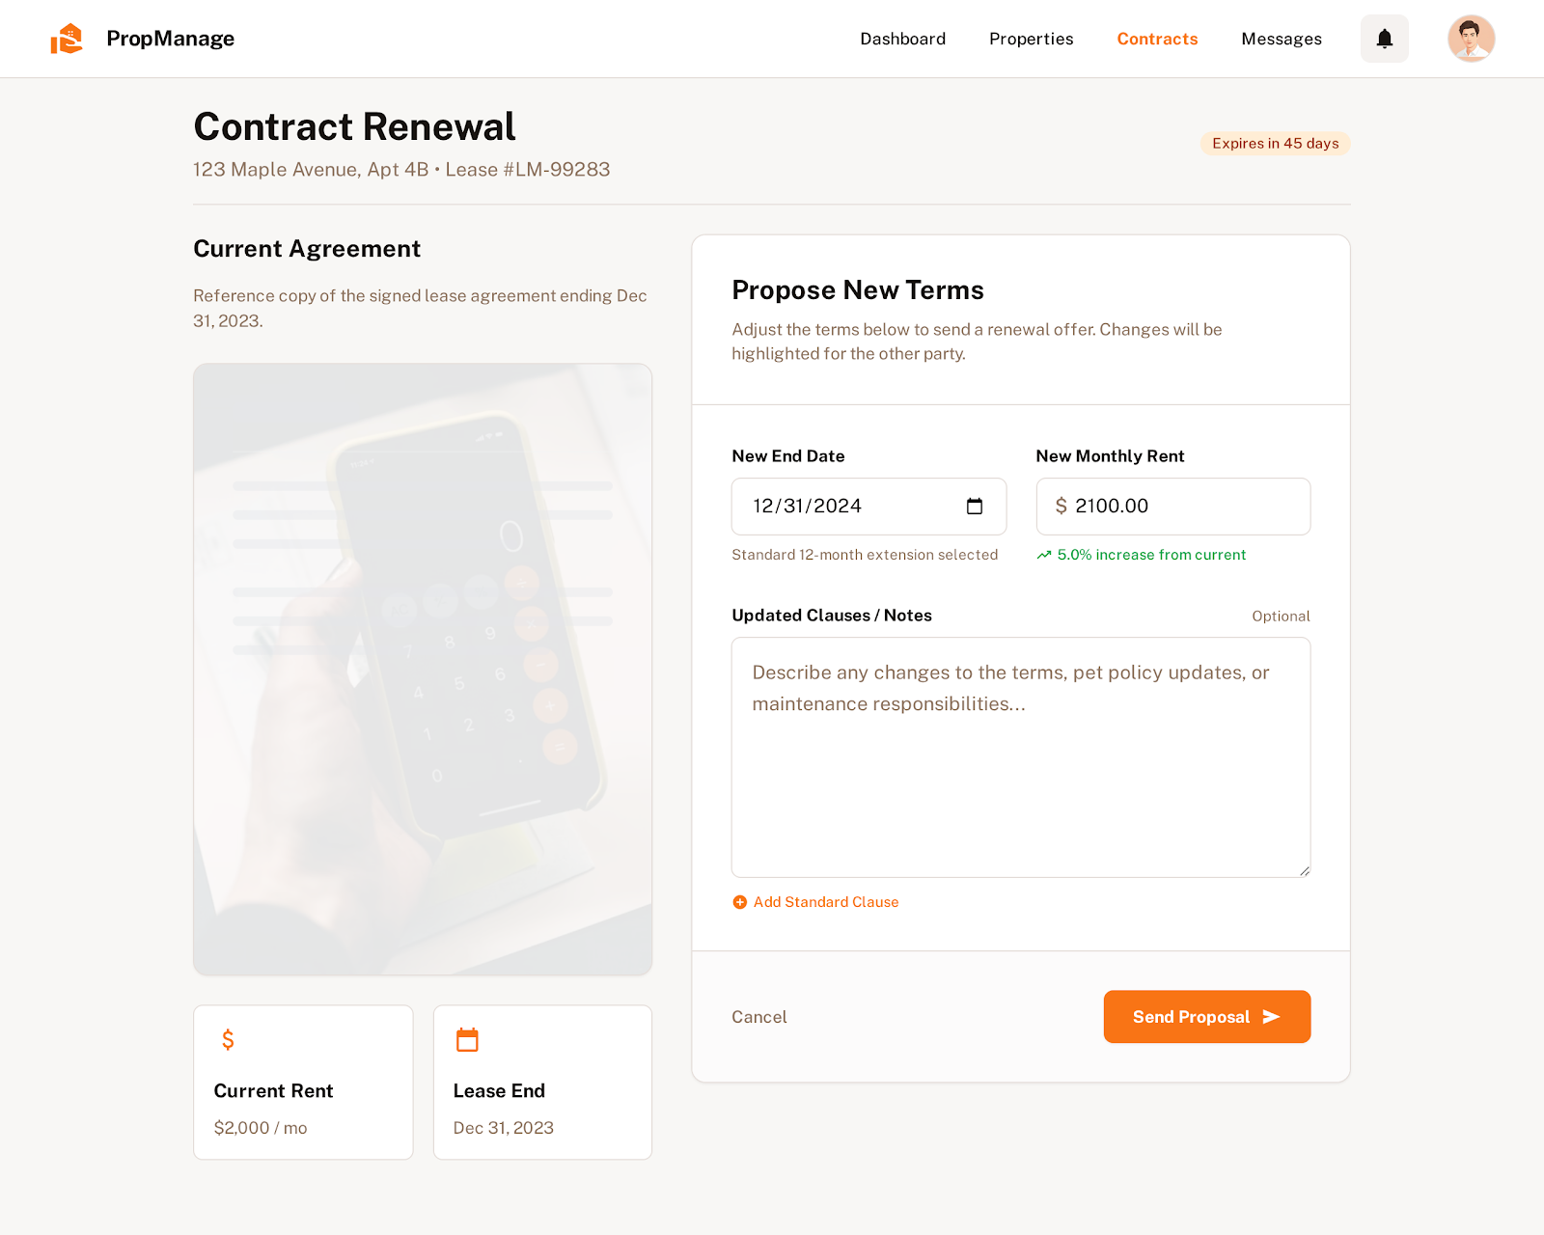

##### 15. **UC-15: Terminate Rental Contract**

**Functional Description Template**

| UC ID and Name: | UC-15 – Terminate Rental Contract | | |
| --- | --- | --- | --- |
| Created By: | Nguyen Hong An | Date Created: | January 14, 2026 |
| Primary Actor: | Property Owner | Secondary Actors: | System, Billing/Finance Module, Tenant, Payment Service |
| Trigger: | The Property Owner decides to end an active rental contract. | | |
| Description: | The system supports terminating a rental contract and handling the liquidation process, including final meter readings, outstanding charges, refunds, and penalties. | | |
| Preconditions: | - An active contract exists.  - Property Owner is authorized to terminate the contract.  - Termination policy (penalty, notice period, refund rules) is defined. | | |
| Postconditions: | - Contract status becomes “Terminated”.  - Final bill is generated.  - Refund or penalty amount is calculated.  - Payment or refund transaction is recorded. | | |
| Normal Flow: | 1.Property Owner selects an active contract.  2.Property Owner clicks “Terminate Contract”.  3.System shows termination form (date, reason, notes).  4.Property Owner confirms termination.  5.System collects final usage data and outstanding balances.  6.System calculates penalties or refunds based on policy.  7.System generates final settlement statement.  8.Property Owner reviews and confirms settlement.  9.System processes payment/refund.  10.System updates contract status to “Terminated” and notifies Tenant. | | |
| Alternative Flows: | **- AF1:** Tenant requests early termination → owner reviews and approves.  **- AF2:** No penalty applies → system only generates final bill.  **- AF3:** Manual adjustment of charges before finalizing. | | |
| Exceptions: | - Outstanding data missing (e.g., meter reading not entered) → system blocks termination.  - Payment/refund fails → system marks settlement as pending.  - Contract already terminated → system prevents duplicate action. | | |
| Priority: | High – Must Have | | |
| Frequency of Use: | Occasional (when a lease ends or is canceled early). | | |
| Business Rules: | - Termination must follow notice and penalty policies.  - Final bill must include rent, utilities, damages, and penalties (if any).  - Refund cannot exceed deposit amount.  - All actions must be logged for audit. | | |
| Other Information: | - Settlement summary can be exported as PDF.  - History of terminated contracts is stored. | | |
| Assumptions: | - Termination rules are clearly defined.  - Property Owner has authority to finalize settlements. | | |

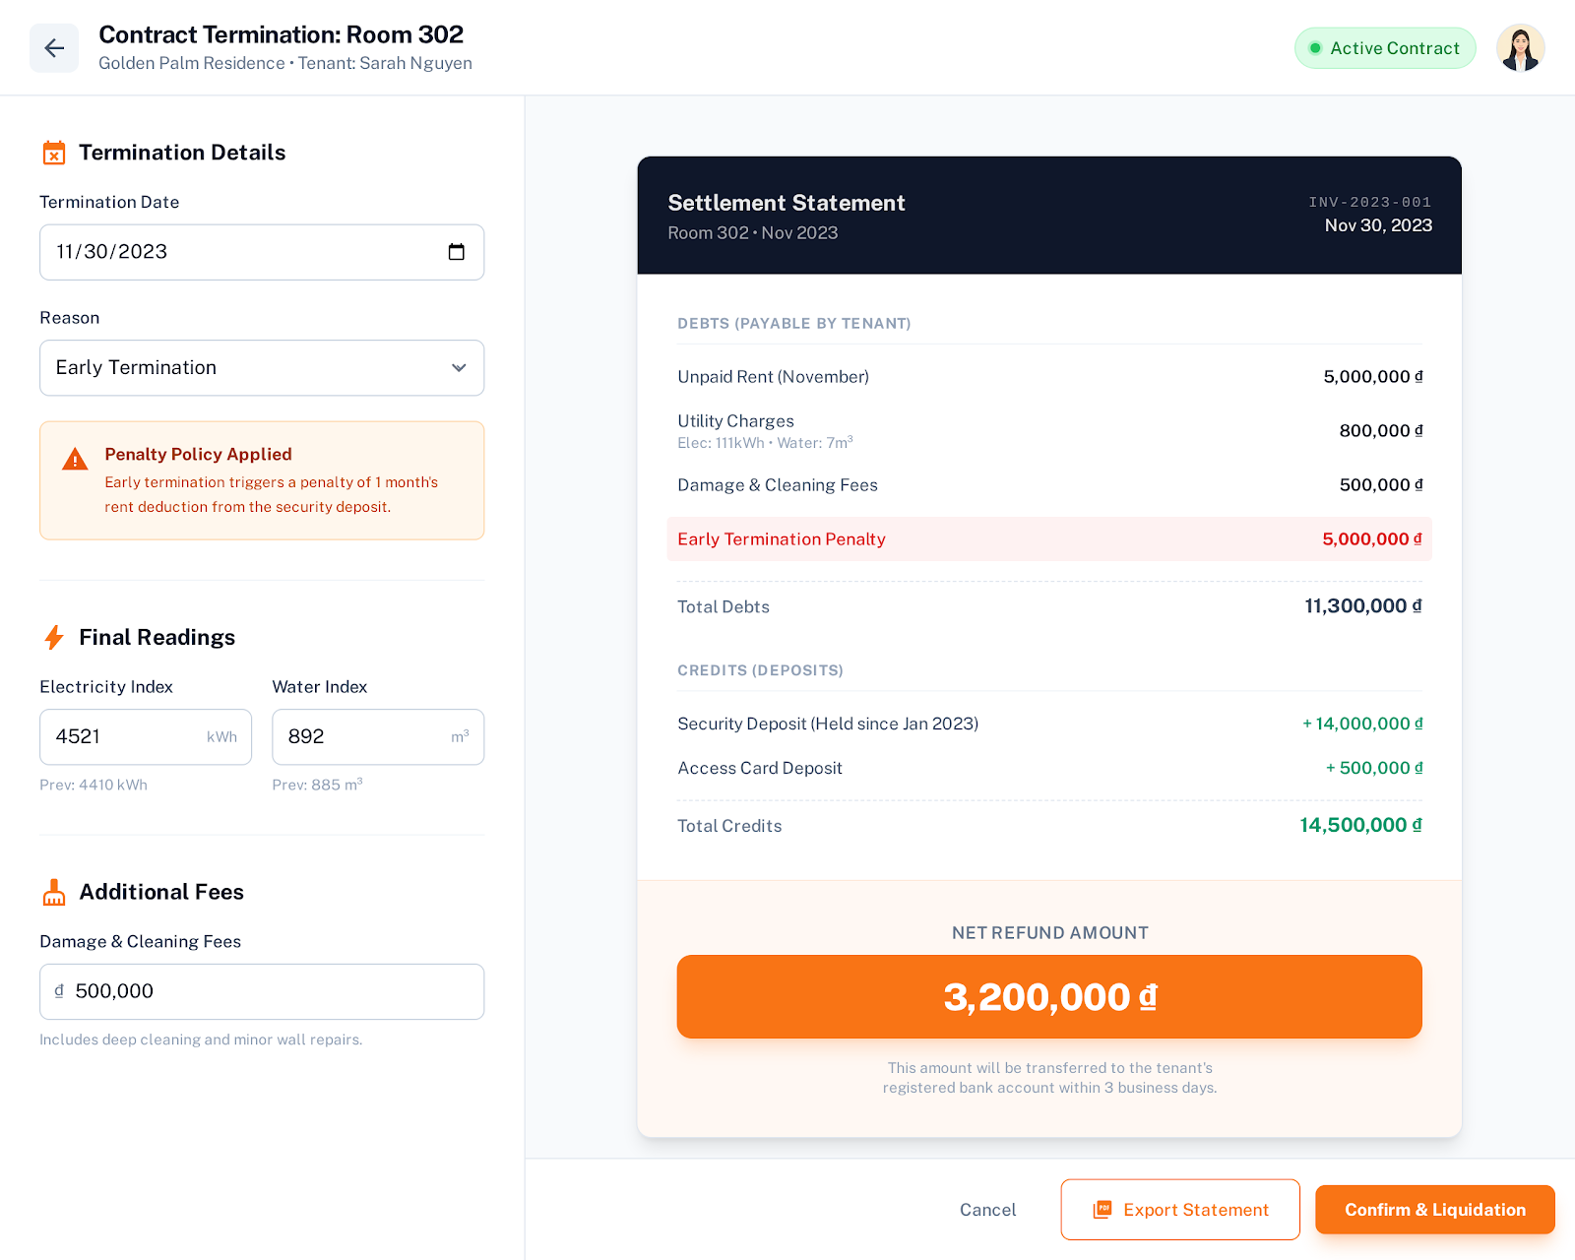

##### 16. UC-16: Record Utility Usage

**Functional Description Template**

| UC ID and Name: | UC-16 – Record Utility Usage | | |
| --- | --- | --- | --- |
| Created By: | Nguyen Hong An | Date Created: | January 14, 2026 |
| Primary Actor: | Property Owner | Secondary Actors: | System, Billing Module, (Optional) AI/Validation Engine |
| Trigger: | Monthly billing cycle starts or Property Owner decides to enter utility readings. | | |
| Description: | The system allows the Property Owner to input monthly electricity and water meter readings so that utility usage can be calculated for each room or unit. | | |
| Preconditions: | - Property Owner is logged in.  - Rooms/units and their meters are configured.  - Previous meter readings exist or an initial reading is set.  - Utility pricing rules are defined. | | |
| Postconditions: | - New meter readings are saved.  - Utility consumption is calculated.  - Data is ready for billing. | | |
| Normal Flow: | 1.Property Owner opens the “Record Utility Usage” page.  2.System shows list of rooms/units with last month’s readings.  3.Property Owner selects the billing month.  4.Property Owner enters new electricity and water readings.  5.System validates that new readings are not less than previous ones.  6.System calculates usage = new reading – previous reading.  7.Property Owner reviews calculated usage.  8.Property Owner confirms and saves.  9.System stores readings and updates billing data. | | |
| Alternative Flows: | **- AF1:** Bulk input for multiple rooms at once.  **- AF2:** Edit readings before final confirmation.  **- AF3:** Use estimated readings if actual reading is unavailable. | | |
| Exceptions: | - New reading is less than previous → system rejects and shows error.  - Room or meter not configured → system blocks entry.  - System error while saving → system asks to retry. | | |
| Priority: | High – Must Have | | |
| Frequency of Use: | Monthly for each room/unit. | | |
| Business Rules: | - Each room/unit has only one official reading per billing period.  - New reading must be greater than or equal to previous reading.  - Readings are locked after billing is finalized.  - All changes must be logged. | | |
| Other Information: | - Support attaching meter photos.  - Can integrate OCR to read numbers from images. | | |
| Assumptions: | - Property Owner provides accurate readings.  - Utility pricing is already configured. | | |

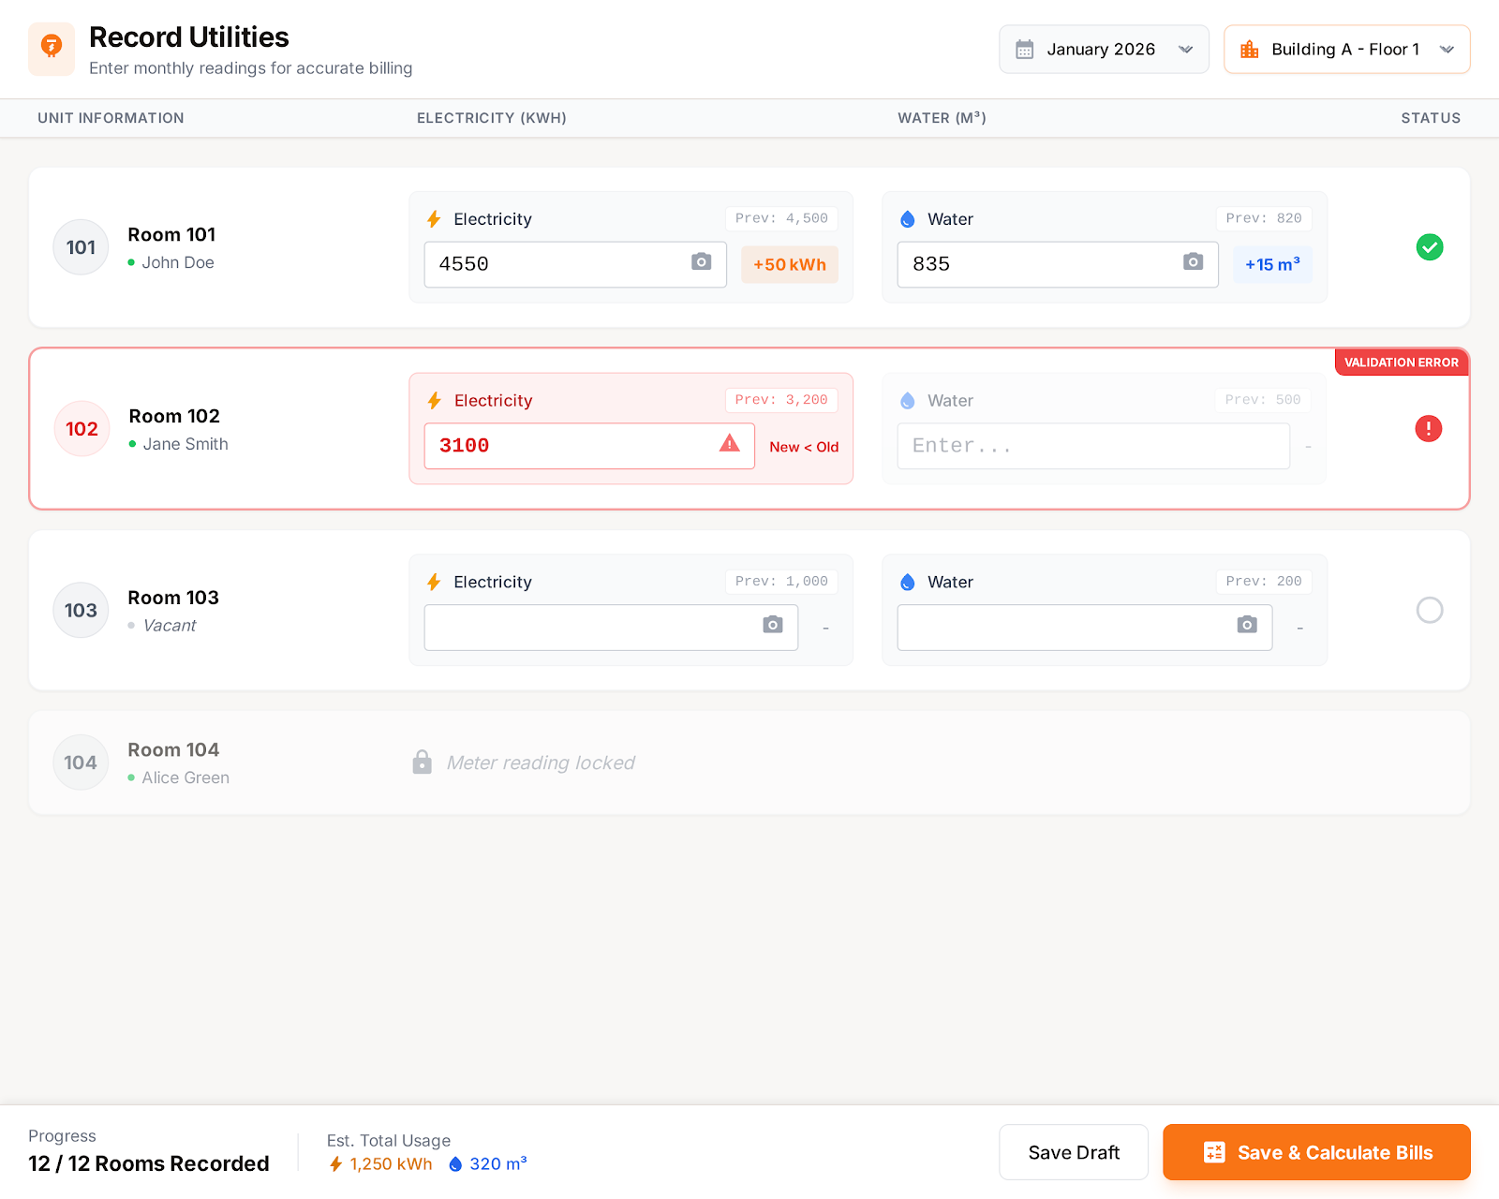

##### 17. UC-17 Generate Monthly Invoice

**Functional Description Template**

| UC ID and Name: | UC-17: Generate Monthly Invoice | | |
| --- | --- | --- | --- |
| Created By: | Tran Dinh Quy | Date Created: | January 14, 2026 |
| Primary Actor: | System (Automatic Timer) OR Property Owner (Manual Trigger) | Secondary Actors: | **Tenant** (Receiver of invoice notification) |
| Trigger: | The monthly billing cycle date arrives (e.g., 5th of every month) OR The Property Owner clicks "Generate Invoice" manually. | | |
| Description: | The system consolidates base rent, recorded utility usage (electricity, water), and additional service fees into a single invoice for the tenant. | | |
| Preconditions: | PRE-1: Active rental contract exists for the room.  PRE-2: Utility readings (Old/New Index) for the current month have  been recorded (UC-16). | | |
| Postconditions: | POST-1: A new invoice is created with status "Unpaid".  POST-2: Notification is sent to the tenant. | | |
| Normal Flow: | **17.0 Normal Flow**  1. The system identifies all active contracts due for billing.  2. System retrieves the Base Rent from the contract.  3. System retrieves Utility Readings (Electricity, Water) for the period.  4. System calculates Utility Costs: (New Index - Old Index) *  Unit Price.  5. System retrieves any Unpaid Service Fees (from UC-24).  6. The system generates a detailed Invoice ID containing all line items.  7. The system saves the invoice with status "Unpaid".  8. The system sends a notification (Email/App) to the tenant. | | |
| Alternative Flows: | **17.1 Manual Adjustment**  At step 6, the Property Owner reviews the draft invoice.  1. The owner manually adds a "Discount" or "Surcharge" line item.  2. The system recalculates the total.  3. The owner confirms the generation.  4. Resume Normal Flow at step 7. | | |
| Exceptions: | **17.0.E1 Missing Utility Data**  At step 3, the system cannot find meter readings for the current month.  1. System alerts the Owner: "Missing Utility Data for Room [X]".  2. The system skips invoice generation for this room.  3. Use Case ends (Owner must perform UC-16 first). | | |
| Priority: | High (Must Have) | | |
| Frequency of Use: | Monthly per occupied room. | | |
| Business Rules: | BR-BILL-01: Invoices must be generated 5 days before the Due Date.  BR-BILL-02: Utility rates are fetched from the Building Configuration. | | |
| Other Information: | The system must handle rounding of currency based on VND standards. | | |
| Assumptions: | Utility readings are accurate and entered prior to generation. | | |

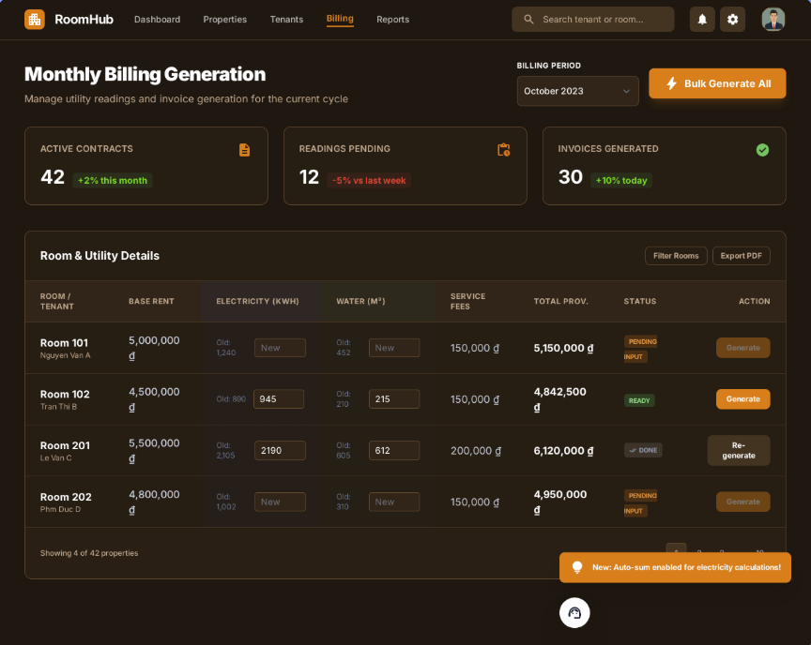

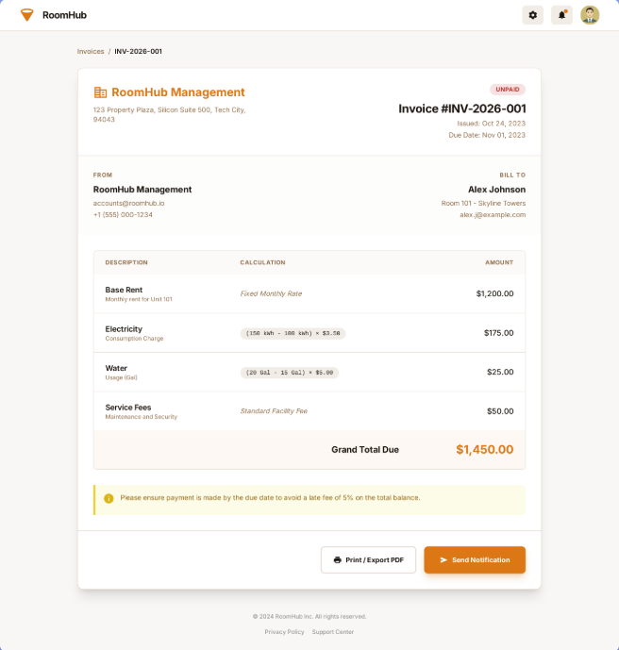

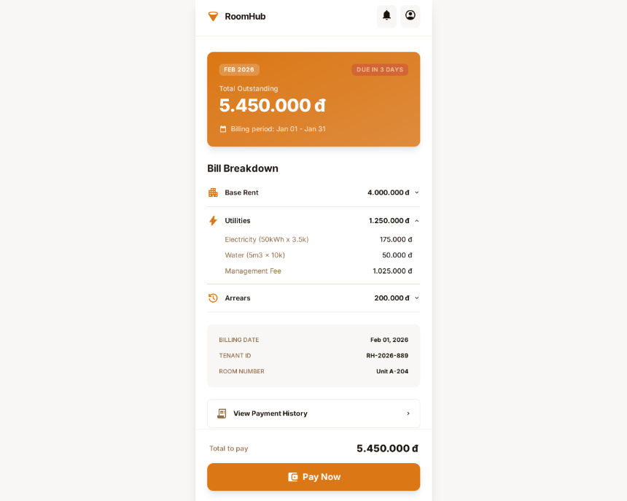

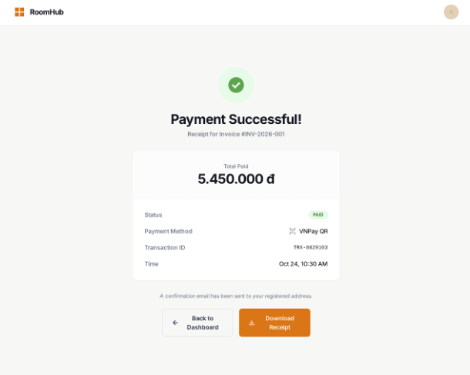

##### 18. UC-18 Pay Monthly Invoice

**Functional Description Template**

| UC ID and Name: | UC-18: Pay Monthly Invoice | | |
| --- | --- | --- | --- |
| Created By: | Tran Dinh Quy | Date Created: | January 14, 2026 |
| Primary Actor: | Tenant | Secondary Actors: | **Payment Gateway** (VNPay/MoMo - External System), **Property Owner** (Receiver of funds) |
| Trigger: | Tenant selects an "Unpaid" invoice and clicks "Pay Now". | | |
| Description: | Processes online payments for outstanding invoices via the integrated Payment Gateway to settle monthly bills. | | |
| Preconditions: | **PRE-1:** Tenant is logged in.  **PRE-2:** At least one invoice with status "Unpaid" or "Overdue" exists. | | |
| Postconditions: | **POST-1:** Invoice status updates to "Paid".  **POST-2:** Transaction record is created in the system. | | |
| Normal Flow: | **18.0 Normal Flow**  1. Tenant views the Invoice Details screen.  2. Tenant clicks "Pay Online".  3. System displays available Payment Methods (E-wallet, QR, Bank  Card).  4. Tenant selects a method (e.g., VNPay QR).  5. System redirects Tenant to the Payment Gateway interface.  6. Tenant completes the transaction on the Gateway.  7. Payment Gateway returns "Success" signal to System.  8. System updates Invoice Status to "Paid".  9. The system displays a "Payment Successful" message to Tenant.  10. The system notifies the Property Owner of the receipt. | | |
| Alternative Flows: | **18.1 Pay by Bank Transfer (Manual Upload)**  *Step 2 branches to:*  1. Tenant chooses "Manual Transfer".  2. The system shows the Owner's Bank Account details.  3. Tenant transfers money externally and uploads a "Proof of Payment"  image.  4. System updates Invoice Status to "Pending Verification".  5. Use Case ends (Awaiting UC-19). | | |
| Exceptions: | **18.0.E1 Payment Failed**  *Occurs at step 7:*  1. Payment Gateway returns "Failed/Timeout" signal.  2. System displays error: "Transaction Failed. Please try again."  3. Invoice status remains "Unpaid".  4. System logs the failed attempt.  5. Return to step 3. | | |
| Priority: | High (Must Have) | | |
| Frequency of Use: | Monthly per tenant. | | |
| Business Rules: | **BR-PAY-01:** Late payments after Due Date + 3 days incur a penalty fee (if configured). | | |
| Other Information: | Secure connection (HTTPS) is mandatory for all payment transactions. | | |
| Assumptions: | Payment Gateway API is available and responsive. | | |

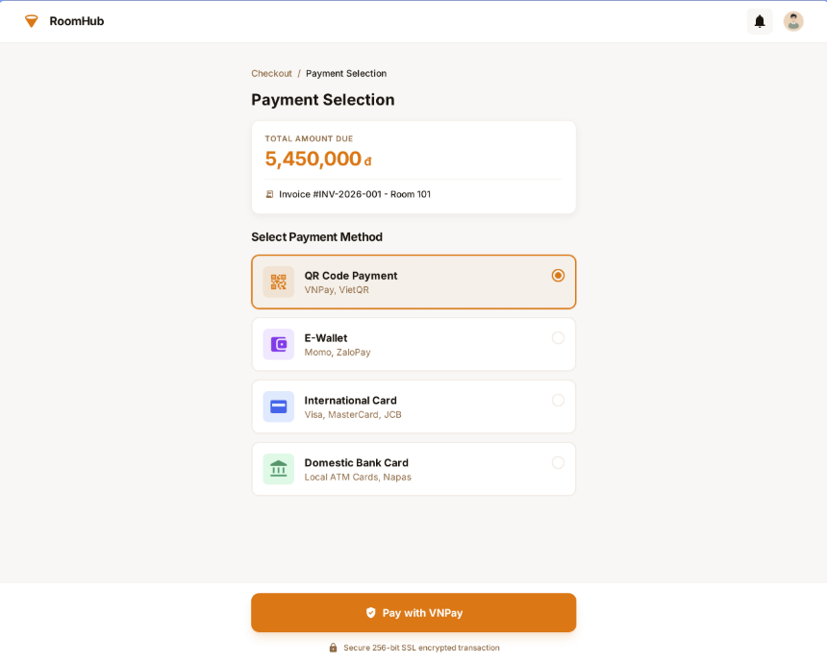

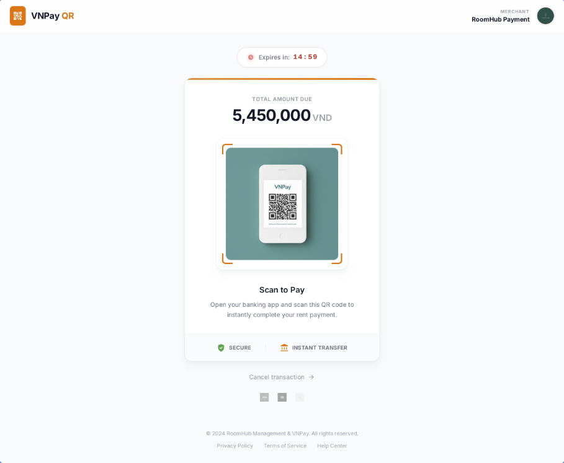

##### 19. UC-19 Verify Payment Transaction

**Functional Description Template**

| UC ID and Name: | UC-19: Verify Payment Transaction | | |
| --- | --- | --- | --- |
| Created By: | Tran Dinh Quy | Date Created: | January 14, 2026 |
| Primary Actor: | **Property Owner** OR **Administrator** | Secondary Actors: | **Tenant** (Notification receiver), **Payment Gateway** (Reference source) |
| Trigger: | An invoice status is "Pending Verification" (Manual Transfer) OR The owner wants to audit a Gateway transaction. | | |
| Description: | Confirms the validity of payments by reviewing manual proofs of payment or checking gateway transaction logs. | | |
| Preconditions: | **PRE-1:** An invoice exists with status "Pending Verification" OR "Paid". | | |
| Postconditions: | **POST-1:** Invoice status is finalized as "Paid" or reverted to "Unpaid". | | |
| Normal Flow: | **19.0 Normal Flow (Manual Verification)**  1. Owner views list of "Pending Verification" invoices.  2. The owner selects an invoice to review.  3. System displays the uploaded "Proof of Payment" image and  Transaction ID.  4. The owner checks their Bank Account (External) to confirm receipt.  5. The owner clicks "Approve Payment".  6. System updates Invoice Status to "Paid".  7. The system sends "Payment Accepted" notification to Tenant. | | |
| Alternative Flows: | **19.1 Reject Payment**  *Step 4 branches to:*  1. The owner cannot find the money in their bank account.  2. Owner clicks "Reject Payment" and enters a reason (e.g., "Invalid  Image").  3. System updates Invoice Status back to "Unpaid".  4. System alerts Tenant to re-submit.  5. Use Case ends. | | |
| Exceptions: | None. | | |
| Priority: | High (Must Have) | | |
| Frequency of Use: | Daily (depends on manual transfer volume). | | |
| Business Rules: | **BR-PAY-02:** Manual verification must be processed within 24 hours of submission. | | |
| Other Information: | The audit log must record who verified the transaction (Owner or Admin). | | |
| Assumptions: | The owner accesses their banking app independently to check funds. | | |

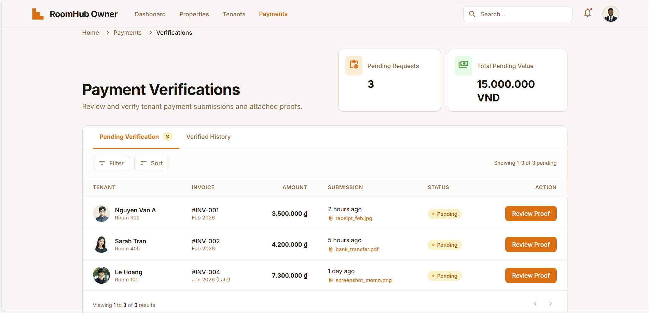

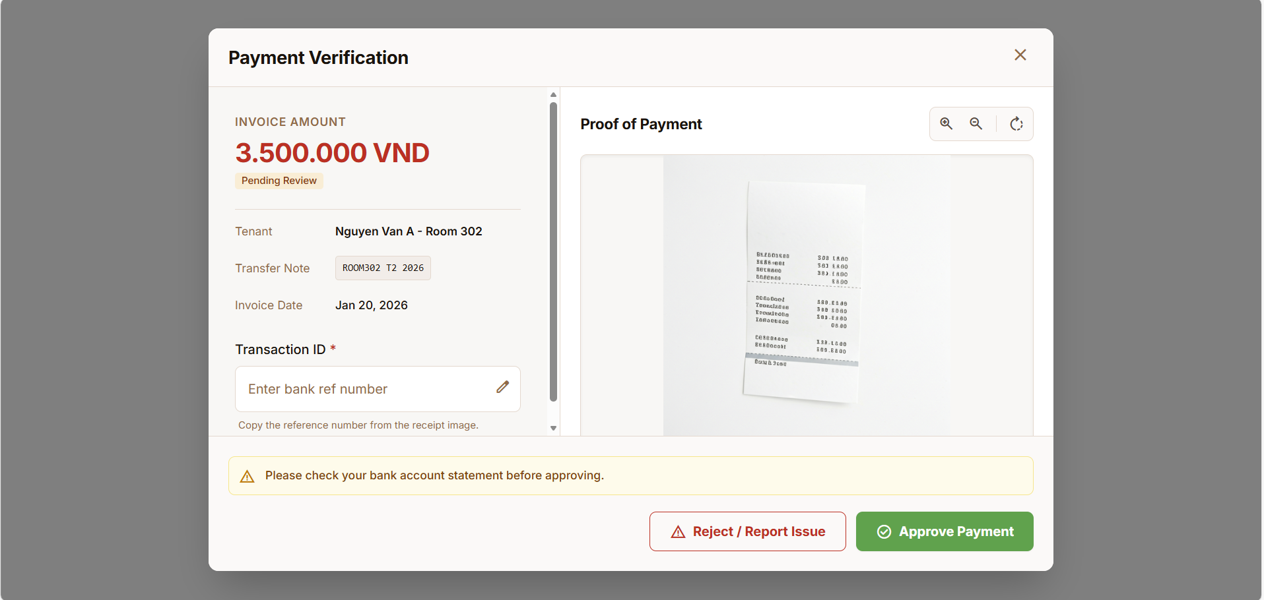

##### 20. UC-20 Export Residence List

**Functional Description Template**

| UC ID and Name: | UC-20: Export Residence List | | |
| --- | --- | --- | --- |
| Created By: | Tran Dinh Quy | Date Created: | January 14, 2026 |
| Primary Actor: | Property Owner | Secondary Actors: | **None** (System generates file locally) |
| Trigger: | The owner needs to report temporary residence to local police (Ad-hoc). | | |
| Description: | Exports tenant data (Name, ID Number, DOB, Hometown) in a standardized format for legal compliance. | | |
| Preconditions: | **PRE-1:** Tenants have completed KYC (UC-03) and profiles are updated. | | |
| Postconditions: | **POST-1:** A file (Excel/PDF) is downloaded to the owner's device. | | |
| Normal Flow: | **20.0 Normal Flow**  1. The owner navigates to "Tenant Management".  2. Owner selects "Export Residence Report".  3. System prompts for date range or specific building.  4. Owner confirms selection.  5. System queries database for active tenants matching criteria.  6. System formats data into the Government Standard Template (.xlsx).  7. System initiates file download.  8. Use Case ends. | | |
| Alternative Flows: | None. | | |
| Exceptions: | **20.0.E1 Missing Data**  *Occurs at step 5:*  1. The system finds tenants with missing ID numbers.  2. The system warns: "Some tenants have incomplete profiles."  3. The system allows export but highlights missing fields in red.  4. Resume step 6. | | |
| Priority: | Medium (Should Have) | | |
| Frequency of Use: | Monthly or Ad-hoc. | | |
| Business Rules: | **BR-LEGAL-01:** Export format must comply with Vietnam regulations (CT03/CT04 forms). | | |
| Other Information: | Data privacy is critical; export logs are recorded. | | |
| Assumptions: | Tenant data is up-to-date in the system. | | |

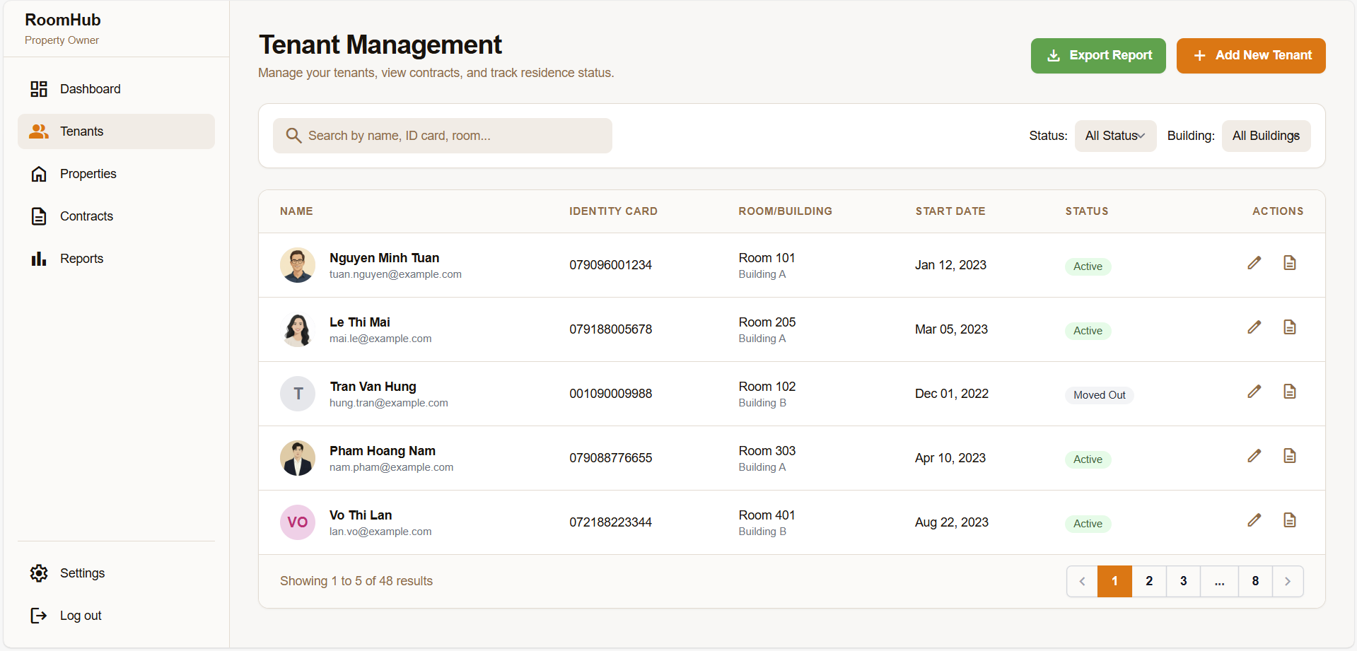

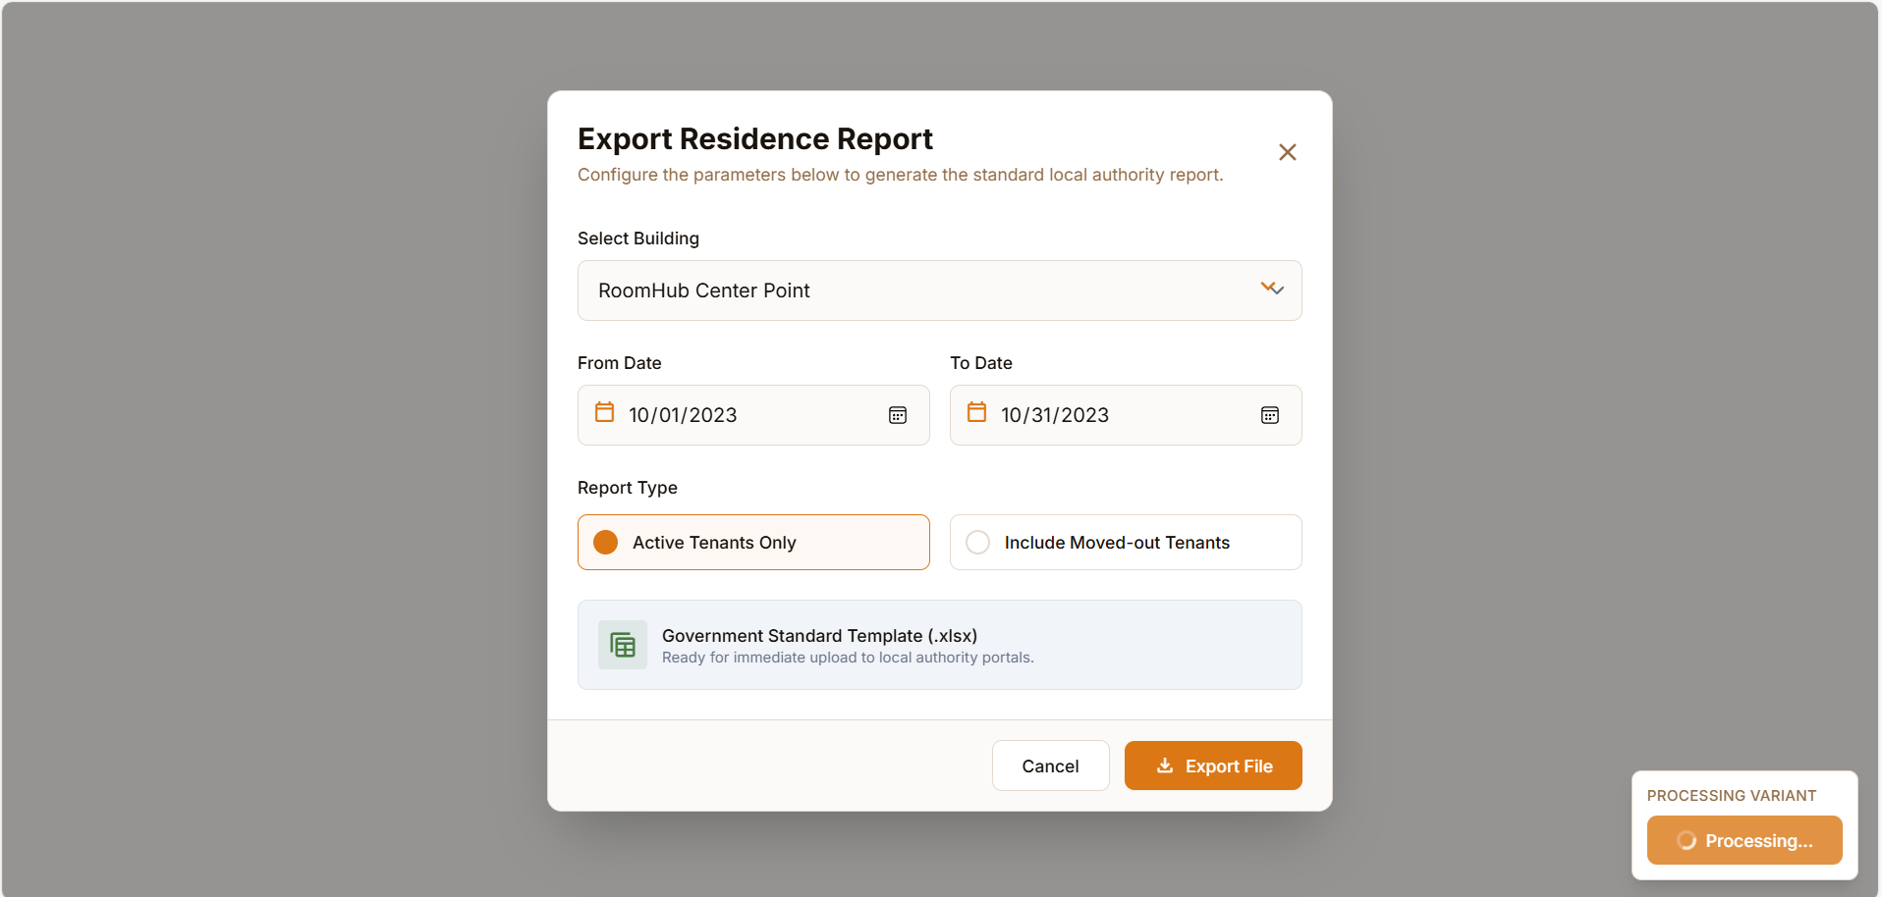

##### 21. UC-21 Submit Maintenance Ticket

**Functional Description Template**

| UC ID and Name: | UC-21: Submit Maintenance Ticket | | |
| --- | --- | --- | --- |
| Created By: | Tran Dinh Quy | Date Created: | January 14, 2026 |
| Primary Actor: | Tenant | Secondary Actors: | **Property Owner** (Notification receiver), **AI Engine** (Sentiment Analysis trigger) |
| Trigger: | Tenant identifies a facility issue (e.g., broken AC, leak). | | |
| Description: | Allows tenants to report facility issues to the owner, including descriptions and photos. Triggers AI sentiment analysis. | | |
| Preconditions: | **PRE-1:** Tenant has an active contract. | | |
| Postconditions: | **POST-1:** A new Ticket is created with status "Open".  **POST-2:** Owner receives a notification. | | |
| Normal Flow: | **21.0 Normal Flow**  1. Tenant navigates to the "Requests" section.  2. Tenant clicks "New Maintenance Ticket".  3. The system asks for Categories (Electric, Water, Internet, Other).  4. Tenant selects Category and enters Description.  5. Tenant uploads photos of the issue (Optional).  6. Tenant clicks "Submit".  7. System validates input.  8. System saves Ticket with status "Open".  9. System triggers **UC-23 (Analyze Maintenance Sentiment)** in the  background.  10. The system displays confirmation to the tenant. | | |
| Alternative Flows: | **21.1 Cancel Submission**  *Before step 6:*  1. Tenant clicks "Cancel".  2. System discards data.  3. Return to Dashboard. | | |
| Exceptions: | **21.0.E1 File Too Large**  *Occurs at step 6:*  1. The uploaded image exceeds the limit (e.g., 5MB).  2. The system displays an error message.  3. Tenant re-uploads a smaller file.  4. Resume step 6. | | |
| Priority: | High (Must Have) | | |
| Frequency of Use: | Ad-hoc (As issues arise). | | |
| Business Rules: | **BR-MAINT-01:** Tenants can only submit tickets for their own room or common areas. | | |
| Other Information: | Integration with UC-23 is seamless to the user. | | |
| Assumptions: | Internet connection is available. | | |

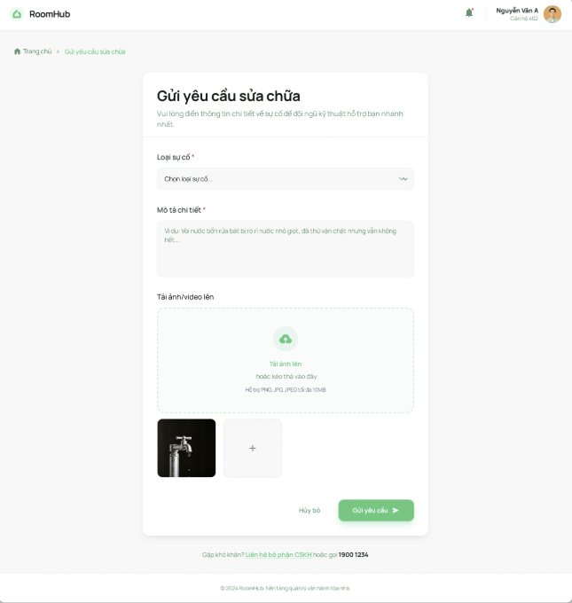

##### 22. UC-22 Manage Maintenance Tickets

**Functional Description Template**

| UC ID and Name: | UC-22: Manage Maintenance Tickets | | |
| --- | --- | --- | --- |
| Created By: | Tran Dinh Quy | Date Created: | January 14, 2026 |
| Primary Actor: | Property Owner | Secondary Actors: | **Tenant** (Notification receiver), **External Repair Service** (Vendor - if assigned) |
| Trigger: | New ticket received OR Update on repair progress. | | |
| Description: | Tracks ticket progress, assigns tasks to repair services, and updates resolution status (Open -> In Progress -> Resolved). | | |
| Preconditions: | **PRE-1:** At least one ticket exists in the system. | | |
| Postconditions: | **POST-1:** Ticket status is updated.  **POST-2:** Tenant is notified of the progress. | | |
| Normal Flow: | **22.0 Normal Flow**  1. Owner views list of Tickets (sorted by Priority/Date).  2. The owner selects a ticket to view details (including AI Sentiment).  3. The owner changes status from "Open" to "In Progress".  4. The owner enters "Estimated Completion Time" and "Note to  Tenant".  5. System notifies Tenant of the update.  6. (Repair process occurs off-system)  7. The owner changes status to "Resolved".  8. The system closes the ticket. | | |
| Alternative Flows: | **22.1 Assign to Vendor**  *Step 3 branches to:*  1. Owner selects "Assign External Service".  2. The system shows a list of saved Vendors.  3. The owner selects a Vendor and sends details.  4. System updates status to "Assigned".  5. Resume Normal Flow. | | |
| Exceptions: | None. | | |
| Priority: | High (Must Have) | | |
| Frequency of Use: | Daily. | | |
| Business Rules: | **BR-MAINT-02:** Resolved tickets cannot be reopened after 3 days. | | |
| Other Information: | Owner can view AI Sentiment analysis results within the Ticket Details. | | |
| Assumptions: | None. | | |

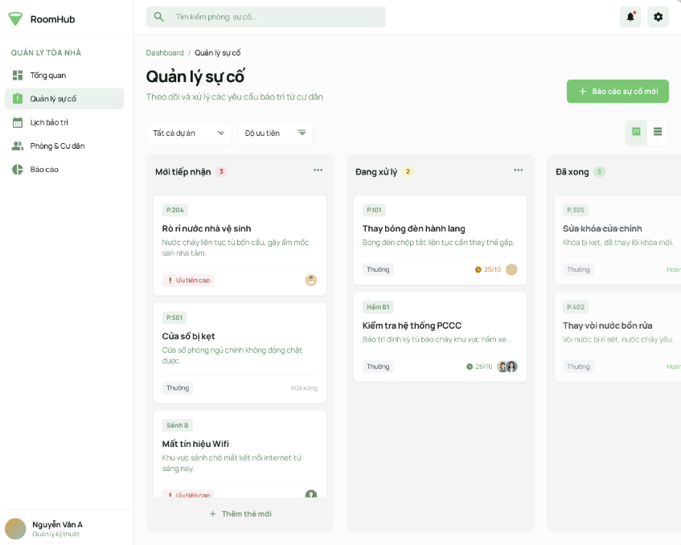

##### 23. UC-23 Analyze Maintenance Sentiment

**Functional Description Template**

| UC ID and Name: | UC-23: Analyze Maintenance Sentiment | | |
| --- | --- | --- | --- |
| Created By: | Tran Dinh Quy | Date Created: | January 14, 2026 |
| Primary Actor: | **AI Engine** (System Actor) | Secondary Actors: | **Property Owner** (Consumer of the analysis) |
| Trigger: | A new Maintenance Ticket is submitted (UC-21) OR Tenant adds a comment to an existing ticket. | | |
| Description: | Uses NLP to analyze the text content of tickets/comments to classify tenant sentiment (Positive, Neutral, Negative, Urgent). | | |
| Preconditions: | **PRE-1:** Ticket contains text description. | | |
| Postconditions: | **POST-1:** A sentiment score/tag is attached to the Ticket entity. | | |
| Normal Flow: | **23.0 Normal Flow**  1. Trigger event occurs (New text detected from UC-21).  2. The system sends text data to the AI Analysis Module.  3. AI Engine processes text (Keyword extraction, Sentiment scoring).  4. AI Engine classifies results (e.g., "Negative - Frustrated").  5. The system updates the Ticket display with a Sentiment Indicator.  6. If Sentiment is "Negative" or "Urgent", System highlights the ticket for  the Property Owner.  7. Use Case ends. | | |
| Alternative Flows: | None. | | |
| Exceptions: | **23.0.E1 Service Unavailable**  *Occurs at step 3:*  1. AI Service is down or timed out.  2. System logs warning.  3. System defaults sentiment to "Neutral".  4. Use Case ends. | | |
| Priority: | Low (Could Have) | | |
| Frequency of Use: | Continuous (triggered by data entry). | | |
| Business Rules: | **BR-AI-01:** Specific keywords (fire, flood, danger) trigger an immediate "High Priority" alert regardless of sentiment score. | | |
| Other Information: | Helps Property Owners prioritize tickets based on tenant emotion. | | |
| Assumptions: | Text is in a supported language (Vietnamese/English). | | |

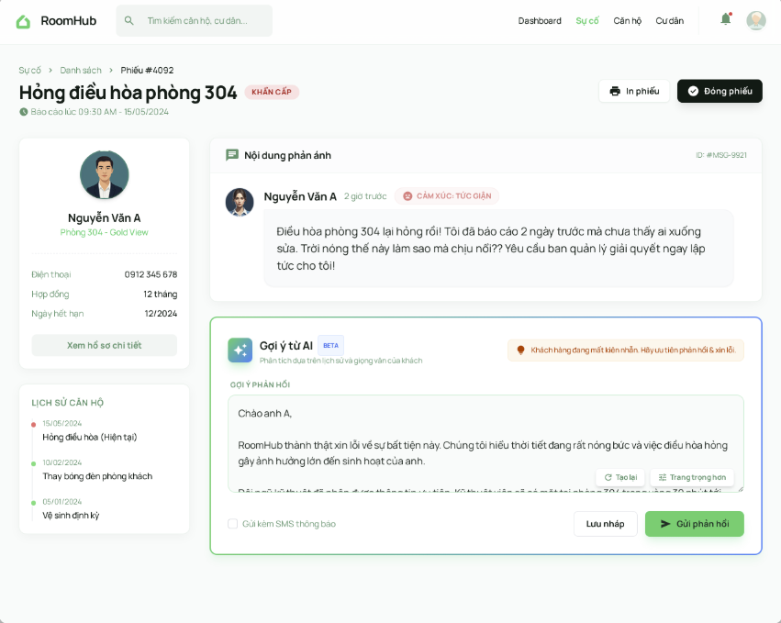

##### 24. UC-24 Request Extra Service

**Functional Description Template**

| UC ID and Name: | UC-24: Request Extra Service | | |
| --- | --- | --- | --- |
| Created By: | Tran Dinh Quy | Date Created: | January 14, 2026 |
| Primary Actor: | Tenant | Secondary Actors: | **Property Owner** (Service Provider), **External Vendor** (If outsourced) |
| Trigger: | Tenants want to use an additional amenity (e.g., Laundry, Room Cleaning). | | |
| Description: | Enables tenants to browse the service marketplace, book services, and have fees added to their monthly bill. | | |
| Preconditions: | **PRE-1:** Tenant has an active contract.  **PRE-2:** Owner has configured available services in the system. | | |
| Postconditions: | **POST-1:** Service request is recorded.  **POST-2:** Fee is added to the "Unbilled Services" queue (for UC-17  Invoice Generation). | | |
| Normal Flow: | **24.0 Normal Flow**  1. Tenant navigates to "Services Marketplace".  2. Tenant browses available services (Name, Price, Description).  3. Tenant selects a service (e.g., "Room Cleaning").  4. Tenant selects Date/Time and Quantity.  5. The system calculates estimated cost.  6. Tenant confirms booking.  7. The system creates a Service Request.  8. The system notifies the owner to arrange the service.  9. System queues the cost to be added to the next Invoice.  10. Use Case ends. | | |
| Alternative Flows: | **24.1 Cancel Request**  *Before service delivery:*  1. Tenant clicks "Cancel Booking".  2. System checks cancellation policy (e.g., must be >24h before).  3. The system removes the request and voids the pending fee.  4. The system notifies the owner of cancellation.  5. Use Case ends. | | |
| Exceptions: | **24.0.E1 Service Unavailable**  *Occurs at step 4:*  1. The selected time slot is full or unavailable.  2. The system displays errors and suggests alternative times.  3. Return to step 4. | | |
| Priority: | Medium (Should Have). | | |
| Frequency of Use: | Ad-hoc. | | |
| Business Rules: | **BR-SERV-01:** Service fees are collected in the next month's rental invoice, not paid immediately (unless configured otherwise). | | |
| Other Information: | None. | | |
| Assumptions: | The owner or 3rd party is available to fulfill the service at the requested time. | | |

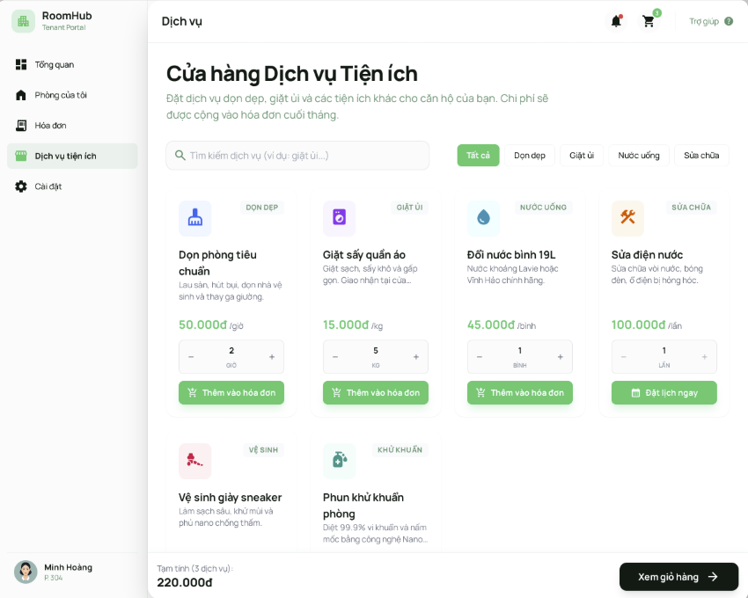

##### **25.** **UC-25: Chat with AI Assistant**

**Functional Description Template**

| UC ID and Name: | UC-25: Chat with AI Assistant | | |
| --- | --- | --- | --- |
| Created By: | Phan Hoài An | Date Created: | January 14, 2026 |
| Primary Actor: | Guest, Tenant | Secondary Actors: | AI Engine |
| Trigger: | - The user clicks on the "AI Support" floating icon on the interface.  - The user inputs a text message into the open chat window and presses "Send". | | |
| Description: | This use case allows users (Guests or Tenants) to interact with an NLP-powered chatbot to receive instant, automated responses regarding rental policies, booking procedures, and general room information. The system utilizes an external AI Engine to process natural language and provide context-aware answers. | | |
| Preconditions: | PRE-1: The user’s device must have an active Internet connection. PRE-2: The external AI Service (API) must be operational and reachable. PRE-3: The System Configuration for "AI Chatbot" is enabled. | | |
| Postconditions: | POST-1: The user's query is processed, and the AI's response is displayed in the chat interface.  POST-2: The chat session history is temporarily cached (for Guests) or saved to the database (for logged-in Tenants) for context continuity. | | |
| Normal Flow: | 1. The User clicks the Chatbot icon to open the chat window.  2. The System displays a welcome message (e.g., "Hello! How can RoomHub assist you today?").  3. The User types a question (e.g., "What is the deposit policy?") and clicks "Send".  4. The System (Frontend) validates the input (non-empty) and sends the message to the Backend.  5. The System (Backend) constructs a prompt context and forwards the query to the AI Engine via API.  6. The AI Engine processes the intent and retrieves relevant information from the Knowledge Base.  7. The AI Engine returns a text response to the System.  8. The System displays the response to the User in real-time.  9. The User reads the response and may continue the conversation or close the chat window. | | |
| Alternative Flows: | **Low Confidence / Unknown Query:**  At step 6, if the AI Engine cannot determine a clear answer or the confidence score is below the threshold:  - The AI returns a fallback response: "I apologize, but I don't have information on that specific topic. Would you like to contact the Property Owner directly?"  - The System displays a "Contact Support" button or links to the "Send Direct Message" function.  **Context-Aware Query (Room Detail Context):**  At step 3, if the User initiates the chat while viewing a specific Room Detail page (e.g., Room 101):  - The System automatically appends the "RoomContext" (Room ID, Price, Address) to the prompt sent to the AI.  - If the User asks "Is this available?", the AI understands "this" refers to Room 101 and answers based on that specific room's status. | | |
| Exceptions: | **Network Connection Failure:**  During step 4, if the System detects a loss of internet connection:  - The System displays an error message: "Connection lost. Please check your network."  - The message is not sent, and a "Retry" button is enabled.  **External AI Service Timeout:**  At step 5, if the AI Engine API fails to respond within the configured timeout (e.g., 10 seconds):  - The System logs the error for the Administrator.  - The System displays a user-friendly message: "Our AI assistant is currently overwhelmed. Please try again in a moment."  **Prohibited Content Detected (Linked to FE-AI-07):**  At step 4, if the Content Moderation filter detects profanity, hate speech, or sensitive personal data in the User's input:  - The System blocks the message immediately (does not send to AI).  - The System displays a warning: "Your message contains inappropriate content and violates our Community Standards." | | |
| Priority: | Medium (Should Have) | | |
| Frequency of Use: | High (Expected interaction for most new visitors). | | |
| Business Rules: | - The AI must strictly answer questions related to RoomHub's domain (Rentals, Policies). It should refuse to answer political or religious questions.  - Response time latency should not exceed 5 seconds under normal network conditions to ensure user satisfaction. | | |
| Other Information: | - Non-functional Requirement: The Chat interface must be responsive and fully functional on mobile devices.  - Developer Note: Consider using SignalR for real-time streaming of the AI response (typing effect) to enhance UX. | | |
| Assumptions: | - The Knowledge Base used by the AI has been populated with up-to-date policies and room data by the Administrator. | | |

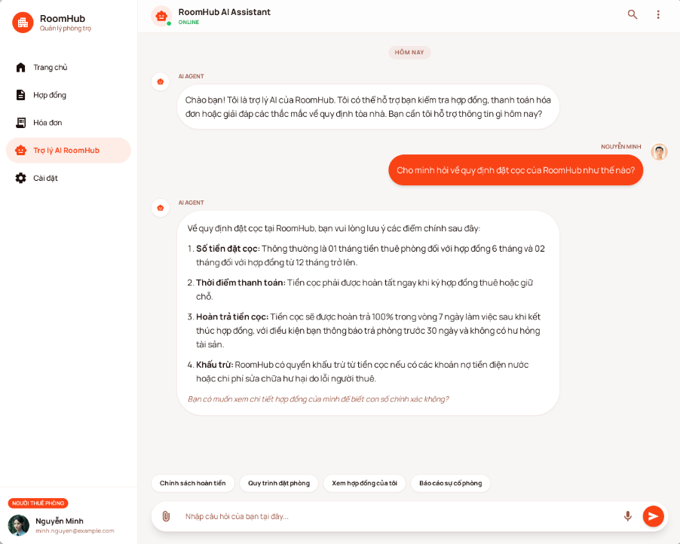

##### 26. UC-26: Send Direct Message

**Functional Description Template**

| UC ID and Name: | UC-26: Send Direct Message | | |
| --- | --- | --- | --- |
| Created By: | Phan Hoài An | Date Created: | January 14, 2026 |
| Primary Actor: | Tenant, Property Owner | Secondary Actors: | Administrator, AI Engine (Content Moderation), Notification Service |
| Trigger: | - User clicks the "Message" button on a Room Detail page or User Profile.  - User selects an existing conversation from the "Inbox" list. | | |
| Description: | Facilitates real-time, one-to-one text and image communication between users. The system ensures immediate message delivery via WebSockets (SignalR) and persists conversation history in the database. It includes AI-driven content moderation to ensure community safety. | | |
| Preconditions: | PRE-1: User is logged in and holds a valid JWT Access Token.  PRE-2: SignalR WebSocket connection is established successfully.  PRE-3: The recipient's account is active (not banned). | | |
| Postconditions: | POST-1: The message is saved to the database (SQL Server) with a "Sent" status.  POST-2: The recipient receives the message instantly via the UI (if online) or receives a notification (if offline). | | |
| Normal Flow: | 1. Sender navigates to the Chat Interface and selects a Recipient.  2. System retrieves and displays the conversation history (paginated).  3. Sender types a text message and executes the "Send" command.  4. System validates the message content via the AI Engine (Check for prohibited content).  5. System stores the message in the database with "Unread" status.  6. System instantly pushes the message payload to the Recipient's active session.  7. System sends an acknowledgment (ACK) back to the Sender.  8. System updates the Sender's view to indicate the message has been sent.  9. Recipient's interface receives the data and appends the new message to the chat window immediately. | | |
| Alternative Flows: | **Sending an Image/File:**  At step 3, if Sender chooses to attach an image:  - User selects an image file from their device.  - System uploads the file to the secure storage server.  - System generates a file access URL.  - System sends a message containing the Image URL to the Recipient (proceeds to step 4).  **Recipient is Offline:**  At step 6, if the System detects the Recipient has no active connection:  - System skips real-time delivery.  - System triggers a background service to send an Email or Push Notification to the Recipient indicating a new message.  - When Recipient logs in later, the "Unread Message" indicator is displayed.  **Contextual Chat (Starting from Room Detail):**  At step 1, if Sender initiates chat from a specific Room Listing:  - System automatically generates a "Context Card" (containing Room Name, Price, Reference Link) and inserts it as the first message of the conversation context. | | |
| Exceptions: | **Content Violation Detected:**  At step 4, if the AI Engine flags the content as inappropriate (profanity, hate speech):  - System rejects the message and does not store it.  - System returns an error code to the Sender.  - Sender's interface displays a warning: "Message blocked due to policy violation."  **Connection Failure:**  During the interaction, if the network connection is interrupted:  - System attempts to automatically reconnect to the messaging service. - Interface displays a "Reconnecting..." status.  - The "Send" function is temporarily disabled until the connection is restored. | | |
| Priority: | High (Must Have) | | |
| Frequency of Use: | Very High (Continuous interaction). | | |
| Business Rules: | BR-26.1: Users cannot delete or edit messages after a specific timeframe (e.g., 1 hour) to ensure transparency for dispute resolution. BR-26.2: Attached images must adhere to the system's file size and format limits.  BR-26.3: Privacy: Administrators are restricted from viewing private messages unless investigating a specific user-reported violation. | | |
| Other Information: | - The system must support "Typing indicators" (e.g., showing when the other user is typing) to enhance user experience.  - Messages should support "Read Receipts" (indicating when the recipient has viewed the message).  - Data transmission must be encrypted (SSL/TLS) to ensure privacy. | | |
| Assumptions: | - The Content Moderation service processes text in near real-time to prevent noticeable delays in message delivery. | | |

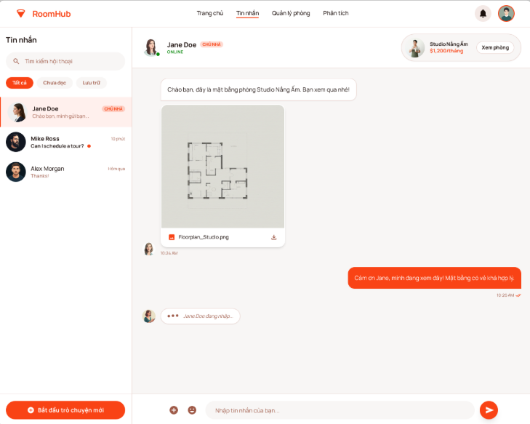

##### 27. UC-27: Moderate Chat Content

**Functional Description Template**

| UC ID and Name: | UC-27: Moderate Chat Content | | |
| --- | --- | --- | --- |
| Created By: | Phan Hoài An | Date Created: | January 14, 2026 |
| Primary Actor: | AI Engine (System Actor) | Secondary Actors: | Administrator, Sender (User) |
| Trigger: | - A generic "Content Submission" event is triggered by other use cases (e.g., User sends a message in UC-26, or submits a review in UC-28). | | |
| Description: | Automatically analyzes user-generated content (text and images) in real-time to detect and handle prohibited material such as hate speech, harassment, spam, or sensitive personal information. The system uses an AI Engine to classify content and enforces blocking or flagging actions based on predefined safety policies. | | |
| Preconditions: | PRE-1: The AI Content Analysis service is operational and configured with the latest safety policies.  PRE-2: The content submission contains valid text or image data. | | |
| Postconditions: | POST-1: The content is assigned a moderation status (e.g., "Safe", "Flagged", "Blocked").  POST-2: (If violation) A violation record is logged in the Audit System for Administrator review. | | |
| Normal Flow: | 1. System intercepts the content payload (text/image) before it is persisted or delivered to the recipient.  2. System sanitizes the input (removes code scripts, html tags).  3. System transmits the content to the AI Engine for analysis.  4. AI Engine analyzes the content against safety categories (Harassment, Hate Speech, Sexual, Self-harm, PII).  5. AI Engine returns a result indicating "Safe" (Confidence Score < Threshold).  6. System tags the content as "Approved".  7. System releases the content to proceed with the original workflow (e.g., delivering the message). | | |
| Alternative Flows: | **Content is Prohibited (Blocking Flow):**  At step 5, if AI Engine returns a result indicating "Unsafe" (High Confidence):  - System tags the content as "Blocked".  - System halts the delivery process immediately.  - System records the violation details (User ID, Content, Violation Category, Timestamp).  - System returns a "Policy Violation" error code to the originating process.  - (Optional) System triggers a warning notification to the Sender.  **Content is Ambiguous (Flagging Flow):**  At step 5, if AI Engine returns a result indicating "Uncertain" (Medium Confidence):  - System tags the content as "Flagged for Review".  - System allows the content to be delivered (to avoid disrupting communication false positives).  - System adds the content to a "Moderation Queue" for the Administrator to manually review later. | | |
| Exceptions: | **AI Service Unreachable:**  At step 3, if the connection to the AI Engine fails or times out: - System logs a "Moderation Bypass" warning.  - System applies a "Fail-Open" policy: The content is marked as "Unverified" and allowed to proceed to ensure service continuity.  - The content is queued for retrospective analysis when the service is back online.  **Unsupported Media Type:**  At step 2, if the content format is not supported by the AI (e.g., a proprietary file format):  - System skips AI analysis.  - System applies standard file extension whitelisting rules. | | |
| Priority: | High (Must Have) | | |
| Frequency of Use: | Very High (Triggered on every message/post). | | |
| Business Rules: | BR-27.1: Zero Tolerance: Content classified as "CSAM" (Child Sexual Abuse Material) or "Terrorism" must be blocked immediately and the user account automatically suspended pending investigation.  BR-27.2: Privacy Protection: The AI Engine must not store user messages for model training purposes to comply with data privacy regulations (GDPR/PDPA).  BR-27.3: Sensitive Data: The system should detect and mask financial information (e.g., Credit Card numbers) if shared in chat. | | |
| Other Information: | - Latency Requirement: The moderation process must complete within 500ms to maintain a real-time feel for chat applications.  - Configuration: Administrators must have an interface to adjust the "Sensitivity Threshold" (e.g., Strict vs. Lenient) without changing code. | | |
| Assumptions: | - The AI model is pre-trained and does not require real-time learning from the specific interactions of this system. | | |

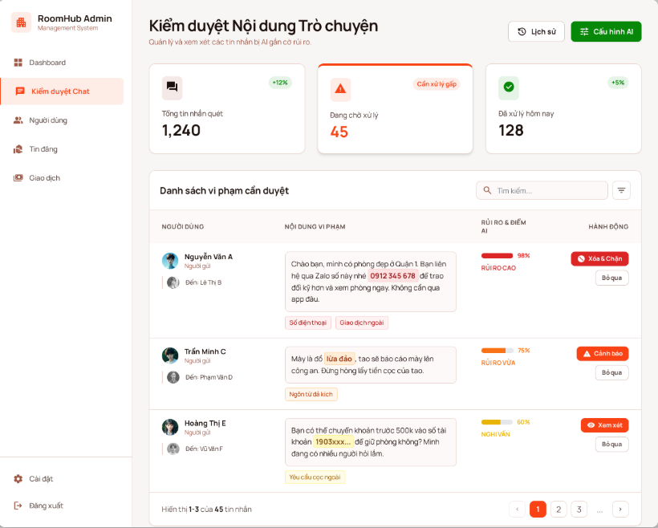

##### **28. UC-28: Submit Rating & Review**

**Functional Description Template**

| UC ID and Name: | UC-28: Submit Rating & Review | | |
| --- | --- | --- | --- |
| Created By: | Phan Hoài An | Date Created: | January 14, 2026 |
| Primary Actor: | Tenant | Secondary Actors: | AI Engine (Content Moderation), Property Owner (Notification receiver) |
| Trigger: | - Tenant navigates to their "Rental History" or "My Contracts" section and clicks the "Write Review" button on a completed contract.  - Tenant clicks on a "Rate your stay" link via an automated email/notification sent by the system after the contract end date. | | |
| Description: | Allows tenants to submit a qualitative (text) and quantitative (star rating) assessment of the room and property owner after their rental period has concluded. The system validates the eligibility of the reviewer, filters content for appropriateness, and updates the aggregated rating metrics of the property. | | |
| Preconditions: | PRE-1: Tenant is logged in and authenticated.  PRE-2: The specific Rental Contract status must be "Liquidated", "Terminated", or "Expired".  PRE-3: Tenant has not previously submitted a review for this specific contract ID.  PRE-4: The review submission is within the allowable timeframe (e.g., 30 days after contract end). | | |
| Postconditions: | POST-1: A new Review record is created in the database.  POST-2: The "Average Rating" score of the Room and the Property Owner is recalculated and updated.  POST-3: The Property Owner receives a notification about the new review. | | |
| Normal Flow: | 1. System retrieves the details of the completed contract (Room Name, Stay Duration) and displays the Review Form.  2. Tenant selects a Star Rating (1 to 5 stars) for specific criteria (e.g., Cleanliness, Amenities, Landlord Support).  3. Tenant enters a textual comment describing their experience.  4. Tenant executes the "Submit" command.  5. System validates the input (Stars are selected, Text length is within limits).  6. System submits the text content to the AI Engine for automated moderation (invoking UC-27).  7. AI Engine returns a "Safe" result.  8. System persists the review data to the database with status "Published".  9. System triggers an asynchronous process to recalculate the average rating of the Room.  10. System displays a success message: "Thank you for your feedback!" and hides the "Write Review" button for this contract. | | |
| Alternative Flows: | **Review Flagged by AI (Linked to UC-27):**  At step 7, if AI Engine returns "Flagged" or "Uncertain":  - System saves the review with status "Pending Approval".  - System informs the Tenant: "Your review has been submitted for moderation and will appear shortly."  - The review is not visible publicly until an Administrator manually approves it.  **Review Blocked by AI (Linked to UC-27):**  At step 7, if AI Engine returns "Blocked" (e.g., Profanity):  - System rejects the submission.  - System displays an error: "Your review contains prohibited language. Please edit and try again." | | |
| Exceptions: | **Duplicate Submission Attempt:**  At step 1, if the System detects that a review for this Contract ID already exists (e.g., user exploits a browser bug or API call):  - System denies access to the form.  - System redirects user to the "View My Review" page.  **Time Window Expired:**  At step 1, if the current date is past the allowed review period (e.g., > 30 days after end date):  - System disables the "Write Review" feature.  - System displays a message: " The review period for this contract has expired." | | |
| Priority: | Medium (Should Have) | | |
| Frequency of Use: | Low (Once per contract lifecycle). | | |
| Business Rules: | BR-28.1: Verified Reviews Only: Only users who have a completed transaction/contract within the system can submit a review. (No guest reviews).  BR-28.2: One-Time Policy: A tenant can only review a specific stay once. Editing is allowed within 3 days of submission, but deleting is not allowed to prevent manipulation.  BR-28.3: Double-Blind (Optional): Reviews are only revealed after the Owner has also reviewed the Tenant, or after 14 days | | |
| Other Information: | - Aggregation Logic: The system must update the average rating using a weighted average or simple average formula immediately or via a scheduled job to ensure search results (UC-10) reflect the new score.  - Privacy: The review will display the Tenant's First Name and Last Initial only (e.g., "An N.") to protect privacy while maintaining authenticity. | | |
| Assumptions: | - The rating scale is fixed at 1-5 integers. | | |

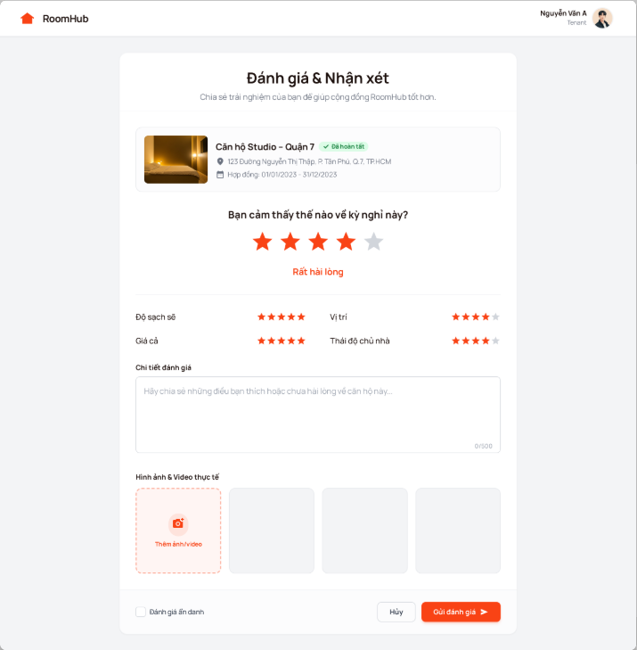

##### **29. UC-29: Moderate Reviews**

**Functional Description Template**

| UC ID and Name: | UC-29: Moderate Reviews | | |
| --- | --- | --- | --- |
| Created By: | Phan Hoài An | Date Created: | January 14, 2026 |
| Primary Actor: | AI Engine (System Actor) | Secondary Actors: | Administrator, Tenant (Reviewer) |
| Trigger: | - A Tenant successfully submits a new review (Triggered by step 4 of UC-28). | | |
| Description: | This use case describes the automated workflow for screening user-submitted reviews before they are publicly visible. The system utilizes an AI Engine to detect policy violations (e.g., spam, fake reviews, hate speech). High-confidence safe content is auto-published, while suspicious content is held for manual Administrator review. | | |
| Preconditions: | PRE-1: A review has been created in the database with an initial status of "Pending Moderation".  PRE-2: The AI Moderation Service is active and configured. | | |
| Postconditions: | POST-1: The review status is updated to "Published", "Rejected", or "Flagged for Review".  POST-2: (If Published) The review becomes visible on the Room Detail page and counts towards the rating aggregate. | | |
| Normal Flow: | 1. System retrieves the newly submitted review content (text and images).  2. System transmits the content to the AI Engine for analysis.  3. AI Engine analyzes the content against the "Community Standards" and "Anti-Spam" models.  4. AI Engine returns a result: Verdict="Safe", Confidence Score > 90%.  5. System updates the Review status from "Pending Moderation" to "Published".  6. System triggers the Rating Aggregation Logic (to update the average star score).  7. System sends a notification to the Property Owner: "You have a new review." | | |
| Alternative Flows: | **Auto-Rejection (Clear Violation):**  At step 4, if AI Engine returns: Verdict="Unsafe" (e.g., Profanity, External Links, PII):  - System updates the Review status to "Rejected".  - System sends a notification to the Tenant: "Your review was not published because it violates our content policy."  - The review remains hidden from the public.  **Manual Review Required (Ambiguous Content):**  At step 4, if AI Engine returns: Verdict="Uncertain" (Confidence Score < 90%):  - System updates the Review status to "Flagged for Review".  - System places the review into the "Administrator Moderation Queue". - (Manual Step) Administrator logs into the Dashboard, reads the review, and manually selects "Approve" or "Reject".  - System updates the status based on Administrator's decision. | | |
| Exceptions: | **AI Service Downtime:**  At step 2, if the System cannot connect to the AI Engine:  - System applies a "Fail-Safe" policy: The review status remains "Pending Moderation".  - System logs the error.  - The review waits in the queue until the AI service is back online or an Administrator manually processes it. | | |
| Priority: | High (Must Have) | | |
| Frequency of Use: | Low to Medium (Depends on the volume of new reviews). | | |
| Business Rules: | BR-29.1: Anti-Spam: Reviews containing URLs, email addresses, or phone numbers in the text body should be automatically flagged or rejected to prevent platform leakage.  BR-29.2: Conflict of Interest: The AI should flag reviews if the textual pattern suggests collusion (e.g., bot-generated text patterns).  BR-29.3: Privacy: The specific reason for rejection (e.g., "Contains Hate Speech") is stored internally but only a generic "Policy Violation" message is shown to the user to prevent gaming the system. | | |
| Other Information: | - SLA (Service Level Agreement): Auto-moderation should complete within 1 minute. Manual moderation (if flagged) should be resolved within 24 hours.  - Dashboard Requirement: Administrators need a specific interface to view "Flagged" reviews side-by-side with the AI's predicted reason (e.g., "AI detected: Harassment 75%"). | | |
| Assumptions: | - The AI model is capable of understanding the local language (Vietnamese) and slang used in the rental context. | | |

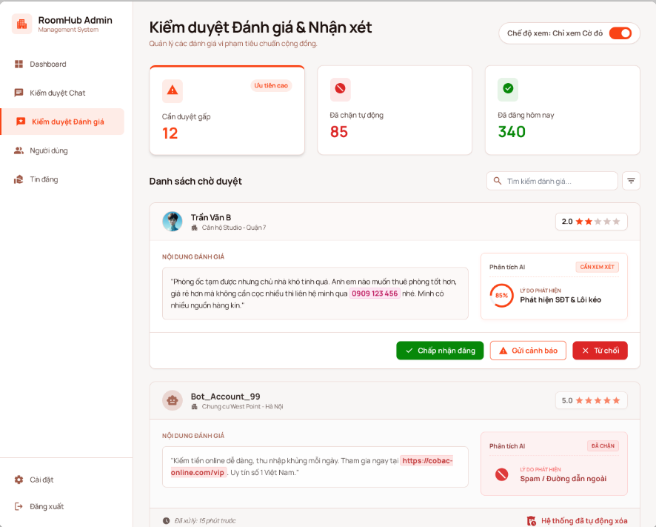

##### 

##### **30. UC-30: View Executive Dashboard**

**Functional Description Template**

| UC ID and Name: | UC-30: View Executive Dashboard | | |
| --- | --- | --- | --- |
| Created By: | Phan Hoài An | Date Created: | January 14, 2026 |
| Primary Actor: | Property Owner | Secondary Actors: | System (Data Aggregator) |
| Trigger: | - The Property Owner logs into the system (Default landing page). - - The Property Owner selects the "Dashboard" or "Overview" tab from the main navigation menu. | | |
| Description: | Provides a centralized visual interface displaying Key Performance Indicators (KPIs) and analytical charts. This allows the Property Owner to monitor business health in real-time, focusing on Monthly Revenue, Occupancy Rates, Outstanding Debts, and recent activity logs. | | |
| Preconditions: | PRE-1: User is successfully authenticated as a Property Owner.  PRE-2: The user has at least one property (Building/Room) configured in the system. | | |
| Postconditions: | POST-1: Statistical data is retrieved and rendered visually (Charts/Graphs).  POST-2: No data modification occurs (Read-only operation). | | |
| Normal Flow: | 1. User accesses the Dashboard page.  2. System identifies the current month and year.  3. System queries the database to aggregate financial and operational data for the current period.  4. System calculates Key Metrics:  - Total Revenue: Sum of all "Paid" invoices in the current month.  - Total Debt: Sum of all "Unpaid" invoices past the due date.  - Occupancy Rate: (Count of "Occupied" Rooms / Total Rooms) * 100.  5. System retrieves the list of "Recent Activities" (e.g., New contract signed, Ticket created).  6. System returns the aggregated data payload to the User Interface.  7. User Interface renders the data into visual components: - Revenue Chart (Bar/Line graph). - Occupancy Donut Chart. - Summary Cards (Revenue, Debt, Total Tenants). 8. User views the insights. | | |
|  | **Filter by Time Range:**  At step 1, User selects a different time range (e.g., "Last Month", "This Year", "Custom Date Range") from the Date Picker:  - System re-executes the query (Step 3) using the selected start and end dates.  - User Interface updates the charts to reflect the new time period.  **Filter by Property (Specific Building):**  At step 1, if User manages multiple buildings, they select "Building A" from a dropdown filter:  - System filters the query scope to include only data related to "Building A".  - User Interface updates metrics to show performance for that specific building only. | | |
| Exceptions: | **No Data Available (Cold Start):**  At step 3, if the System finds no historical data (e.g., new account): - System returns zero values for all metrics.  - User Interface displays an "Empty State" with a Call-to-Action: "No data yet. Start by creating your first room."  **Data Aggregation Timeout:**  At step 3, if the volume of data is too large and the query exceeds the timeout limit (e.g., > 10 seconds):  - System cancels the request to prevent server overload.  - User Interface displays an error: "Unable to load analytics. Please try selecting a shorter date range." | | |
| Priority: | High (Must Have) | | |
| Frequency of Use: | High (Daily/Weekly). | | |
| Business Rules: | BR-30.1: Data Isolation: A Property Owner must ONLY see data related to properties they own or manage. Strictly prohibit accessing another owner's financial data.  BR-30.2: Revenue Definition: "Revenue" is calculated based on the *Payment Date*, not the *Invoice Creation Date*. (Cash-flow basis).  BR-30.3: Occupancy Logic: Rooms under "Maintenance" status are excluded from the "Available" count but included in the "Total Rooms" denominator for occupancy calculation. | | |
| Other Information: | - Performance Requirement: Dashboard loading time should be under 2 seconds. - Optimization Strategy: For heavy systems, consider using "Materialized Views" or "Caching" (Redis) to store calculated metrics instead of running complex SQL Aggregation queries on every page load. - UI Requirement: Charts must be interactive (e.g., hovering over a bar shows the exact monetary value). | | |
| Assumptions: | - The currency display format defaults to VND (Vietnam Dong). | | |

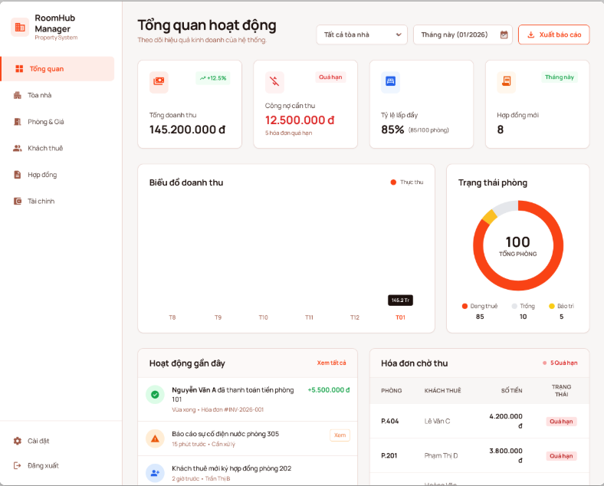

##### 31. UC-31: View AI-Powered Demand Forecast

**Functional Description Template**

| UC ID and Name: | UC-31: View AI-Powered Demand Forecast | | |
| --- | --- | --- | --- |
| Created By: | Phan Hoài An | Date Created: | January 14, 2026 |
| Primary Actor: | Property Owner | Secondary Actors: | AI Engine (Predictive Analytics Service), System (Data Aggregator) |
| Trigger: | - Property Owner clicks on the "Forecast & Insights" tab within the Executive Dashboard.  - Property Owner requests a "Revenue Projection" report for the upcoming quarter. | | |
| Description: | Allows the Property Owner to view predictive analytics regarding future room occupancy and revenue trends. The system utilizes an AI Engine (Time-series forecasting models) to analyze historical booking data, seasonality, and market trends, providing visual forecasts to aid in pricing and marketing decisions. | | |
| Preconditions: | PRE-1: User is authenticated as a Property Owner.  PRE-2: The property has sufficient historical data (e.g., at least 3 months of operation) OR the system has sufficient aggregate market data to generate a prediction.  PRE-3: The AI Prediction Service is operational. | | |
| Postconditions: | POST-1: A forecast chart (occupancy % and estimated revenue) is displayed for the selected future period (e.g., next 1-6 months). POST-2: Actionable insights (e.g., "Suggest raising prices in June") are generated. | | |
| Normal Flow: | 1. User navigates to the "Forecast" interface.  2. System determines the default forecast horizon (e.g., Next 3 Months).  3. System retrieves historical performance data (Occupancy rates, Revenue) for the Owner's properties.  4. System transmits the dataset to the AI Engine.  5. AI Engine processes the data using regression or time-series algorithms (e.g., ARIMA, Prophet).  6. AI Engine returns a prediction payload containing: - Predicted Occupancy Percentage (with Confidence Intervals). - Predicted Revenue Range (Min/Max). - Detected Trends (e.g., "Rising Demand").  7. System renders the data onto a generic Line/Area Chart, showing "Historical Data" (Solid line) connecting to "Forecast Data" (Dotted line).  8. System displays text-based "Smart Insights" (e.g., "Expect 90% occupancy in September due to student enrollment season"). | | |
| Alternative Flows: | **Forecast by Room Category:**  At step 1, User filters by specific room type (e.g., "Studio" vs. "1-Bedroom"):  - System aggregates data specific to that category.  - AI Engine generates a forecast specifically for that segment (e.g., "Studios will be fully booked, but 1-Bedrooms will have low demand").  **Scenario Analysis (What-If):**  At step 8, User adjusts a "Simulated Price" slider (e.g., Increase price by 10%):  - System requests a quick re-calculation from the AI Engine based on price elasticity models.  - AI predicts the impact on Occupancy (e.g., "Increasing price by 10% may drop occupancy by 5%, but total revenue will increase by 4%"). | | |
| Exceptions: | **Insufficient Data (Cold Start Problem):**  At step 3, if the property is new and has less than the required data points:  - System cannot run the personalized prediction model.  - System falls back to "Market Average" mode.  - User Interface displays a disclaimer: "Not enough personal data. Showing general market trends for your area instead."  - System displays aggregated data from other properties in the same District/Ward (anonymized).  **Low Confidence Score:**  At step 6, if the AI detects high volatility and the Confidence Score is low (< 60%):  - System displays the forecast but overlays a warning badge: "Low Accuracy".  - The chart visualizes a wider "Margin of Error" (shaded area) to inform the user of uncertainty. | | |
| Priority: | Low (Could Have) | | |
| Frequency of Use: | Medium (Monthly planning). | | |
| Business Rules: | BR-31.1: Data Anonymity: When using "Market Average" (E1), the system must never reveal specific competitors' data. Only aggregated averages are shown.  BR-31.2: Disclaimer: All forecasts must be clearly labeled as "Estimates" to prevent liability if predictions do not materialize. | | |
| Other Information: | - Visual Requirement: The chart should clearly distinguish between "Actual Data" (Past) and "Predicted Data" (Future) using different colors or line styles.  - Algorithm: The model should account for "Seasonality" (e.g., Tet Holiday, University semester start dates) as these are major drivers in the Vietnamese rental market. | | |
| Assumptions: | - External factors (like a sudden pandemic or economic crash) are not accounted for unless real-time external data feeds are integrated. | | |

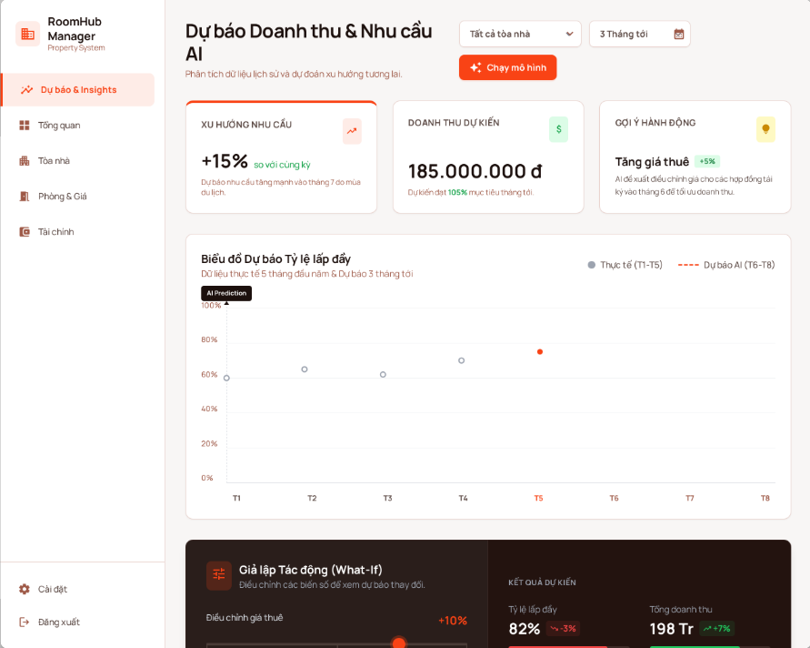

##### 32. UC-32: View Platform Analytics

**Functional Description Template**

| UC ID and Name: | UC-32: View Platform Analytics | | |
| --- | --- | --- | --- |
| Created By: | Phan Hoài An | Date Created: | January 14, 2026 |
| Primary Actor: | Administrator | Secondary Actors: | System (Analytics Service) |
| Trigger: | - Administrator logs into the Admin Portal.  - Administrator clicks on the "Platform Stats" or "Growth Report" menu item. | | |
| Description: | Provides a holistic, system-wide view of the platform's performance. It aggregates data across all tenants and property owners to track User Growth (New Signups), Traffic Volume (Active Sessions), and Financial Health (Total Transaction Volume & Platform Revenue). This data aids in strategic decision-making and investor reporting. | | |
| Preconditions: | PRE-1: User is authenticated and possesses the "Administrator" role (Root/Super Admin).  PRE-2: The Analytics background jobs have successfully run to aggregate the latest data. | | |
| Postconditions: | POST-1: Aggregated statistical data is retrieved and displayed via interactive dashboards.  POST-2: No operational data is modified (Read-only). | | |
| Normal Flow: | 1. Administrator requests the Platform Analytics page.  2. System verifies the user's "Administrator" privileges.  3. System retrieves the latest "Daily Snapshot" of aggregated metrics from the high-performance cache (or Analytics Database).  4. System compiles the data payload, including: - User Metrics: Total Users, New Users (Today/Week), Tenant vs. Owner ratio. - Engagement: Daily Active Users (DAU), Monthly Active Users (MAU). - Financials: Gross Merchandise Value (GMV - Total Rent processed), Platform Revenue (Commissions/Service Fees). - System Health: Total new contracts signed, Total support tickets opened.  5. System returns the data to the Admin Interface.  6. Admin Interface renders: - Growth Line Charts (Users over time). - Revenue Bar Charts. - Heatmap (Geographic distribution of listings).  7. Administrator reviews the trends. | | |
| Alternative Flows: | **Export Report:**  At step 7, Administrator clicks "Export Data" (CSV/PDF):  - System generates a downloadable file containing the raw data points for the currently selected date range.  - System initiates the file download.  **Drill-Down Analysis:**  At step 6, Administrator clicks on a specific data point (e.g., "New Users" bar for January):  - System expands the view to show a detailed list of users registered in that specific month.  - Admin can inspect individual user profiles from this list. | | |
| Exceptions: | **Access Denied:**  At step 2, if the user does not have the "Administrator" role:  - System logs a security audit event ("Unauthorized Admin Access Attempt").  - System redirects the user to the Login page or Home page. - System displays an error: "Access Denied. Insufficient privileges."  **Data Unavailable (Service Down):**  At step 3, if the Analytics Service is unreachable:  - System displays cached data from the last successful snapshot (if available).  - System displays a warning: "Data may be outdated. Last updated: [Timestamp]". | | |
| Priority: | Medium (Should Have) | | |
| Frequency of Use: | Medium (Weekly/Monthly reporting). | | |
| Business Rules: | BR-32.1: Data Privacy: While the Admin sees aggregated numbers, they should not be able to view private user messages or passwords through this dashboard.  BR-32.2: Latency: Data displayed in this dashboard is not required to be "Real-time" (to save resources). "Near real-time" (e.g., updated every hour or daily at midnight) is acceptable. | | |
| Other Information: | - Visualization: Use Heatmaps to show which Districts/Cities have the most rental demand.  - Optimization: Do NOT run `SELECT COUNT(*)` on the main transaction table during peak hours. Use a separate "Stats Table" that is updated via Scheduled Jobs (Cron Jobs). | | |
| Assumptions: | - The platform business model involves either a subscription fee or a % commission per transaction to calculate "Platform Revenue". | | |

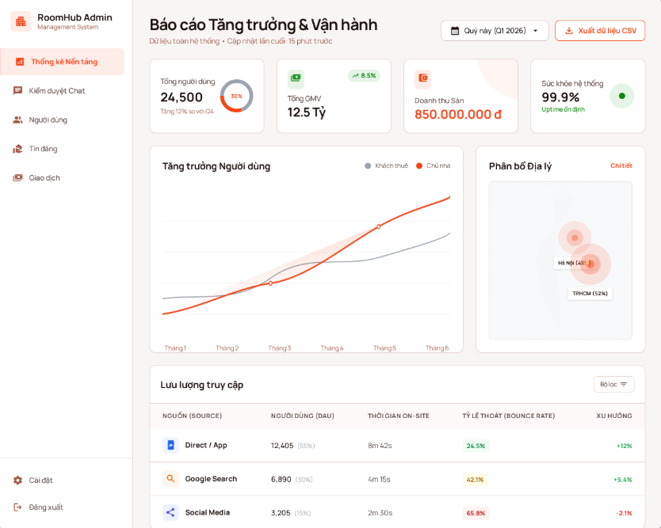

#### b. Business Rules

Provide the business rules those are applied only to the use case

| **ID** | **Business Rule** | **Business Rule Description** |
| --- | --- | --- |
| FR1 | Password Encoding | User’s password must be encoded with MD5 hashing |

### II.5.3 Activity diagram

*[This part describes the use cases, you can follow the table form as below]*

*Sample:*

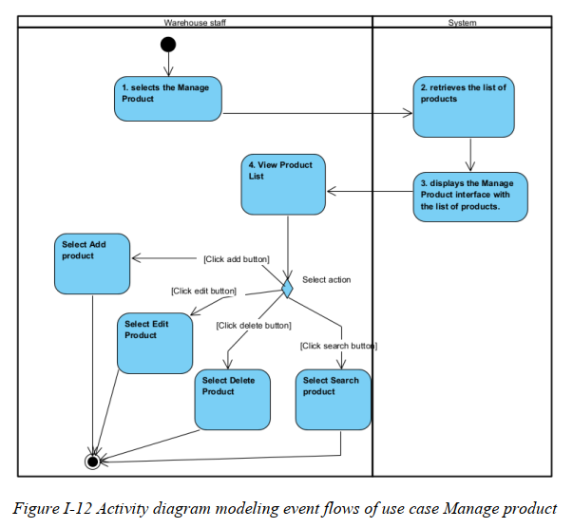

………

***II.6 Entity Relationship Diagram***

***[Provide the entity relationship diagram and the entity descriptions in the table format as below]***



# III. Analysis models.

## III.1 Interaction diagrams

***[Interaction diagrams*** *are a type of UML diagram that illustrate how objects interact in a particular scenario of a use case. They focus on the flow of* ***messages*** *between* ***objects or components*** *over time.*

*There are two main types:*

* ***Sequence Diagram*** *– Emphasizes the time-ordering of messages*
* ***Communication Diagram*** *– Emphasizes the structure and relationships between objects]*

### III.1.1.Sequence Diagram

#### UC-03: Verify User Identity (KYC)

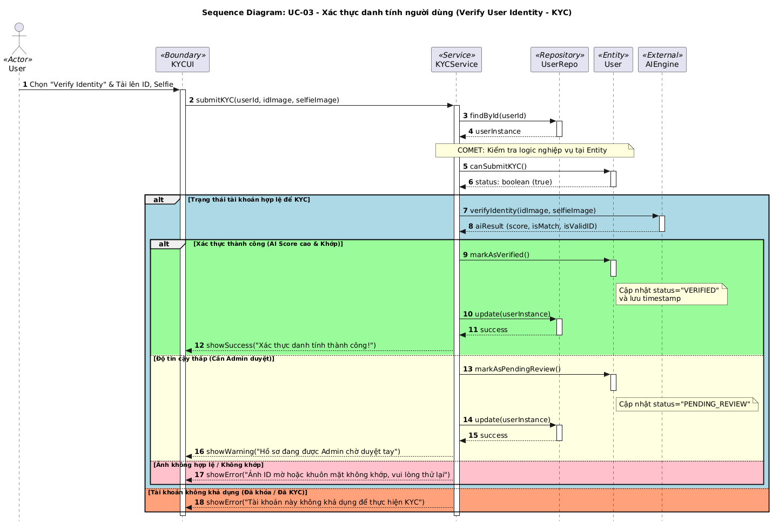

#### UC-11: Place Holding Deposit

**Phân tích bối cảnh (Context)**

* Mục tiêu: Khách thuê (Tenant) thực hiện đặt cọc một số tiền để giữ chỗ cho phòng trọ trong một khoảng thời gian nhất định.
* Luồng chính: Hệ thống kiểm tra trạng thái phòng -> Khởi tạo yêu cầu đặt cọc -> Giao tiếp với cổng thanh toán -> Cập nhật trạng thái thực thể nếu thành công.

**Liệt kê Lifelines (Stereotypes)**

* <<Actor>> Tenant: Người thực hiện yêu cầu.
* <<Boundary>> BookingUI: Giao diện người dùng trên Mobile/Web.
* <<Service>> BookingService: Điều phối luồng nghiệp vụ.
* <<Repository>> RoomRepo, BookingRepo: Giao tiếp với Database.
* <<Entity>> Room, Booking: Chứa dữ liệu và logic tự thân (Ví dụ: Room tự kiểm tra slot).
* <<External>> PaymentGateway: Hệ thống thanh toán bên thứ ba (VNPay/MoMo).

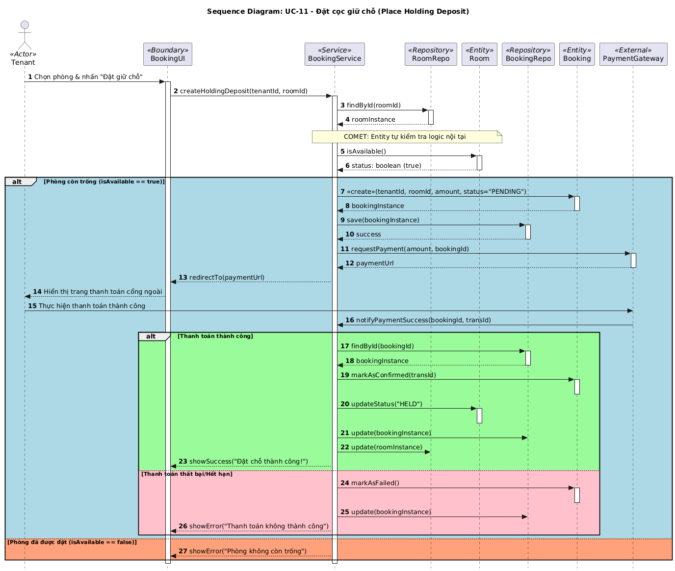

#### UC-13: Sign Digital Contract

**Phân tích bối cảnh (Context)**

* Mục tiêu: Khách thuê (Tenant) xem nội dung hợp đồng và thực hiện ký số để xác nhận thuê phòng.
* Luồng chính: Hệ thống truy xuất hợp đồng -> Khách hàng ký số -> Hệ thống kiểm tra tính hợp lệ -> Cập nhật trạng thái hợp đồng và kích hoạt các quyền lợi liên quan.

**Liệt kê Lifelines (Stereotypes)**

* <<Actor>> Tenant: Người ký hợp đồng.
* <<Boundary>> ContractUI: Giao diện hiển thị văn bản hợp đồng và trình ký.
* <<Service>> ContractService: Điều phối logic ký kết.
* <<Repository>> ContractRepo: Truy xuất/Lưu trữ hợp đồng.
* <<Entity>> Contract: Chứa logic kiểm tra trạng thái (vd: chỉ cho ký khi ở trạng thái PENDING_SIGNATURE).
* <<External>> DigitalSignatureService: Hệ thống mã hóa/xác thực chữ ký số (hoặc AI Engine hỗ trợ xác thực vân tay/khuôn mặt).

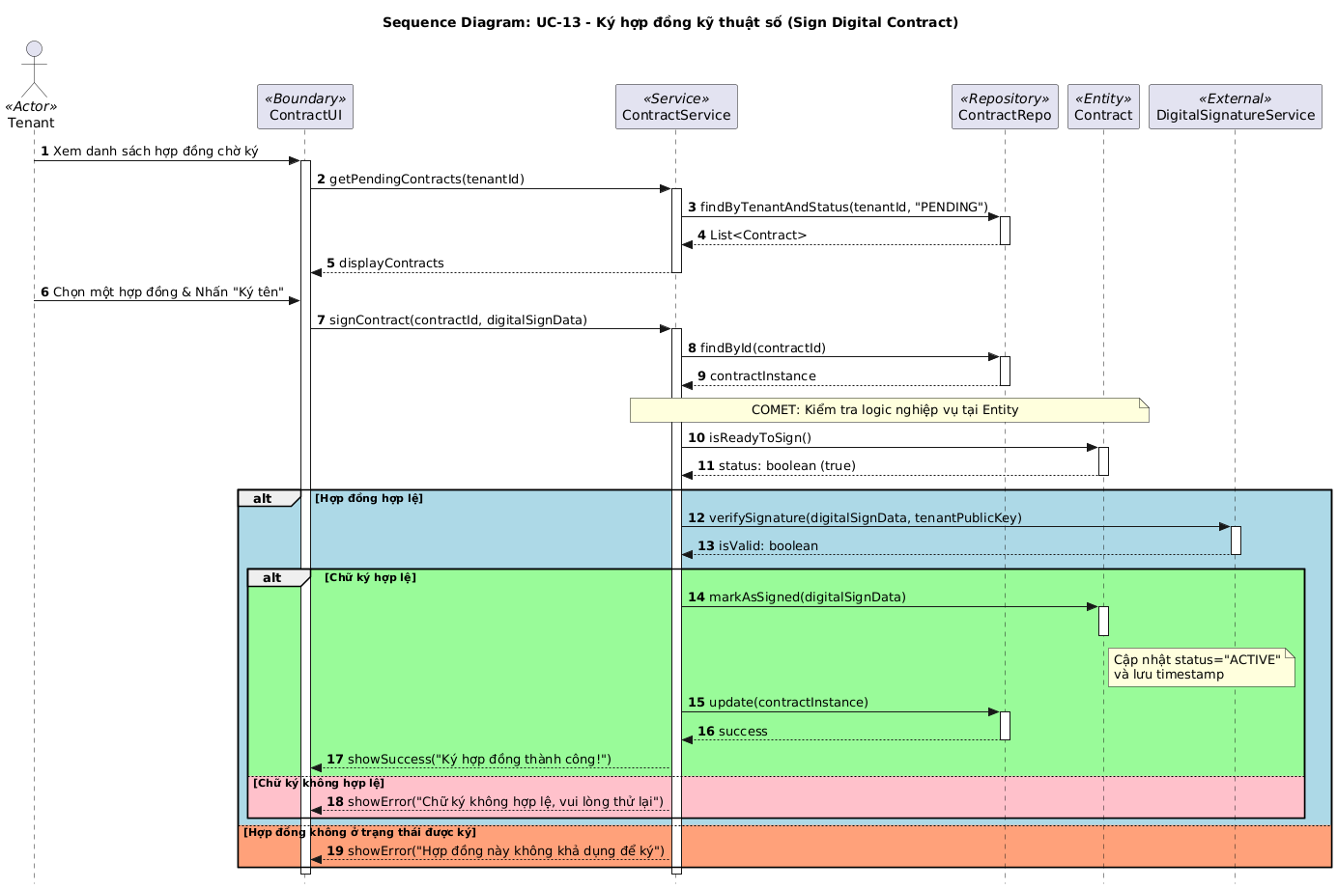

#### UC-15: Terminate Rental Contract

**Phân tích bối cảnh (Context)**

* Mục tiêu: Chủ nhà (Property Owner) thực hiện chấm dứt hợp đồng thuê với khách thuê.
* Luồng chính: Hệ thống kiểm tra hợp đồng -> Tính toán tiền hoàn cọc/phạt vi phạm (nếu có) -> Cập nhật trạng thái hợp đồng -> Giải phóng trạng thái phòng về "Trống".

**Liệt kê Lifelines (Stereotypes)**

* <<Actor>> PropertyOwner: Người thực hiện chấm dứt hợp đồng.
* <<Boundary>> ContractUI: Giao diện quản lý hợp đồng.
* <<Service>> ContractService: Điều phối nghiệp vụ chấm dứt hợp đồng.
* <<Repository>> ContractRepo, RoomRepo: Truy xuất và lưu trữ dữ liệu.
* <<Entity>> Contract: Chứa logic tính toán tiền cọc/phạt và chuyển trạng thái.
* <<Entity>> Room: Chứa logic cập nhật trạng thái phòng.

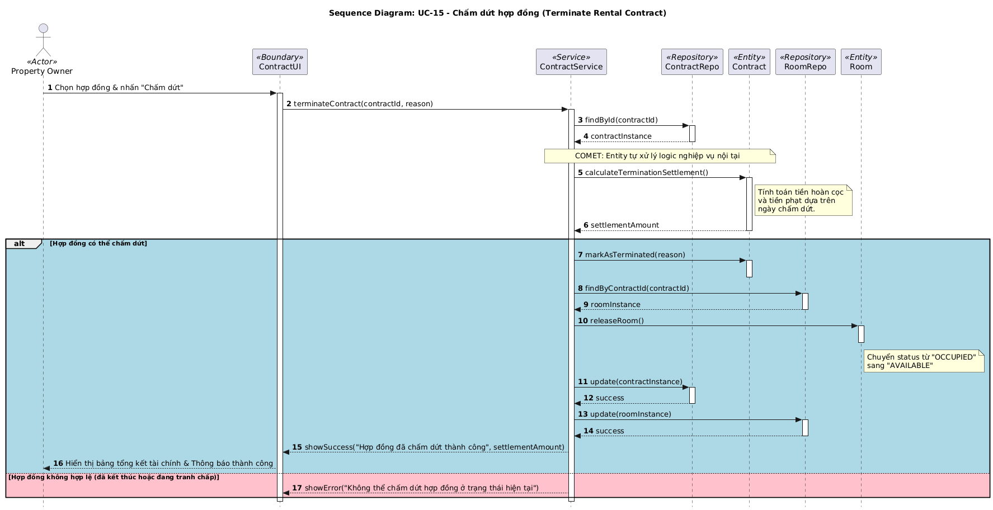

#### UC-18: Pay Monthly Invoice

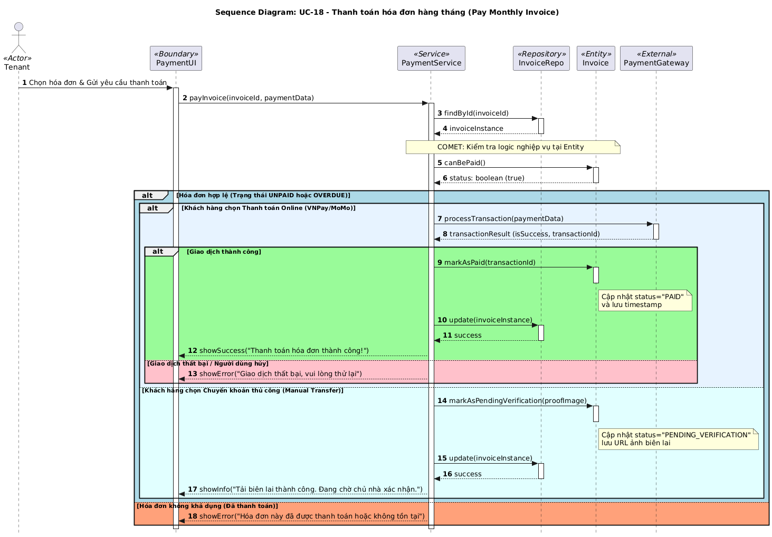

#### UC-26: Send Direct Message

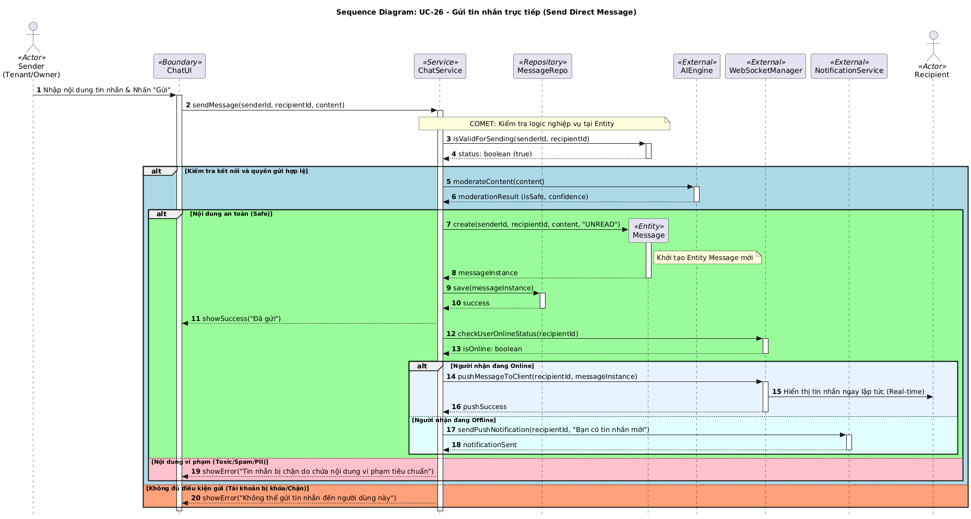

### III.1.2.Communication Diagram

[Provide the Communication diagram(s) for the feature, see the sample below]

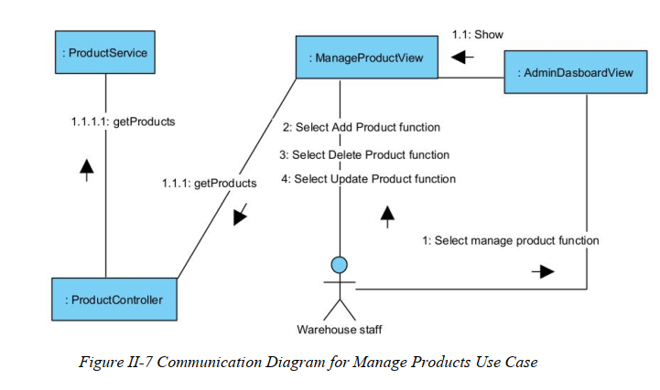

## III.2 State diagram

[Provide the State diagram(s) for the feature, see the sample below]

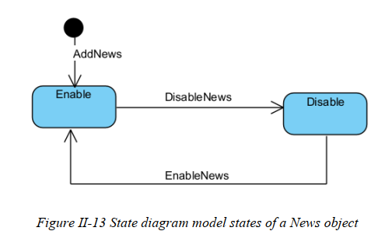

# IV. Design specification

## IV.1 Integrated Communication Diagrams

*Sample*

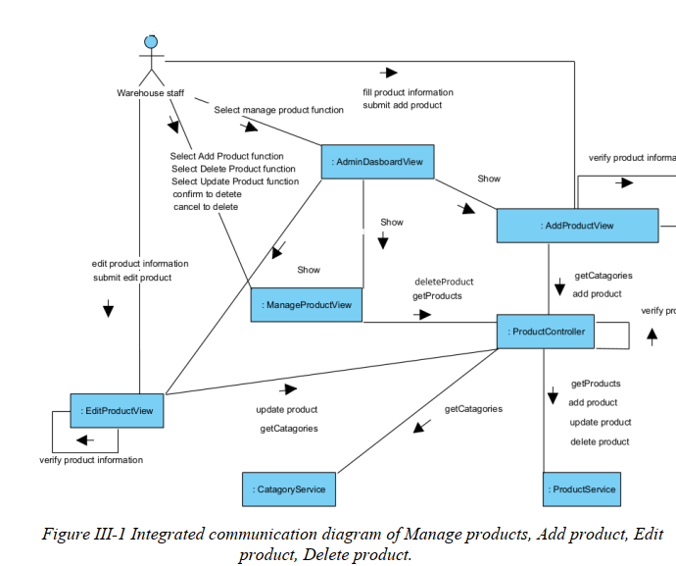

## IV.2 System High-Level Design

*Sample*

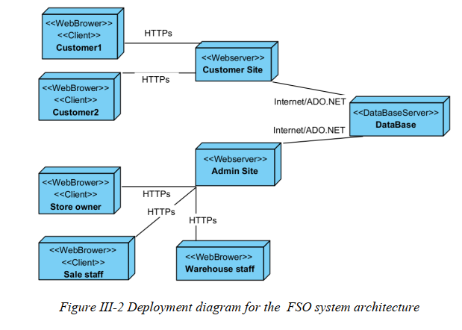

## IV.3 Component and Package Diagram

## IV.3.1 Component Diagram

*Sample*

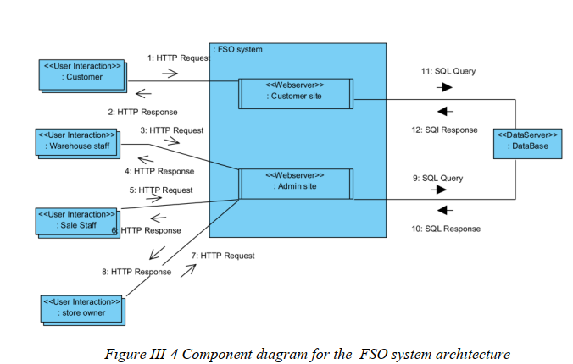

## IV.3.1 . Package Diagram

*[Provide the package diagram for each sub-system. The content of this section including the overall package diagram, the explanation, package and class naming conventions in each package. Please see the sample & description table format below (****please note: package names don’t follow Java package naming convention yet****)]*

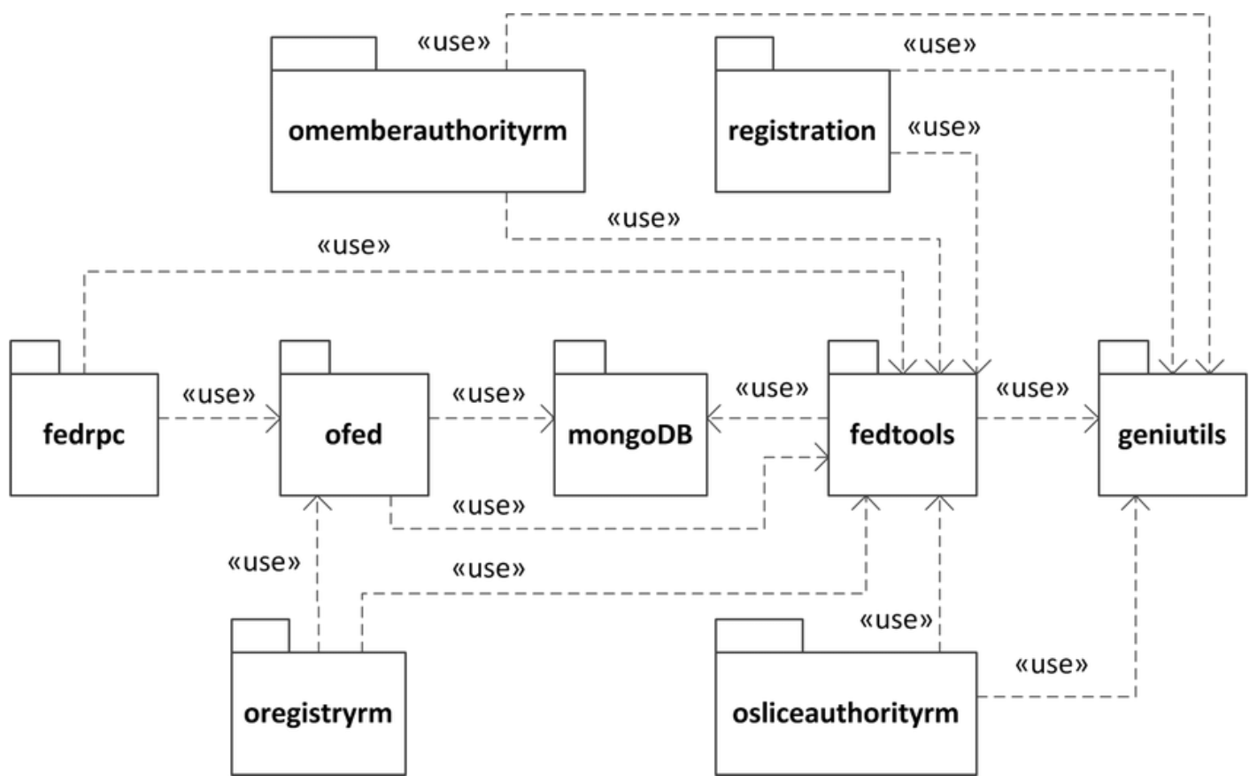

***Package descriptions***

| **No** | **Package** | **Description** |
| --- | --- | --- |
| *01* | *omemberauthorityrm* | *<Description of the package>* |
| *02* | *registration* | *<Description of the package>* |
| *03* | *fedrpc* | *<Description of the package>* |
| *04* | *ofed* | *<Description of the package>* |
| *05* | *mongoDB* | *<Description of the package>* |
| *06* | *fedtools* | *<Description of the package>* |
| *07* | *…* |  |

## IV.4 Class diagram

*[This part presents the class diagram for the relevant feature]*

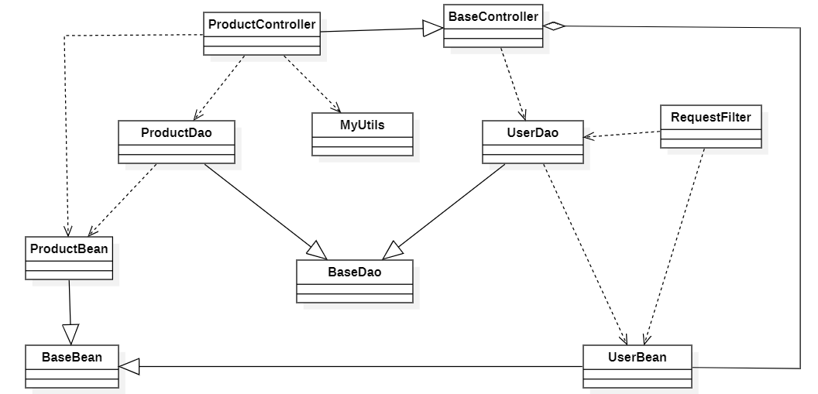

## IV.5 Database Design

*[Provide the tables relationship like example below – following MySQL database naming convention]*

# V. Implementation

## V.1 Map architecture to the structure of the project

*[Provide:*

1. ***Overview of the Chosen Architecture***

*Briefly describe the architectural style (e.g., Layered, MVC, Service-Oriented Architecture)*

*Explain* ***why it was selected*** *for this project (e.g., to meet non-functional requirements like maintainability, scalability, reusability)*

1. ***Mapping to Project Structure***

*Present the* ***actual project folder/package structure***

*Map each layer/component in the architecture to concrete project modules]*

## V.2 Map Class Diagram and Interaction Diagram to Code

*[Demo the implementation of several features using design patterns]*

# VI. Applying Alternative Architecture Patterns

## VI.1 Applying the ………….. (ex: **Service-Oriented Architecture (SOA))** architecture

*[Redesign part of the system architecture using* ***Service-Oriented Architecture (SOA)*** *to improve* ***reusability****,* ***scalability****, and* ***modularity****.*

***Students must provide:***

1. ***Problem Identification***

*Briefly describe which non-functional requirement(s) are* ***not fully supported*** *by the current architecture (e.g., NF-05: Reusability)*

1. ***SOA-Based Solution***

*Reorganize system components into independent services*

*E.g., refactor FSOData into separate service modules*

1. ***Supporting Diagrams***

*Deployment Diagram*

*Updated Class Diagram*

*Component Diagram showing separate services]*

## VI.2 Applying Service Discovery Pattern in the service-oriented architecture

*[Support dynamic service registration and discovery in* ***SOA or microservice-based architecture*** *for* ***horizontal scalability*** *and ease of expansion.*

***Students must provide:***

1. ***Problem & Requirement***

*Explain the relevant non-functional requirement (e.g., NF-06: Scalability)*

*Describe the need for service discovery in a growing system (e.g., multiple branches, independent modules)*

1. ***Service Discovery-Based Solution***

*Integrate a* ***Service Discovery Pattern***

*Mention possible technologies:* ***Consul****,* ***Eureka****,* ***Kubernetes DNS***

1. ***Supporting Diagrams***

*Deployment Diagram (with multiple instances and registry)*

*Updated Class/Component Diagram including a Discovery Service]*